An Hai Criteria: A1

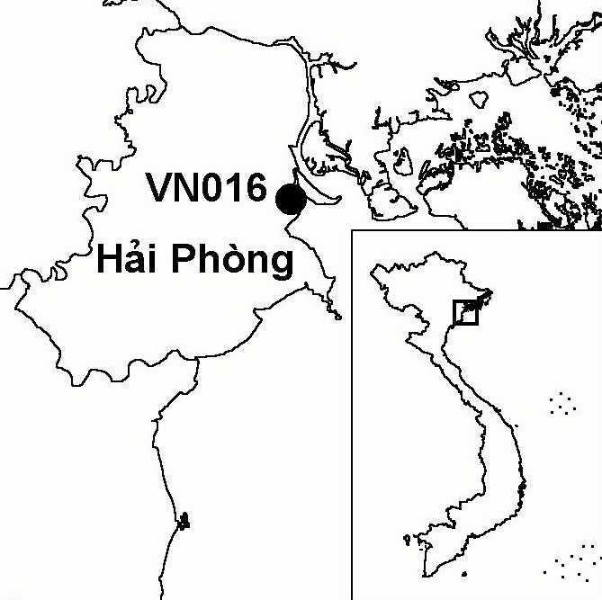
Province(s): Hai Phong
PA Status: None

Latitude: 20º49'N
Longitude: 106º45'E
Area: 5,000 ha
Altitude Range: 0-2 m asl

EBA / SA:

None
Priority Landscape:
None

General Description

The IBA comprises the coastal zone of An Hai district, in the Red River Delta. The coastline of An Hai district stretches for 9 km between the Lach Tray estuary in the south and the Cam estuary in the north. The intertidal area in the Cam estuary is very narrow and deep but there is a wider intertidal area in the Lach Tray estuary. The intervening coastline is fringed by a narrow belt of mangrove. In the mouth of the Cam river, there are two islands, Dinh Vu and Vu Yen, dominated by aquacultural ponds, many of which contain reedbeds¹.

Bird Fauna: Key Features

An Hai IBA has been the focus of little ornithological survey to date. However, the site is believed to be important for a number of migratory waterbirds. Most significantly, the intertidal mudflats at the site appear to be an important wintering area for gulls, including Common Black-headed Gull Larus ridibundus, Heuglin's Gull L. heuglini, and the globally threatened Saunders's Gull L. saundersi. Also, during a survey in 1996, a roost of 1,400 shorebirds was observed in the intertidal zone¹.

Species | IBA  Criteria | Global Threat Status | Other  IBAs | Notes
†Black-faced Spoonbill  Platalea minor | A1 | EN | 8 | A single bird was observed in the Lach Tray estuary in 1996¹. The site probably does not regularly support a significant population.
Saunders's Gull  Larus saundersi | A1 | VU | 5 | Seventeen birds were observed in the Lach Tray estuary in 1996¹.

Notes: † = not confirmed to regularly occur in significant numbers.

Biome Restricted Species: The site does not qualify under criterion A3. See Appendix 4 for details.

Secondary Criteria

The site does not qualify under any secondary criterion.

Threats to Biodiversity

One major threat to biodiversity at An Hai is afforestation of intertidal mudflats with mangrove, leading to the loss of the key habitat for migratory waterbirds. Other major threats include hunting and disturbance to birds. During a survey in 1996, collection of mangrove crab in the intertidal area and hunting with shotguns were both observed¹. In 1996, the district people's committee reported plans to build an industrial harbour on Dinh Vu island; it is not known whether these plans have been implemented.
Threat | Severity
Afforestation | ● ● ●
Aquaculture / fisheries | ● ●
Disturbance to birds | ● ●
Hunting | ● ●
Industrial / urban development | ● ●

Conservation Actions

- To date, the site has not been the focus of any conservation action.

Recommendations

- Measures should be undertaken to raise awareness among local communities of the need for sustainable use of natural resources¹.
- Effective measures to control hunting at the site should be introduced.
- There should be no further afforestation of intertidal mudflats with mangrove.

References

1. Pedersen, A. and Nguyen Huy Thang (1996) The conservation of key coastal wetland sites in the Red River Delta. Hanoi: BirdLife International Vietnam Programme.

Saunders's Gull Larus saundersi

