A Yun Pa Criteria: A1 & A3

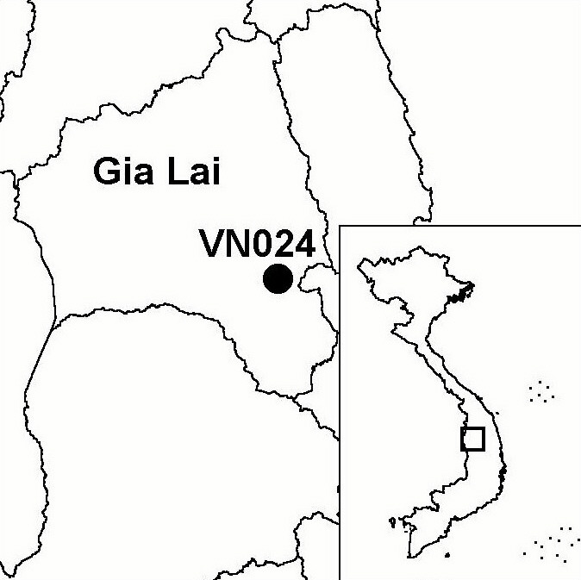
Province(s): Gia Lai
PA Status: None

Latitude: 13º31'N
Longitude: 108º38'E
Area: 44,268 ha
Altitude Range: 150-1,200 m asl

EBA / SA:

None
Priority Landscape:
None

General Description

The IBA is centred on A Yun Pa proposed nature reserve, which is located in the Central Highlands. The IBA is situated in an area of hills and low mountainous, situated mid-way between the much higher Da Lat and Kon Tum plateaus. The forest cover in the IBA is over 90%, and comprises a mosaic of lowland deciduous forest, lowland semi-evergreen forest and lower montane evergreen forest. Although large areas have been subjected to selective timber extraction, the forest remains in a relatively good condition, with a closed canopy in most places. There is no permanent human settlement within the IBA and the human population density in the surrounding area is relatively low. Most local people belong to the Gia Rai ethnic minority, while most of the remainder are Kinh in-migrants from northern Vietnam^{1,2}.

Bird Fauna: Key Features

A Yun Pa IBA is believed to support one of the largest remaining populations of Green Peafowl Pavo muticus in Vietnam². A recent study of the habitat requirements of this species revealed that it occurs at highest densities in deciduous forest within 2 km of permanent water and greater than 2 km from permanent human settlement³. A Yun Pa IBA contains over 16,000 ha of this habitat; in particular, the IBA supports extensive lengths of wide, slow-flowing, forested streams with sandbanks along their lengths². A Yun Pa IBA also supports populations of the globally vulnerable Pale-capped Pigeon Columba punicea and the globally near-threatened Siamese Fireback Lophura diardi².

Species | IBA  Criteria | Global Threat Status | Other  IBAs | Notes
Green Peafowl  Pavo muticus | A1, A3 | VU | 8 | In April 2000, three birds were seen along the Ea Djirao stream, and footprints and feathers were seen in the same area. Local hunters reported the species to be common in the area².
Pale-capped Pigeon  Columba punicea | A1, A3 | VU | 5 | In April 2000, a single bird was seen in semi-evergreen forest along the Ea Djirao stream².
Siamese Fireback  Lophura diardi | A1, A3 | NT | 13 | A pair was observed in a small patch of scrub surrounded by semi-evergreen forest in April 2000².

Biome Restricted Species: The site qualifies under criterion A3 because it supports eight species restricted to the Indochinese Tropical Moist Forests (Biome 09) and 12 species restricted to the Indo-Malayan Tropical Dry Zone (Biome 11). See Appendix 4 for details.

Secondary Criteria

Species Status Species Status
Northern Pigtail Macaque Macaca leonina² VU [Buff-cheeked Gibbon Nomascus gabriellae]² VU
[Long-tailed Macaque Macaca fascicularis]² NT [Southern Serow Naemorhedus sumatraensis]² VU
[Douc species Pygathrix sp.]² EN/DD

Notes: [ ] = unconfirmed record.

Threats to Biodiversity

One of the major threats to biodiversity at A Yun Pa IBA is hunting. Because of the gentle topography, open forest structure and the presence of wide stream valleys hunters can access even the most remote parts of the IBA. Hunting is a particular threat to the population of Green Peafowl Pavo muticus, which is susceptible to ground snaring and for which there exists demand from the wildlife trade. An associated threat is fire, as hunters often deliberately burn the forest^{1,2}.

Another major threat is timber extraction. In the past, parts of the IBA were under the management of state forest enterprises. Although commercially logging has now ceased, small-scale timber extraction by local people, particularly for high-value timber species, is widespread. Although clearance of forest for agriculture is currently not a major threat, it may increase in the future, as there exist plans to settle migrants from northern Vietnam into the surrounding area^{1,2}. Another potential threat is posed by plans to construct an irrigation dam on the Ia Tul stream. The resultant reservoir would inundate large areas of riverine habitat, the key habitat for Green Peafowl, and facilitate access into the IBA.
Threat | Severity
Agricultural intensification / expansion | ●
Construction of dykes / dams | ● ●
Fire | ● ●
Hunting | ● ●
Selective logging / cutting | ● ●

Conservation Actions

- In 2001, a feasibility study for the establishment of a protected area at A Yun Pa was prepared, and recommended the establishment of a 44,268 ha nature reserve².

Recommendations

- A Yun Pa should be decreed as a nature reserve by the government of Vietnam, and a management board should be established².
- Effective controls on hunting, logging, clearance of forest for agriculture and forest fire should be introduced.
- A guard station should be built along the Ia Tul stream, in order to control extraction of timber and wildlife and to act as a focus for extension with local communities to reduce deliberate forest fires.
- Current proposals for resettlement of migrants for northern Vietnam into the surrounding area should be assessed and, if necessary, revised, in order to mitigate potential negative impacts on biodiversity.
- An Environmental Impact Assessment for the planned irrigation dam on the Ia Tul stream should be conducted, and appropriate mitigation measures should be introduced, these may include restricting the height of the dam, to limit the area of inundation, or selecting an alternative location.
- The capacity of forest protection department staff at the provincial, district and commune levels in forest protection and management should be strengthened.

References

1. BirdLife International and the Forest Inventory and Planning Institute (2001) Sourcebook of existing and proposed protected areas in Vietnam. Hanoi: BirdLife International Vietnam Programme and the Forest Inventory and Planning Institute.
2. Tran Quang Ngoc, Tordoff, A. W., Hughes, R., Vu Van Can and Le Van Phong (2001) [A feasibility study for the establishment of A Yun Pa Nature Reserve, Gia Lai province, Vietnam.] Hanoi: BirdLife International Vietnam Programme and the Forest Inventory and Planning Institute. (In Vietnamese.)
3. Brickle, N. W., Nguyen Cu, Ha Quy Quynh, Nguyen Thai Tu Cuong and Hoang Van San (1998) The status and distribution of Green Peafowl Pavo muticus in Dak Lak province, Vietnam. Hanoi: BirdLife International Vietnam Programme.

Green Peafowl Pavo muticus

