Bai Boi Criteria: A1 & A4i

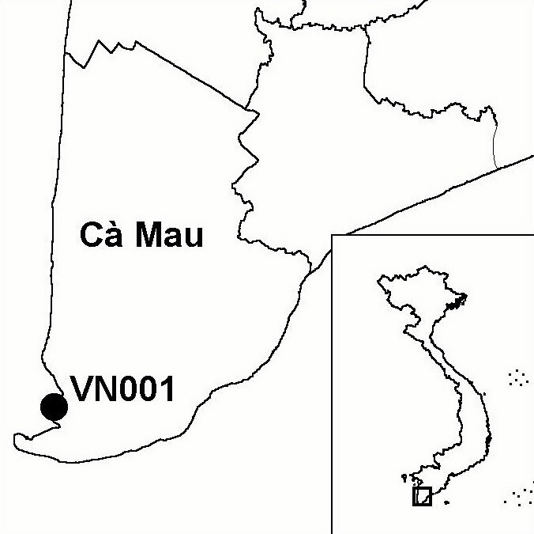
Province(s): Ca Mau
PA Status: None

Latitude: 8º42'N
Longitude: 104º50'E
Area: 5,525 ha
Altitude Range: 0-2 m asl

EBA / SA:

None
Priority Landscape:
None

General Description

Bai Boi is situated on the west coast of the Ca Mau peninsular, in the southernmost part of the Mekong Delta. The IBA supports a number of coastal habitats, including abandoned aquacultural ponds, which are being re-colonised by mangrove, and extensive areas of accreting mudflats, the landward side of which supports naturally colonising mangrove. The IBA is bisected by the Lon river, in the mouth of which are two islands formed by the accretion of sediment: Con Trong and Con Ngoai. Bai Boi is designated as a coastal protection forest, and is bounded by the Bai Hap estuary to the north and by Dat Mui IBA to the south.

Bird Fauna: Key Features

Bai Boi forms part of an important staging area for shorebirds on the East Asian-Australasian flyway before they cross the Gulf of Thailand to Peninsular Malaysia and Indonesia². The complex of mudflats and areas of open regenerating mangrove at the site provide excellent habitats for migratory shorebirds, herons, egrets, gulls and terns¹. To date, four globally threatened and near-threatened species have been recorded at Bai Boi, together with numerous other species of congregatory waterbirds, including good numbers of Whiskered Terns Chlidonias hybridus and Caspian Terns Sterna caspia¹. A roost of egrets Egretta spp. and Little Cormorants Phalacrocorax niger, comprising over 1,000 birds, was recorded at the site 1999, although no breeding activity was observed¹. Given the relatively limited amount of survey effort expended at the site so far, it is possible that the low numbers of birds recorded so far do not accurately reflect the importance of the site¹.

Species | IBA  Criteria | Global Threat Status | Other  IBAs | Notes
Chinese Egret  Egretta eulophotes | A1, A4i | VU | 6 | Five individuals were recorded in 1999¹. A total of 83 birds were recorded at this site and Dat Mui IBA in March 2000 and six birds were recorded Bai Boi in December 2000³.
Far Eastern Curlew  Numenius madagascariensis | A1 | NT | 4 | Four individuals were recorded in March 1999¹. A single individual was recorded in December 2000³.
Asian Dowitcher Limnodromus semipalmatus | A1 | NT | 5 | Sixteen individuals were recorded in March 1999¹. A total of 23 individuals were recorded at this site and Dat Mui IBA in March 2000³.
Painted Stork  Mycteria leucocephala | A1 | NT | 10 | A single individual was recorded in August 1999¹.

Biome Restricted Species: The site does not qualify under criterion A3. See Appendix 4 for details.

Secondary Criteria

The site does not qualify under any secondary criterion.

Threats to Biodiversity

Current levels of human use of the site are thought to be low¹. However, illegal fishing involving the use of electricity, traps and trawled nets has been documented as widespread at the site, and is thought to cause significant disturbance to the avifauna³. These activities, if not regulated, could also potentially lead to declines in abundance of local marine life³. One potentially severe threat to Bai Boi is that, while the site remains designated as a coastal protection forest, the intertidal mudflats may be afforested with mangrove with the objective of coastal protection. This activity would be incompatible with biodiversity conservation, because it would destroy the key habitat for migratory waterbirds². Typhoons are another potential threat to biodiversity at the site.
Threat | Severity
Afforestation | ● ● ●
Aquaculture/ fisheries | ● ●
Disturbance to birds | ● ●
Natural events | ● ●

Conservation Actions

- Bai Boi has been identified by the Vietnam Man and the Biosphere (MAB) National Committee as a candidate site for designation as an MAB Reserve.

Recommendations

- Bai Boi should be combined with Dat Mui Nature Reserve as a single protected area, which should be nominated as a Ramsar site^{1,3}.
- Bai Boi should be nominated under the East Asian-Australasian Shorebird Network^{1,3}.
- No further development of aquaculture should be permitted within the boundaries of the site¹.
- Fishing activities at the site should be strictly controlled to minimise potential disturbance to migratory waterbirds¹.
- No mangrove afforestation should be carried out on areas of accreting mudflats¹.
- A monitoring programme to further assess the importance of the site for migratory waterbirds should be initiated¹.
- Awareness-raising activities should be conducted among local communities to promote understanding of the importance and fragility of the biodiversity of the site and stimulate interest and motivation towards sustainable use of local natural resources³.
- The potential for ecotourism at the site should be investigated³.

References

1. Buckton, S. T., Nguyen Cu, Nguyen Duc Tu and Ha Quy Quynh (1999) The conservation of key wetland sites in the Mekong Delta. Hanoi: BirdLife International Vietnam Programme.
2. BirdLife International and the Forest Inventory and Planning Institute (2001) Sourcebook of existing and proposed protected areas in Vietnam. Hanoi, Vietnam: BirdLife International Vietnam Programme and the Forest Inventory and Planning Institute.
3. Moores, N. and Nguyen Phuc Bao Hoa (2001) Vietnam Mekong shorebird site survey 2000. Unpublished report to Wetlands International Asia-Pacific and Can Tho University.


Asian Dowitcher Limnodromus semipalmatus

