Ban Bung Criteria: A1 & A3

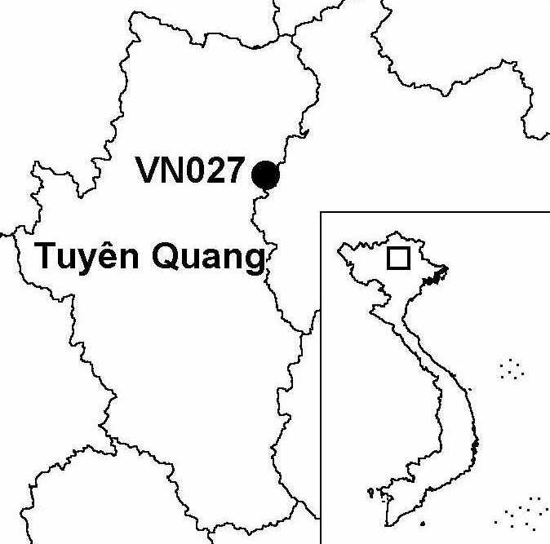
Province(s): Tuyen Quang
PA Status: None

Latitude: 22º19'N
Longitude: 105º28'E
Area: 15,000 ha
Altitude Range: 300-980 m asl

EBA / SA:

None
Priority Landscape:
None

General Description

The IBA comprises the Ban Bung sector of Na Hang proposed nature reserve. The topography of the IBA is dominated by limestone karst formations, which support limestone forest. There are smaller areas of non-calcereous substrates within the IBA, which support lowland evergreen forest and lower montane evergreen forest. Ban Bung IBA is notable as one of the few remaining sites in Vietnam to support a viable population of the globally critically endangered Tonkin Snub-nosed Monkey Rhinopithecus avunculus, a species endemic to northern Vietnam^{1,2,3}.

Bird Fauna: Key Features

Ban Bung IBA is known to support populations of three globally near-threatened species: Chestnut-necklaced Partridge Arborophila charltonii, Red-collared Woodpecker Picus rabieri and Brown Hornbill Anorrhinus tickelli. However, the most significant feature of the avifauna of the site is the high number of biome-restricted species. In particular, Ban Bung supports a number of biome-restricted species that are found at few other sites in Vietnam, including Eared Pitta Pitta phayrei, Grey-winged Blackbird Turdus boulboul, Slaty-blue Flycatcher Ficedula tricolor, Greater Rufous-headed Parrotbill Paradoxornis ruficeps and Spot-winged Grosbeak Mycerobas melanozanthos. In addition, Ban Bung may support the globally endangered White-eared Night Heron Gorsachius magnificus, which is known from the contiguous Ban Thi-Xuan Lac IBA. If the occurrence of this species was confirmed, Ban Bung IBA would qualify for inclusion within the South-east China Mountains Endemic Bird Area.

Species | IBA  Criteria | Global Threat Status | Other  IBAs | Notes
Chestnut-necklaced Partridge  Arborophila charltonii | A1 | NT | 7 | The species was recorded between January and March 1996².
Red-collared Woodpecker  Picus rabieri | A1, A3 | NT | 11 | A total of nine birds were observed between January and March 1996².
Brown Hornbill  Anorrhinus tickelli | A1, A3 | NT | 16 | The species was recorded between January and March 1996².

Biome Restricted Species: The site qualifies under criterion A3 because it supports 32 species restricted to the Sino-Himalayan Subtropical Forests (Biome 08) and 13 species restricted to the Indochinese Tropical Moist Forests (Biome 09). See Appendix 4 for details.

Secondary Criteria

Species Status Species Status
Assamese Macaque Macaca assamensis³ VU Keeled Box Turtle Pyxidea mouhotii³ EN
Stump-tailed Macaque Macaca arctoides³ VU Podocarpus neriifolius² DD
[Francois's Langur Southern Serow Naemorhedus sumatraensis^{2,3} VU
Trachypithecus francoisi francoisi]³ VU
Tonkin Snub-nosed Monkey
Rhinopithecus avunculus³ CR

Notes: [ ] = unconfirmed record.

Threats to Biodiversity

One of the main threats to biodiversity at Ban Bung IBA is hunting, which is particularly severe in the case of Tonkin Snub-nosed Monkey, which has a small population and is targeted due to its perceived medicinal properties. Other threats are over-exploitation of timber and NTFPs, and clearance of forest for shifting cultivation.

The major threat to biodiversity at Ban Bung IBA is the planned construction of a hydroelectric dam on the Gam river, which forms the western boundary of the IBA. As well as inundating parts of the IBA, this dam, and associated access roads, would lead to increased human pressure on forest resources due to improved access to remote forest areas, and increased human population in the surrounding area. Potentially, the construction of the dam may lead to conversion of forest to agricultural land, if existing agricultural land is inundated⁴.
Threat | Severity
Construction of dykes / dams | ● ● ●
Extraction mining | ●
Hunting | ● ● ●
Infrastructure development | ● ●
Selective logging / cutting | ● ●
Unsustainable exploitation of NTFPs | ● ●

Conservation Actions

- Tuyen Quang Provincial People's Committee approved the establishment of Na Hang Nature Reserve, which includes the IBA, in 1994 and, subsequently, a management board was established. To date, however, Na Hang Nature Reserve has not been decreed by the government of Vietnam¹.
- Since 1997, Allwetter Zoo and the Zoological Society for the Conservation of Species and Populations have been implementing a project entitled the Tonkin Snub-nosed Monkey Conservation Project, which has established community-based patrol groups to control hunting of this species¹.
- In 1998, Fauna and Flora International implemented a project entitled the Na Hang Rainforest Conservation Project, with the primary objective of strengthening the management of Na Hang proposed nature reserve³.
- Na Hang proposed nature reserve is one of the focal sites of a full-sized GEF project entitled Creating Protected Areas for Resource Conservation using Landscape Ecology (PARC) Project, which began implementation in 1999¹.

Recommendations

- Na Hang should be decreed as a protected area by the government of Vietnam.
- Enforcement of protected area management regulations, particularly controls on hunting and unsustainable exploitation of forest products, should be strengthened.
- An international quality Environmental Impact Assessment for the planned hydroelectric dam should be conducted, and appropriate mitigation measures should be introduced. These may include selecting an alternative location for the dam, limiting the height of the dam, or controlling forest clearance and illegal exploitation of natural resources during and after dam construction.

References

1. BirdLife International and the Forest Inventory and Planning Institute (2001) Sourcebook of existing and proposed protected areas in Vietnam. Hanoi: BirdLife International Vietnam Programme and the Forest Inventory and Planning Institute.
2. Hill, M. and Kemp, N. (1996) Biological survey of Na Hang Nature Reserve, Tuyen Quang province, Vietnam: part 1, Ban Bung sector. London: Society for Environmental Exploration.
3. Boonratana, R. (1998) Na Hang rainforest conservation project. Hanoi: Fauna & Flora International Indochina Programme.
4. McNab, A., Vo Tri Chung and Nguyen Huu Hong (2000) River Gam dam preliminary environmental impact assessment. Hanoi: Scott Wilson, Asia-Pacific Ltd.

Red-collared Woodpecker Picus rabieri

