Bi Dup Criteria: A1, A2 & A3

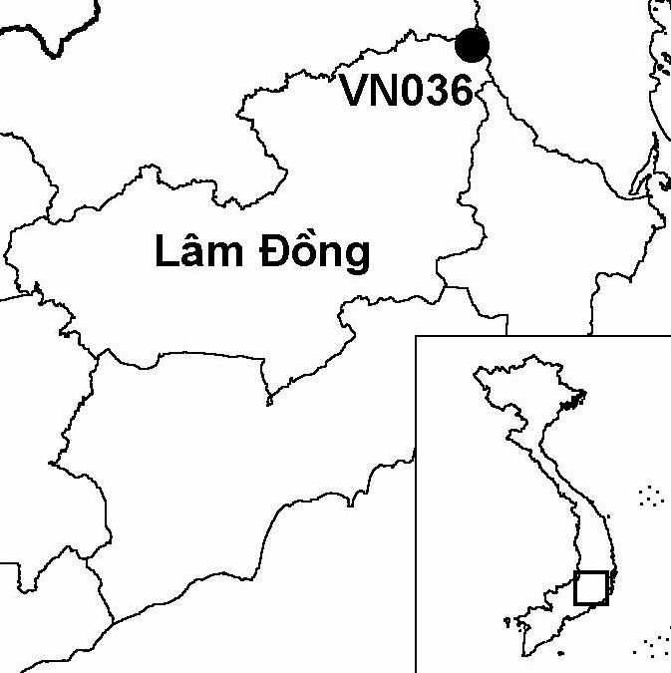
Province(s): Lam Dong
PA Status: Nature Reserve

Latitude: 12º08'N
Longitude: 108º40'E
Area: 20,000 ha
Altitude Range: 1,400-2,287 m asl

EBA / SA:

Da Lat Plateau EBA
Priority Landscape:
SA 3 - Southern Annamites Main Montane Block

General Description

Situated on the Da Lat plateau, the IBA is centred on Mount Bi Dup, the highest peak in Bi Dup-Nui Ba Nature Reserve. The topography of the IBA is dominated by a range of high mountains, including Mount Bi Dup (2,287 m asl) and Mount Gia Rich (1,922 m asl). The vegetation of the IBA is dominated by montane evergreen forest, although there are smaller areas of coniferous forest and mixed broadleaf and coniferous forest¹. The Da Lat plateau supports high levels of endemism in plants and animals, and a significant proportion of the taxa endemic to the plateau are found on Mount Bi Dup.

Bird Fauna: Key Features

Bi Dup IBA lies within the Da Lat Plateau Endemic Bird Area (EBA), and supports seven of the eight restricted-range bird species that define this EBA. Most notably, Bi Dup supports a population of the globally endangered Collared Laughingthrush Garrulax yersini, a species whose global range is confined to the Da Lat Plateau EBA. Bi Dup IBA is of particular importance for the conservation of this species, because it is restricted to montane evergreen forest, a habitat type that is in decline across the Da Lat plateau. Bi Dup IBA is also supports a large number of subspecies endemic to the Da Lat plateau, some of which may be worthy of elevation to species level. These include subspecies of Spot-breasted Laughingthrush Garrulax merulinus annamensis, Blue-winged Minla Minla cyanouroptera and Grey-headed Parrotbill Paradoxornis gularis margaritae.

Species | IBA  Criteria | Global Threat Status | Other  IBAs | Notes
Collared Laughingthrush  Garrulax yersini | A1, A2 | EN | 5 | The species was recorded on several occasions on Mount Bi Dup and at Long Lanh in May 1991². During December 1993, the species was recorded on Mount Bi Dup and Mount Gia Rich, at elevations between 1,780 and 2,130 m asl, on five occasions².
Crested Argus  Rheinardia ocellata | A1, A2 | VU | 15 | The species was heard calling on Mount Bi Dup and at Long Lanh in May 1991³ and, also, on Mount Bi Dup and Mount Gia Rich in December 1993².
Pale-capped Pigeon  Columba punicea | A1, A3 | VU | 5 | A single bird was observed on Mount Bi Dup in December 1993².
[Brown Hornbill  Anorrhinus tickelli] | A1, A3 | NT | 17 | The species was provisionally recorded on the basis of hornbill calls heard on Mount Gia Rich in December 1994².
Yellow-billed Nuthatch  Sitta solangiae | A1, A2 | NT | 11 | Several birds were observed on Mount Bi Dup in May 1991³, and a single bird was observed on Mount Gia Rich in December 1993².
Black-hooded Laughingthrush  Garrulax milleti | A1, A2 | NT | 8 | A flock of four to six birds was seen in forest edge on Mount Gia Rich in December 1993².
Short-tailed Scimitar Babbler  Jabouilleia danjoui | A1, A2 | NT | 17 | The species was recorded on Mount Bi Dup and Mount Gia Rich in May 1991 and December 1993^{2,3}.
Vietnam Greenfinch  Carduelis monguilloti | A1, A2 | NT | 4 | The species was recorded on the lower slopes of Mount Bi Dup and at Long Lanh in May 1991^{2,3}. The species was heard flying over Mount Bi Dup at 1,740 m asl in December 1993².
White-cheeked Laughtingthrush  Garrulax vassali | A2 |  | 8 | Several birds, including at least one juvenile, were seen on Mount Gia Rich in May 1991³.
Notes: [ ] = unconfirmed record.

Biome Restricted Species: The site qualifies under criterion A3 because it supports 27 species restricted to the Sino-Himalayan Subtropical Forests (Biome 08). See Appendix 4 for details.

Secondary Criteria

Species Status Species Status
[Stump-tailed Macaque Macaca arctoides]⁴ VU Calocedrus macrolepis^{4,6} VU
[Black-shanked Douc Pygathrix nigripes]⁵ EN Fokienia hodginsii^{4,6} NT
Buff-cheeked Gibbon Nomascus gabriellae⁴ VU Podocarpus neriifolius^{4,6} DD
Pinus dalatensis⁴ VU [Asian Elephant Elephas maximus]⁴ EN
Pinus krempfii^{4,6} VU Gaur Bos gaurus⁴ VU
Pinus merkusii⁶ VU [Southern Serow Naemorhedus sumatraensis]⁴ VU

Notes: [ ] = unconfirmed record.

Threats to Biodiversity

Prior to the establishment of Bi Dup-Nui Ba Nature Reserve, significant areas of forest in Bi Dup IBA were degraded and cleared by commercial logging operations. Since the cessation of commercial logging at the site, habitat loss and degradation continue but at lower levels. The main causes of habitat loss at the IBA are clearance of forest for shifting cultivation and fire. Over-exploitation of forest productions, particularly firewood collection and charcoal production, also contribute to habitat degradation and loss¹.

Habitat loss presents a particular threat to biodiversity with regards to montane evergreen forest, which is the key habitat for restricted-range bird species at Bi Dup IBA, with the exception of Vietnamese Greenfinch Carduelis monguilloti, which prefers coniferous forest. Most remaining montane evergreen forest in the IBA is at elevations above 1,500 m asl, which is towards the upper end of the altitudinal ranges of Crested Argus Rheinardia ocellata and Black-hooded Laughingthrush Garrulax milleti. Therefore, further loss of montane evergreen forest may result in the extinction of these and other species at the site. Indeed, the globally endangered Grey-crowned Crocias Crocias langbianis, a species currently believed restricted to montane evergreen forest between 900 and 1,450 m asl, may already have been extirpated from the site for this reason.
Threat | Severity
Agricultural intensification / expansion | ● ●
Fire | ● ●
Hunting | ●
Selective logging / cutting | ● ●
Unsustainable exploitation of NTFPs | ● ●

Conservation Actions

- The establishment of Thuong Da Nhim Nature Reserve, which was later incorporated within Bi Dup-Nui Ba Nature Reserve, was decreed by the government of Vietnam in 1986¹.
- A management board for Bi Dup-Nui Ba Nature Reserve was established in 1993¹.

Recommendations

- Enforcement of protected area management regulations, particularly over-exploitation of forest products and clearance of forest for cultivation, should be strengthened.
- A comprehensive fire management programme should be initiated, including environmental awareness activities aimed at raising awareness among local communities of the hazards posed by fire.
- Bi Dup IBA should be managed with the objective of conserving the biodiversity of the Da Lat plateau as a whole. In particular, attention should be given to creating or maintaining habitat corridors with other areas of natural habitat, and maintaining sufficient area of each natural habitat to support all endemic taxa for which the IBA is important. To this end, an detailed programme of research should be conducted to investigate the ecological requirements of all endemic taxa on the Da Lat plateau.

References

1. BirdLife International and the Forest Inventory and Planning Institute (2001) Sourcebook of existing and proposed protected areas in Vietnam. Hanoi: BirdLife International Vietnam Programme and the Forest Inventory and Planning Institute.
2. Eames, J. C. (1995) Endemic birds and protected area development on the Da Lat plateau, Vietnam. Bird Conservation International 5(4): 491-523.
3. Robson, C. R., Eames, J. C., Nguyen Cu and Truong Van La (1993) Birds recorded during the third BirdLife/Forest Birds Working Group expedition in Vietnam. Forktail 9: 89-119.
4. Eames, J. C. and Nguyen Cu (1994) A management feasibility study of Thuong Da Nhim and Chu Yang Sin Nature Reserves on the Da Lat Plateau, Vietnam. Hanoi: WWF Vietnam Programme and the Forest Inventory and Planning Institute.
5. Eames, J. C. and Robson, C. R. (1993) Threatened primates in southern Vietnam. Oryx 27(3): 146-154.
6. Nguyen Tien Hiep and Vidal, J. E. (1996) Flore du Cambodge du Laos et du Vietnam. Vol. 28: Gymnospermae. Paris: Museum National D'Histoire Naturelle. (In French.)

Crested Argus Rheinardia ocellata

