Binh Dai Criteria: A1, A4i & A4iii

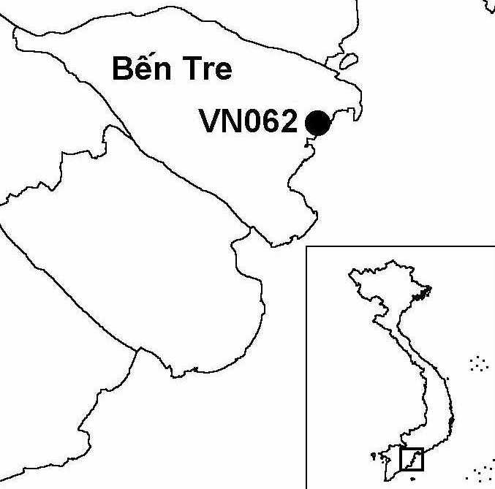
Province(s): Ben Tre
PA Status: None

Latitude: 10º08'N
Longitude: 106º45'E
Area: 30,000 ha
Altitude Range: 0-2 m asl

EBA / SA:

None
Priority Landscape:
None

General Description

The IBA is situated in the Mekong Delta, and comprises the coastal zone of Binh Dai district and the Dai estuary to the north. The IBA is situated within a formerly extensive area of flood-prone marshlands and mangrove. From the 1980s onwards, much of the original vegetation was converted into a series of anthropogenic habitats, including paddyfields, aquacultural ponds and salt pans. The remaining natural vegetation comprises intertidal sand and mudflats, sea grass beds and remnant stands of mangrove¹. To the north, the site is bounded by the Dai estuary, while, to the south-west, it is bounded by the Ba Lai estuary. To the south-west, Binh Dai IBA is contiguous with Ba Tri IBA.

Bird Fauna: Key Features

Binh Dai IBA is the most important known site for migratory shorebirds in the Mekong Delta. Despite the predominantly anthropogenic habitats at the site, several factors contribute to the suitability of the site for shorebirds, including the widespread use of integrated pest management in place of insecticides in paddy fields, the coincidence of fallow periods with the peak migration periods, and the presence of mangrove within aquacultural ponds¹.

Although Binh Dai IBA has received only a relatively small amount of survey effort to date, the results indicate that the site supports at least eight globally threatened and near-threatened species, including Malaysian Plover Charadrius peronii, a species known from only one other IBA in Vietnam, and the globally endangered Spotted Greenshank Tringa guttifer. Binh Dai supports five species that meet the 1% population threshold for the Asian biogeographic population: Chinese Egret Egretta eulophotes, Black-tailed Godwit Limosa limosa, Kentish Plover Charadrius alexandrinus, Greater Sand Plover Charadrius leschenaulti and Great Egret Casmerodius albus. In addition, the IBA supports significant concentrations of Caspian Tern Sterna caspia and Whiskered Tern Chlidonias hybridus, which may also meet the 1% population threshold, although this has not been confirmed to date. Furthermore, based upon the results of a survey conducted in 2000, the site is also believed to qualify under criterion A4iii.

Species | IBA  Criteria | Global Threat Status | Other  IBAs | Notes
Spotted Greenshank  Tringa guttifer | A1 | EN | 3 | Between one and three birds were observed on intertidal flats in December 2000¹.
Chinese Egret  Egretta eulophotes | A1 | VU | 6 | Eleven individuals were observed in April 2000 and 13 individuals were observed in December 2000, on intertidal flats¹. This species probably meets the 1% population threshold.
Lesser Adjutant  Leptoptilos javanicus | A1 | VU | 7 | Three individuals were seen in an area of salt-pans and shrimp ponds in December 2000¹.
Far Eastern Curlew  Numenius madagascariensis | A1 | NT | 4 | A single bird was observed in April 2000 and two birds were observed in December 2000¹.
Asian Dowitcher  Limnodromus semipalmatus | A1 | NT | 5 | Three individuals were observed in April 2000¹. Around eight birds were observed on intertidal flats in December 2000¹.
Malaysian Plover  Charadrius peronii | A1 | NT | 1 | Four individuals were observed on separate occasions on intertidal flats in April and December 2000¹.
Oriental Darter  Anhinga melanogaster | A1 | NT | 9 | A single bird was observed in an area of salt pans and shrimp ponds December 2000¹.
Painted Stork  Mycteria leucocephala | A1 | NT | 10 | Two individuals were observed on intertidal flats, and a single bird was observed in an area of salt pans and shrimp ponds in December 2000¹.
Black-tailed Godwit  Limosa limosa | A4i |  | 1 | A maximum count of c.3,000 individuals was made in an area of salt pans and shrimp ponds in December 2000¹.
Kentish Plover  Charadrius alexandrinus | A4i |  | 0 | A count of 1,300 individuals was made in December 2000¹.
Greater Sand Plover  Charadrius leschenaulti | A4i |  | 1 | A maximum count of c.3,000 individuals was made on intertidal flats in December 2000¹.
Great Egret  Casmerodius albus | A4i |  | 1 | A count of c.400 individuals was made in December 2000¹. The site probably meets the 1% threshold for this species.

Biome Restricted Species: The site does not qualify under criterion A3. See Appendix 4 for details.

Secondary Criteria

The site does not qualify under any secondary criterion.

Threats to Biodiversity

One of the major threats to biodiversity at Binh Dai IBA is enclosure of remaining areas of mangrove within aquacultural ponds. Another major threat is hunting, which includes both mist-netting and, less commonly, hunting with guns. Over-exploitation of invertebrates in intertidal areas threatens the food source of certain migratory bird species. In addition, this activity is a potential source of disturbance to birds¹. Finally, agricultural intensification, particularly the abandonment of integrated pest management, is a potential threat, although there is no evidence of this at the current time.
Threat | Severity
Agricultural intensification / expansion | ● ●
Aquaculture / fisheries | ● ●
Disturbance to birds | ● ●
Hunting | ● ● ●

Conservation Actions

None to date.

Recommendations

- Binh Dai should be decreed as a protected area, and nominated under the East Asian-Australasian Shorebird Network.
- Binh Dai meets the criteria for designation as a site of international importance for wetland conservation under the Ramsar Convention, and should, therefore, be designated as a Ramsar site.
- A programme of conservation awareness activities should be implemented to increase understanding of the biodiversity and economic values of the IBA, and promote sustainable natural resource use.
- The existing use of integrated pest management within the IBA should be continued and extended to areas outside of the IBA.
- There should be no further enclosure of mangrove within aquacultural ponds.
- Use of mist nets and hunting with guns should be strictly prohibited at the IBA.
- Further research is required to assess the sustainability of current levels of harvesting in fisheries and intertidal areas, and to determine whether these activities are detrimental to the bird fauna of the site¹.

References

1. Moores, N. and Nguyen Phuc Bao Hoa (2001) Vietnam Mekong shorebird site survey 2000. Unpublished report to Wetlands International Asia-Pacific and Can Tho University.

