Bac Lieu Criteria: A1 & A4i

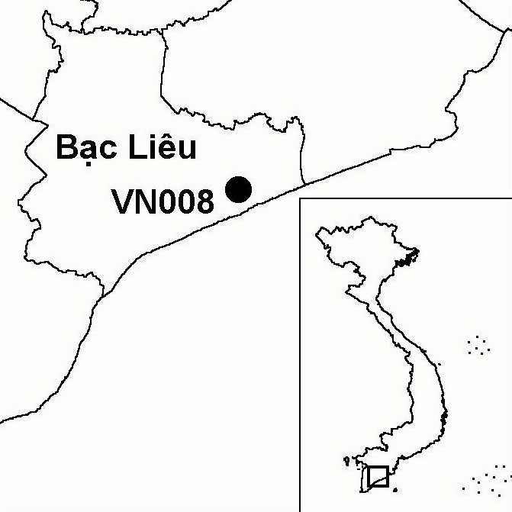
Province(s): Bac Lieu
PA Status: Nature Reserve

Latitude: 9º15'N
Longitude: 105º43'E
Area: 127 ha
Altitude Range: 0-2 m asl

EBA / SA:

None
Priority Landscape:
None

General Description

The IBA comprises the last remnant of an elevated mangrove forest that once covered the coastline of Bac Lieu province. During the 1970s, after most of the mangrove that had survived the Second Indochina War intact was converted to agriculture, a 30 ha fragment was designated as a bird sanctuary by the local authorities and later expanded to 127 ha. In terms of area, Bac Lieu is now the largest bird sanctuary within the Mekong Delta¹. The vegetation at the site is dominated by the mangrove Lumnitzera racemosa and the palm species Phoenix paludosa². Other habitats present include Thespesia populnea and Acacia auriculiformis plantations and small areas of seasonally inundated grassland². The site is surrounded by agricultural land.

Bird Fauna: Key Features

Bac Lieu IBA supports one of the most important colonies of breeding waterbirds in the Mekong Delta¹. The site supports significant numbers of Little Cormorant Phalacrocorax niger, Black-crowned Night Heron Nycticorax nycticorax and Glossy Ibis Plegadis falcinellus¹. Of greatest importance, however, is the population of Indian Cormorant P. fuscicollis, which accounts for over 3% of the global population of this species¹. In addition, two globally near-threatened species occur at the site: Black-headed Ibis Threskiornis melanocephalus and Oriental Darter Anhinga melanogaster¹.

Species | IBA  Criteria | Global Threat Status | Other  IBAs | Notes
Oriental Darter  Anhinga melanogaster | A1 | NT | 9 | A single individual was recorded in August 1999¹.
Black-headed Ibis  Threskiornis melanocephalus | A1 | NT | 8 | Four juveniles were recorded in August 1999¹.
Indian Cormorant  Phalacrocorax fuscicollis | A4i |  | 0 | A count of 930 birds was made in August 1999¹.

Biome Restricted Species: The site does not qualify under criterion A3. See Appendix 4 for details.

Secondary Criteria

The site does not qualify under any secondary criterion.

Threats to Biodiversity

Bac Lieu IBA is situated in an area of high human population density, and many of the threats at the site derive from the local population. Hunting and poisoning of birds, together with the collection of eggs and fishing still occur on a huge scale at the site, despite its protected status. As a result of over-exploitation, the number of the birds at the site was estimated to have declined by approximately 90% between 1980 and 1992². Another threat is the spread of unsustainable aquaculture within the buffer zone. Over 300 households are currently leasing land in the 258 ha buffer zone for aquaculture, and the widespread practice of intensive methods is resulting in a loss of key habitat for waterbirds. One potential threat to the site is the development of tourism, as the site is located close to Bac Lieu provincial town and already attracts high numbers of visitors².
Threat | Severity
Agricultural intensification / expansion | ●
Aquaculture / fisheries | ● ● ●
Disturbance to birds | ● ●
Hunting | ● ● ●
Recreation and tourism | ● ●

Conservation Actions

- An investment plan for Bac Lieu Bird Sanctuary was approved by the provincial people's committee in 1997².

Recommendations

- Effective measures to control bird poaching and disturbance to bird populations at the site should be introduced.
- There should be no further expansion of aquacultural ponds within the buffer zone of the site, and sustainable, extensive aquacultural methods should be introduced to existing ponds.
- No tourism infrastructure should be constructed within the boundary of the site.
- Management actions to reduce human pressures on the site should include conservation awareness raising activities and promotion of alternative sources of income for the local community².

References

1. Buckton, S. T., Nguyen Cu, Nguyen Duc Tu and Ha Quy Quynh (1999) The conservation of key wetland sites in the Mekong Delta. Hanoi: Birdlife International Vietnam Programme.
2. Birdlife International and the Forest Inventory and Planning Institute (2001) Sourcebook of existing and proposed protected areas in Vietnam. Hanoi: BirdLife International Vietnam Programme and the Forest Inventory and Planning Institute.

