Bach Ma Criteria: A1, A2 & A3

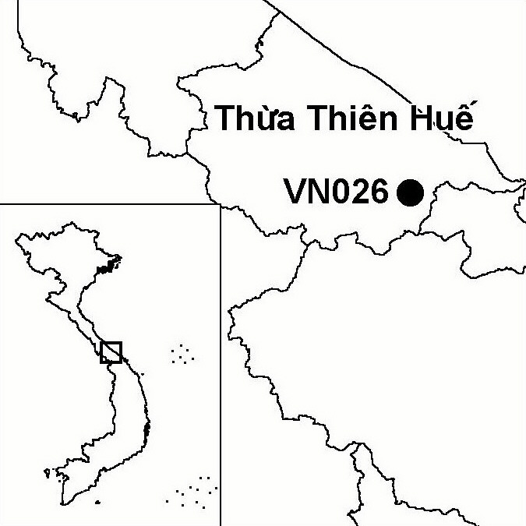
Province(s): Thua Thien Hue
PA Status: National Park

Latitude: 16º11'N
Longitude: 107º48'E
Area: 22,031 ha
Altitude Range: 20-1,448 m asl

EBA / SA:

Annamese Lowlands EBA
Priority Landscape:
CA1 - Central Annamites

General Description

The IBA comprises Bach Ma National Park, which is situated at the southern extent of the Annamese lowlands. The IBA is situated on a mountain ridge that runs between the Annamite mountains and the coast at the Hai Van pass. Consequently, the IBA has a mountainous topography and experiences some of the highest levels of rainfall in Vietnam. The IBA supports a range of habitat types, including lowland evergreen forest below 900 m asl, and montane evergreen forest above this elevation. At lower elevations, the natural forest has been extensively cleared and replaced by scrub and grassland. In the south of the IBA is the valley of the Ta Trach river¹.

Bird Fauna: Key Features

Bach Ma IBA lies at the southern extent of the Annamese Lowlands Endemic Bird Area (EBA), and five of the nine restricted-range species that define this EBA have been recorded at the site. Most notable is a recent record of Edwards's Pheasant Lophura edwardsi from near the IBA. This globally endangered species, endemic to central Vietnam, is known historically from Bach Ma². However, extensive loss of forest at low elevations means that it is unlikely that the site continues to support a significant population of this species, although neighbouring sites may. In addition to Edwards's Pheasant, Bach Ma IBA supports three other galliform taxa endemic to central Vietnam: Annam Partridge Arborophila merlini, and subspecies of Silver Pheasant L. nycthemera beli and Rufous-throated Partridge A. rufogularis guttata. Bach Ma IBA is also of importance for the conservation of Crested Argus Rheinardia ocellata, a globally vulnerable species, which occurs at the site in high densities.

Species | IBA  Criteria | Global Threat Status | Other  IBAs | Notes
†Edwards's Pheasant  Lophura edwardsi | A1, A2 | EN | 2 | In May 1998, a single individual was captured at 300 m asl in regenerating forest, 1 km to the north-east of the buffer zone of the national park². Given the small remaining area of suitable habitat, it is unlikely that the IBA regularly supports a significant population of this species.
Crested Argus  Rheinardia ocellata | A1, A2 | VU | 15 | During January and February 1990, at least 75 birds were heard and a single male was seen³. At least 21 birds were heard during April and May 1991 (Robson et al. 1993b). The most recent documented record of this species at Bach Ma was made in March 1999⁴.
†Green Peafowl  Pavo muticus | A1, A3 | VU | 8 | A single male was recorded just outside the IBA in January 1990, and two or three females were reported to be present by local hunters³. This is the most recent record of this species, which may possibly have already been extirpated from the site⁴.
Siamese Fireback  Lophura diardi | A1, A3 | NT | 13 | The species has been recorded in lowland and hill evergreen forest at the site⁵.
Red-collared Woodpecker  Picus rabieri | A1, A3 | NT | 11 | Two birds were observed in January 1990³.
Brown Hornbill  Anorrhinus tickelli | A1, A3 | NT | 16 | This species was recorded at the site between January and February 1990³.
†Blyth's Kingfisher  Alcedo hercules | A1, A3 | NT | 8 | A single bird was observed to the south of the IBA in April 1991⁶. It is not clear whether the site regularly supports a significant population of this species.
Grey-headed Fish Eagle  Ichthyophaga ichthyaetus | A1 | NT | 8 | One individual was recorded in the south of the IBA in April 1991⁶.
Short-tailed Scimitar Babbler  Jabouilleia danjoui | A1, A2 | NT | 17 | At least two birds were seen, and another was heard, at c.700 m asl in February 1990³.
Annam Partridge  Arborophila merlini | A2 |  | 4 | The species was found to be common during a survey in January and February 1990³.
Grey-faced Tit Babbler  Macronous kelleyi | A2 |  | 12 | The species was found to be common during a survey in January and February 1990³.

Notes: † = not confirmed to regularly occur in significant numbers.

Biome Restricted Species: The site qualifies under criterion A3 because it supports 17 species restricted to the Indochinese Tropical Moist Forests (Biome 09). See Appendix 4 for details.

Secondary Criteria

Species Status Species Status
[Pygmy Loris Nyticebus pygmaeus]⁷ VU [Chinese Stripe-necked Turtle Ocadia sinensis]⁷ EN
[Rhesus Macaque Macaca mulatta]⁷ NT [Wattle-necked Softshell Turtle Palea steindachneri]⁷ EN
[Long-tailed Macaque Macaca fascicularis]⁷ NT Pinus wangii^{7,8} EN
[Stump-tailed Macaque Macaca arctoides]⁷ VU [Pinus merkusii]⁷ VU
Red-shanked Douc Pygathrix nemaeus nemaeus^{7,9} EN Fokienia hodginsii^{7,8} NT
White-cheeked / Buff-cheeked Gibbon DD/VU Podocarpus neriifolius^{7,8} DD
Nomascus leucogenys/ gabriellae^{7,9} [Cephalotaxus mannii]⁷ VU
[Big-headed Turtle Platysternon megacephalum]⁷ EN [Southern Serow Naemorhedus sumatraensis]⁷ VU
[Indochinese Box Turtle Cuora galbinifrons]⁷ CR [Saola Pseudoryx nghetinhensis]⁷ EN

Notes: [ ] = unconfirmed record.

Threats to Biodiversity

The biggest threat to biodiversity at Bach Ma IBA is habitat loss, particularly the loss of lowland evergreen forest, which is the preferred habitat of a number of key species. In fact, Edwards's Pheasant may have already become extinct due to loss of this habitat type. The main causes of habitat loss at the site are wartime spraying of defoliants, forest fires, past commercial logging activities and subsequent illegal timber extraction¹. Over 60,000 people live in the buffer zone of the national park, and NTFP collection is a major source of income for these people. Unsustainable exploitation has resulted in supplies of certain NTFPs becoming exhausted near villages¹.
Threat | Severity
Fire | ● ●
Infrastructure development | ●
Recreation / tourism | ●
Selective logging / cutting | ● ●
Unsustainable exploitation of NTFPs | ● ●

Conservation Actions

- Bach Ma was decreed as a national park by the government of Vietnam in 1986 and a management board was established in 1987¹.
- Between 1995 and 1997, the WWF Indochina Programme implemented a European Commission-funded project entitled Participatory Development of Bach Ma National Park¹.
- With funding from the Dutch government, Thua Thien Hue Provincial Department of Agriculture and Rural Development recently initiated a four-year project entitled Strengthening the Forestry Management Capacity of Thua Thien Hue Province, which aims to strengthen management of the buffer zone of the national park¹.
- Bach Ma will form part of a future medium-sized GEF project, currently being developed by the WWF Indochina Programme, which aims to create a "green corridor" in southern Thua Thien Hue province¹.

Recommendations

- The biodiveristy value of contiguous forest areas should be evaluated and, where appropriate, these should be incorporated within the national park. Priority should be given to areas of lowland evergreen forest, which is a potentially suitable habitat for Edwards's Pheasant and other endemic galliforms.
- Continued efforts should be made to reduce unsustainable exploitation of forest products, through an integrated programme of activities aimed at reducing local people's dependency on natural resources and strengthening enforcement of forest management regulations.

References

1. BirdLife International and the Forest Inventory and Planning Institute (2001) Sourcebook of existing and proposed protected areas in Vietnam. Hanoi: BirdLife International Vietnam Programme and the Forest Inventory and Planning Institute.
2. Eames, J. C. and Tordoff, A. W. (in prep.) Recent records and a conservation status review of some threatened and near-threatened bird species in Vietnam.
3. Robson, C. R., Eames, J. C., Nguyen Cu and Truong Van La (1993a) Further records of birds from Vietnam. Forktail 8: 25-52.
4. Birdlife International (2001) Threatened birds of Asia: the Birdlife International Red Data Book. Cambridge, UK: Birdlife International.
5. Eve, R. (1996) Birdlist of Bach Ma National Park. Hue: EC/WWF Bach Ma National Park Project.
6. Robson, C. R., Eames, J. C., Nguyen Cu and Truong Van La (1993b) Birds recorded during the third BirdLife/Forest Birds Working Group Expedition in Vietnam. Forktail 9: 89-119.
7. Anon. (1990) [Investment plan for Bach Ma-Hai Van National Park.] Hanoi: Forest Inventory and Planning Institute. (In Vietnamese).
8. Nguyen Tien Hiep and Vidal, J. E. (1996) Flore du Cambodge, du Laos et du Vietnam, volume 28: Gymnospermae. Paris: Museum National d'Histoire Naturelle. (In French.)
9. Eames, J. C., and Robson, C. R. (1993) Threatened primates in southern Vietnam. Oryx 27: 146-154.

Annam Partridge Arborophila merlini

