Ba Tri Criteria: A1 & A4i

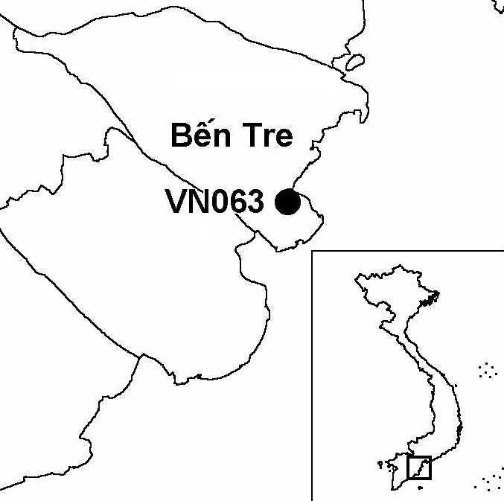
Province(s): Ben Tre
PA Status: None

Latitude: 10º01'N
Longitude: 106º40'E
Area: 6,000 ha
Altitude Range: 0-2 m asl

EBA / SA:

None
Priority Landscape:
None

General Description

The IBA is located in the Mekong Delta and comprises the coastal zone of Ba Tri district. At the north of the IBA is the Bai Lai estuary, the north-eastern side of which is included in Binh Dai IBA. The Bai Lai estuary contains significant areas of sandflats and shallows, backed by sand ridges and recently established aquacultural ponds, in what were formerly extensive areas of unenclosed mangrove. The IBA also includes the mouth of the Con Nhan river, which supports a significant high-tide roost of shorebirds¹. The IBA is bounded to the south-west by the Ham Luong estuary.

Bird Fauna: Key Features

Although Ba Tri IBA has only been the focus of two brief surveys, the findings indicate that the site is of high importance for migratory waterbirds. During December 2000, over 3,000 shorebirds were counted at the IBA, including over 1% of the Asian biogeographic population of Greater Sand Plover Charadrius leschenaultii. In addition, the IBA supports four globally threatened and near-threatened species, including Malaysian Plover C. peronii, a species known from only one other IBA in Vietnam¹.

Species | IBA  Criteria | Global Threat Status | Other  IBAs | Notes
Spoon-billed Sandpiper  Eurynorhynchus pygmaeus | A1 | VU | 3 | Up to five individuals were observed at the site in December 2000¹.
Chinese Egret  Egretta eulophotes | A1 | VU | 6 | Two individuals were recorded in April 2000 and three birds were recorded in December 2000¹.
Malaysian Plover  Charadrius peronii | A1 | NT | 1 | Thirteen individuals were recorded in intertidal habitats in December 2000¹.
Painted Stork  Mycteria leucocephala | A1 | NT | 10 | Nine individuals were observed in mangrove areas in the Bai Lai river mouth in December 2000¹.
Greater Sand Plover  Charadrius leschenaulti | A4i |  | 1 | Counts of 140 and 1,425 individuals were made in April and December 2000 respectively¹.

Biome Restricted Species: The site does not qualify under criterion A3. See Appendix 4 for details.

Secondary Criteria

The site does not qualify under any secondary criterion.

Threats to Biodiversity

The major threats to biodiversity at the site include hunting, disturbance to birds, unsustainable exploitation of marine products and unsustainable aquacultural development. Hunting with mist nets reportedly takes place between December and March each year. Areas of mangrove are being enclosed within aquacultural ponds.
Threat | Severity
Aquaculture / fisheries | ● ●
Disturbance to birds | ● ●
Hunting | ● ● ●

In addition, the large numbers of people harvesting invertebrates on the intertidal flats threaten the food supply of a number of migratory birds, as well as cause disturbance¹.

Conservation Actions

None to date.

Recommendations

- Ba Tri should be decreed as a protected area, and nominated under the East Asian-Australasian Shorebird Network.
- Ba Tri meets the criteria for designation as a site of international importance for wetland conservation under the Ramsar Convention, and should, therefore, be designated as a Ramsar site.
- A programme of conservation awareness activities should be implemented to increase understanding of the biodiversity and economic values of the IBA, and promote sustainable natural resource use.
- Effective controls on hunting should be introduced at the IBA, and should include intensive site patrols during the main bird migration periods¹.
- Further expansion of intensive aquaculture at the IBA should be prohibited.
- Further research is required to assess the sustainability of current levels of harvesting in fisheries and intertidal areas, and to determine whether these activities are detrimental to the bird fauna of the site¹.

References

1. Moores, N. and Nguyen Phuc Bao Hoa (2001) Vietnam Mekong shorebird site survey 2000. Unpublished report to Wetlands International Asia-Pacific and Can Tho University.

Chinese Egret Egretta eulophotes

