Ban Thi-Xuan Lac Criteria: A1, A2, A3 & A4i

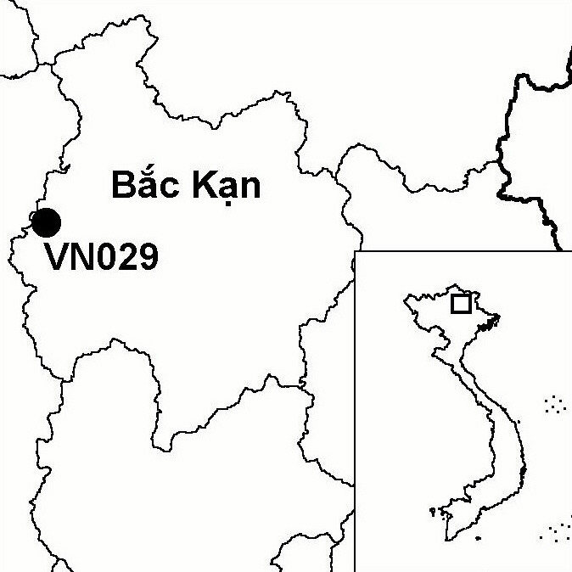
Province(s): Bac Kan
PA Status: None

Latitude: 22º18'N
Longitude: 105º31'E
Area: 2,200 ha
Altitude Range: 650-1,159 m asl

EBA / SA:

South-east Chinese Mountains EBA
Priority Landscape:
None

General Description

Ban Thi-Xuan Lac (BTXL) IBA is situated within the Na Hang/Ba Be Forest Complex in northern Vietnam. The topography of the IBA is characterised by limestone karst formations, interspersed with flat valleys containing fertile soil suitable for agriculture. As a result, the primary vegetation has been almost totally cleared from the flat valleys. However, the steep limestone karst slopes, which are unsuitable for agriculture, still support extensive areas of closed canopy forest¹. To the west, BTXL IBA is contiguous with Ban Bung IBA.

Bird Fauna: Key Features

BTXL is the only site in Vietnam from where there are confirmed records of White-eared Night Heron Gorsachius magnificus. These records reveal that BTXL should be included within the South-east China Mountains Endemic Bird Area (EBA). To date, however, there is no evidence to indicate that any of the other four restricted-range species that occur in this EBA (White-necklaced Partridge Arborophila gingica, Cabot's Tragopan Tragopan caboti, Elliot's Pheasant Syrmaticus ellioti and Brown-chested Jungle Flycatcher Rhinomyias brunneata) also occur in Vietnam¹. In addition to White-eared Night Heron, the IBA also supports a number of biome-restricted species that are known from few other sites in Vietnam, these include Eared Pitta Pitta phayrei, Collared Treepie Dendrocitta frontalis, Purple Cochoa Cochoa purpurea, Limestone Wren Babbler Napothera crispifrons and Greater Rufous-headed Parrotbill Paradoxornis ruficeps.

Species | IBA  Criteria | Global Threat Status | Other  IBAs | Notes
White-eared Night Heron  Gorsachius magnificus | A1, A2, A4i | EN | 0 | During April and May 2001, single birds, probably the same individual, were observed on two occasions roosting in a tall tree next to a stream in an area of limestone karst¹.

Biome Restricted Species: The site qualifies under criterion A3 because it supports 29 species restricted to the Sino-Himalayan Subtropical Forests (Biome 08) and 14 species restricted to the Indochinese Tropical Moist Forests (Biome 09). See Appendix 4 for details.

Secondary Criteria

Species Status Species Status
[Northern Slow Loris Nycticebus bengalensis]¹ DD [Big-headed Turtle Platysternon megacephalum]¹ EN
[Rhesus Macaque Macaca mulatta]¹ NT Black-breasted Leaf Turtle Geoemyda spengleri¹ EN
[Stump-tailed Macaque Macaca arctoides]¹ VU [Keeled Box Turtle Pyxidea mouhotii]¹ EN
[Francois's Langur [Amenotaxus argotaenia var. argotaenia]¹ VU
Trachypithecus francoisi francoisi]¹ VU [Southern Serow Naemorhedus sumatraensis]¹ VU

Notes: [ ] = unconfirmed record.

Threats to Biodiversity

Currently, the major threats to biodiversity at BTXL are clearance of forest for agriculture, hunting, over-exploitation of NTFPs, timber extraction, and isolation from nearby forest areas. Clearance of forest for agriculture, is a potential threat if there is an increase in the human population in surrounding areas in the future. However, the potential impact of this threat is limited by the unsuitability of the limestone karst terrain for agriculture. A more serious threat is habitat degradation as a result of over-exploitation of timber and NTFPs, which is occurring at relatively high levels in response to commercial demand. In addition, wildlife populations in the IBA are under intense pressure from hunting, which is taking place both for domestic consumption and to supply the wildlife trade. Finally, isolation from nearby forest areas as a result of clearance of intervening forest areas is a potential threat¹.
Threat | Severity
Agricultural intensification / expansion | ●
Hunting | ● ● ●
Selective logging / cutting | ● ● ●
Unsustainable exploitation of NTFPs | ● ●

Conservation Actions

- None to date.

Recommendations

- BTXL should be afforded protected area status, either as part of Ba Be National Park or Na Hang proposed nature reserve, or as a separate nature reserve.
- Forest protection activities should be initiated at the IBA to reduce current levels of forest clearance, wildlife hunting and over-exploitation of forest products at the site. Particular attention should be given to forested streams and rivers, which are the key habitats for White-eared Night Heron.
- Further studies should be conducted to assess the status and distribution of White-eared Night Heron at the site.

References

1. Le Trong Trai, Eames, J. C., Kuznetsov, A. N., Nguyen Van Sang, Bui Xuan Puong and Monastyrskii, A. L. (2001) A biodiversity survey of the Dong Phuc, Ban Thi-Xuan Lac and Sinh Long areas, Tuyen Quang and Bac Kan provinces, Vietnam. Unpublished report to the Vietnam PARC Project, Na Hang/Ba Be Component.

White-eared Night Heron Gorsachius magnificus

