Can Gio Criteria: A1

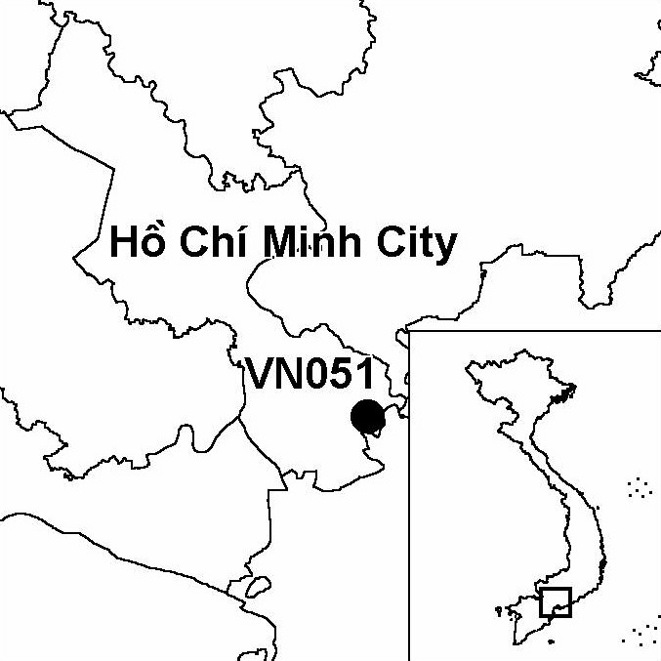
Province(s): Ho Chi Minh City
PA Status: Man and the Biosphere Reserve

Latitude: 10º31'N
Longitude: 106º54'E
Area: 75,740 ha
Altitude Range: 0-4 m asl

EBA / SA:

None
Priority Landscape:
None

General Description

The IBA comprises Can Gio Man and the Biosphere Reserve, which is situated on the coastline of southern Vietnam, at the point where the Dong Nai, Vam Co and Sai Gon rivers discharge into the sea. Sediment deposited by these rivers has formed a dynamic complex of intertidal flats, which, prior to the Second Indochina War, supported extensive areas of natural mangrove forest. However, most of the natural mangrove was destroyed by wartime spraying of defoliants, and the main habitat types at the site are now plantation mangrove and naturally recolonising mangrove. In recent years, some areas of mangrove have been enclosed within aquacultural ponds. In addition, there are significant areas of intertidal mudflats and sandbanks at the IBA¹.

Bird Fauna: Key Features

While dominant habitat type at Can Gio IBA, plantation mangrove, is of relatively low importance for key bird species, the intertidal mudflats and sandbanks at the IBA are important habitats for migratory waterbirds. Several globally threatened and near-threatened waterbird species have been recorded at the IBA, including Spotted Greenshank Tringa guttifer, Asian Dowitcher Limnodromus semipalmatus, Spot-billed Pelican Pelecanus philippensis and Painted Stork Mycteria leucocephala. In addition, the globally endangered Black-faced Spoonbill Platalea minor has been recorded at the IBA, although it is not believed to regularly occur in significant numbers².

Species | IBA  Criteria | Global Threat Status | Other  IBAs | Notes
Spotted Greenshank  Tringa guttifer | A1 | EN | 3 | A single bird was observed in July 1996¹.
†Black-faced Spoonbill  Platalea minor | A1 | EN | 8 | A single adult was observed in March 1996¹. The site probably does not regularly support a significant population of this species.
Spot-billed Pelican  Pelecanus philippensis | A1 | VU | 6 | Five birds were observed in September 1993 and six were observed in July 1996¹.
Asian Dowitcher  Limnodromus semipalmatus | A1 | NT | 5 | Eight birds were observed in September 1993, 89 were observed in July 1996 and 2 were observed in September 2000¹.
Painted Stork  Mycteria leucocephala | A1 | NT | 10 | This species has been observed on a number of occasions, including 20 birds in September 1993, 22 in December 1993, 169 in July 1996 and 37 in September 2000¹.

Notes: † = not confirmed to regularly occur in significant numbers.

Biome Restricted Species: The site does not qualify under criterion A3. See Appendix 4 for details.

Secondary Criteria

Species Status
Long-tailed Macaque Macaca fascicularis¹ NT

Threats to Biodiversity

While the human population in and around Can Gio IBA is relatively low, it is the major source of threats to biodiversity. The major threats are cutting mangrove for timber and firewood, and unsustainable aquaculture development, which is resulting in the enclosure of mangrove within aquacultural ponds. Other threats include unsustainable fishing techniques, and pollution, in the form of oil spills and sewage discharge from Ho Chi Minh City¹. Although the scale and impacts have not been assessed, afforestation of intertidal flats with mangrove is presumably also a threat, as it threatens to destroy the key habitat for migratory waterbird species.
Threat | Severity
Afforestation | ●
Aquaculture / fisheries | ● ●
Industrial / urban development | ●
Recreation / tourism | ●
Selective logging / cutting | ● ●

Conservation Actions

- A number of organisations have funded projects to research or support mangrove rehabilitation activities at Can Gio including, Action for Mangrove Reforestation Japan (ACTMANG), the European Union, the MacArthur Foundation, Oxfam America and UNESCO/UNDP¹.

Recommendations

- There should be no further mangrove afforestation on intertidal mudflats or enclosure of mangrove within aquacultural ponds.
- Enforcement of regulations prohibiting unsustainable exploitation of mangrove and destructive fishing techniques should be strengthened.

References

1. BirdLife International and the Forest Inventory and Planning Institute (2001) Sourcebook of existing and proposed protected areas in Vietnam. Hanoi: BirdLife International Vietnam Programme and the Forest Inventory and Planning Institute.
2. Eames, J. C. and Tordoff, A. W. (in prep.) Recent records and a conservation status review of some threatened and near-threatened bird species in Vietnam.
3. Anon. (1998) Draft biosphere reserve nomination form: Can Gio Mangrove Biosphere Reserve. Draft submission to UNESCO.

Spot-billed Pelican Pelecanus philippensis

