Chua Hang Criteria: A1 & A4i

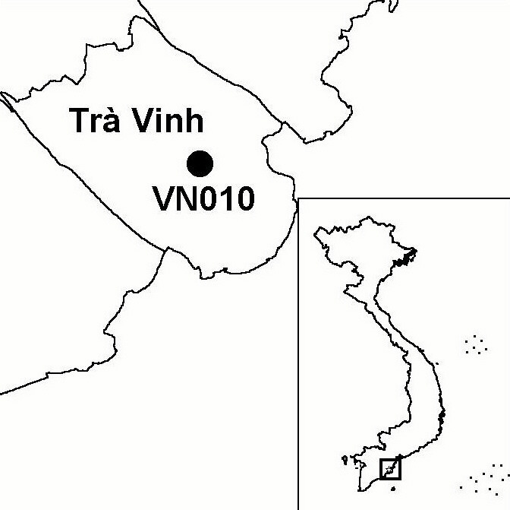
Province(s): Tra Vinh
PA Status: None

Latitude: 9º57'N
Longitude: 106º19'E
Area: 2 ha
Altitude Range: 0-2 m asl

EBA / SA:

None
Priority Landscape:
None

General Description

The IBA comprises Chua Hang Bird Sanctuary, which is located in the grounds of a pagoda, close to Tra Vinh town. The monks at the pagoda protect and manage the bird sanctuary, which comprises a grove of tall, broadleaf trees¹.

Bird Fauna: Key Features

The IBA supports large breeding colonies of several common waterbird species, including Little Egret Egretta garzetta, Cattle Egret Bubulcus ibis and, most significantly, Black-crowned Night Heron Nycticorax nycticorax. The site is also used by smaller numbers of Glossy Ibis Plegadis falcinellus and Oriental Darter Anhinga melanogaster but it is not known whether they breed or only roost at the site¹.

Species | IBA  Criteria | Global Threat Status | Other  IBAs | Notes
Oriental Darter  Anhinga melanogaster | A1 | NT | 9 | Five individuals were observed in July 1999¹.
Black-crowned Night Heron  Nycticorax nycticorax | A4i |  | 1 | A total of 1,200 individuals were observed in July 1999¹.

Biome Restricted Species: The site does not qualify under criterion A3. See Appendix 4 for details.

Secondary Criteria

The site does not qualify under any secondary criterion.

Threats to Biodiversity

Detailed information on threats to biodiversity at the IBA is not available. However, it is assumed that the bird populations are threatened by hunting and disturbance, at least potentially, particularly as they are concentrated in a very small area.
Threat | Severity
Disturbance to birds | ●
Hunting | ●

Conservation Actions

- The site is not under any formal protected area designation.

Recommendations

- Activities to raise awareness of the importance and fragility of the bird fauna of Chua Hang IBA should be conducted among the local community.

References

1. Buckton, S. T., Nguyen Cu, Nguyen Duc Tu and Ha Quy Quynh (1999) The conservation of key wetland sites in the Mekong Delta. Hanoi: Birdlife International Vietnam Programme.

