Cat Loc Criteria: A1, A2 & A3

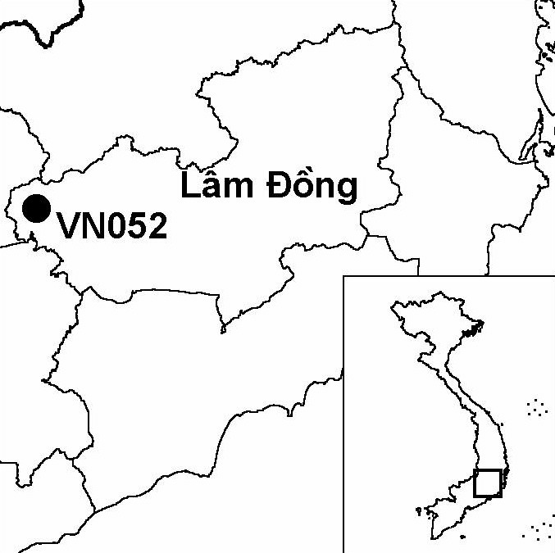
Province(s): Lam Dong
PA Status: National Park

Latitude: 11º40'N
Longitude: 107º23'E
Area: 30,635 ha
Altitude Range: 150-659 m asl

EBA / SA:

South Vietnamese Lowlands EBA
Priority Landscape:
SA 5 - Lowland Dong Nai Watershed

General Description

The IBA comprises the Cat Loc sector of Cat Tien National Park. Cat Loc is situated in the foothills of the Central Highlands, and is quite distinct from the other sectors of Cat Tien National Park in that the topography is not predominantly flat but dominated by undulating hills. The IBA supports a range of habitat types, including lowland semi-evergreen forest, lowland evergreen forest, bamboo forest, flooded forest and grassland. To the west, the IBA is bounded by the Dong Nai river, one of the major rivers in southern Vietnam. Cat Loc IBA is of international significance for mammal conservation, as it is the only site in Vietnam, and one of only two sites in the world, known to support a population of Lesser One-horned Rhinoceros Rhinoceros sondaicus¹. Cat Loc IBA is not contiguous with the other sectors of Cat Tien National Park, as it is separated by Cat Tien town, and associated human settlements and agricultural land. The IBA is, however, contiguous with significant areas of natural habitat to the east.

Bird Fauna: Key Features

The avifauna of Cat Loc IBA has a lot of similarities with that of Nam Cat Tien IBA. One major difference between the two sites is that Cat Loc does not support such extensive areas of wetland habitat as are found at Nam Cat Tien, and, therefore, Cat Loc supports fewer wetland-dependent species. Most notably, there are no records of White-winged Duck Cairina scutulata, White-shouldered Ibis Pseudibis davisoni, Lesser Adjutant Leptoptilos javanicus or Painted Stork Mycteria leucocephala from Cat Loc, although this may, in part, reflect differences in survey effort between the two IBAs. Regarding terrestrial forest species, Cat Loc supports a similar complement to Nam Cat Tien, most notably the three restricted-range species that define the South Vietnamese Lowlands Endemic Bird Area: Orange-necked Partridge Arborophila davidi, Germain's Peacock Pheasant Polyplectron germaini and Grey-faced Tit Babbler Macronous kelleyi. Of these species, Orange-necked Partridge is perhaps the most significant, as Cat Loc IBA is one of only three sites in the world known to support this globally endangered species.

Species | IBA  Criteria | Global Threat Status | Other  IBAs | Notes
Orange-necked Partridge  Arborophila davidi | A1, A2 | EN | 1 | Up to 27 birds were recorded between February and April 1997^{2,3}. The species was recorded on at least 52 occasions between January and May 2000 and between April and June 2001⁴.
Germain's Peacock Pheasant  Polyplectron germaini | A1, A2 | VU | 4 | A total of 12 birds were recorded in April 1993, including three groups of three birds⁵. Three males and one female were trapped in October 1993³. The species was recorded between February and April 1997². At least 17 individuals were recorded between January and May 2000 and between April and June 2001⁴. Finally, feathers belonging to this species were found in November 2001⁶.
Siamese Fireback  Lophura diardi | A1, A3 | NT | 13 | Feathers belonging to this species were found in September 1993⁵ and between November and December 2001⁶. The species was also recorded at the site between February and April 1997², between January and May 2000, and between April and June 2001⁴.
Great Hornbill  Buceros bicornis | A1 | NT | 13 | A single bird was recorded in December 2001⁶.
Oriental Darter  Anhinga melanogaster | A1 | NT | 9 | The species was recorded in 2000⁷.
[Asian Golden Weaver  Ploceus hypoxanthus] | A1 | NT | 4 | Several birds were observed among reeds in a small marsh outside of the IBA in April 1997⁵. While it is likely that the IBA may regularly support a significant population of this species, its occurrence within the IBA has not yet been confirmed.
Grey-faced Tit Babbler  Macronous kelleyi | A2 |  | 12 | The species was recorded on several occasions during October 1993 and April 1997⁵.

Notes: [ ] = unconfirmed record.

Biome Restricted Species: The site qualifies under criterion A3 because it supports 15 species restricted to the Indochinese Tropical Moist Forests (Biome 09) and seven species restricted to the Indo-Malayan Tropical Dry Zone (Biome 11). See Appendix 4 for details.

Secondary Criteria

Species Status Species Status
Buff-cheeked Gibbon Nomascus gabriellae⁸ VU Lesser One-horned Rhinoceros Rhinoceros sondaicus⁸ CR

Threats to Biodiversity

The major threats to biodiversity at Cat Loc IBA are conversion of forest into agriculture, hunting, and unsustainable exploitation of timber and NTFPs. Of these, clearance of forest for agriculture, principally cashew plantations, is perhaps the biggest threat, as it is resulting in fragmentation and loss of habitat. All these threats are compounded by the presence of several villages within the IBA, populated by members of the Kinh, Tay, Chau Ma and Stieng ethnic groups. However, there exist plans to resettle some of these people outside of the IBA in order to secure the integrity of the key area for Lesser One-horned Rhinoceros¹.
Threat | Severity
Agricultural intensification / expansion | ● ●
Construction of dykes / dams | ●
Hunting | ● ●
Selective logging / cutting | ●

Conservation Actions

- Lam Dong Provincial People's Committee approved an investment plan to establish a rhinoceros sanctuary at Cat Loc in 1992, and a management board was established in 1996¹.
- In 1998, Cat Loc Rhincoceros Sanctuary was incorporated within Cat Tien National Park, together with the Nam Cat Tien sector in Dong Nai province and the Tay Cat Tien sector in Binh Phuoc province¹.
- In 1998, WWF and the Ministry of Agriculture and Rural Development initiated a five-year project, entitled the Cat Tien National Park Conservation Project, with funding from the governments of the Netherlands and Vietnam¹. In 2002, this project was extended for a further two years.

Between 1999 and 2000, the U.S. Fish and Wildlife Service funded two smaller WWF-implemented projects at Cat Tien National Park, which comprised scientific studies and awareness raising activities related to Lesser One-horned Rhinoceros¹.

Recommendations

- Existing controls on hunting, extraction of forest products, and conversion of forest into agricultural land, particularly cashew plantations, should be maintained and strengthened.
- Providing suitable measures are implemented to mitigate negative impacts on the communities involved, all villages currently within the IBA should be resettled outside the boundaries of the national park.
- Existing environmental awareness activities in communities within and around the IBA should be continued.
- The feasibility of extending protected area status, or another appropriate land-use designation, to contiguous areas of natural habitat to the east of the IBA should be assessed.

References

1. BirdLife International and the Forest Inventory and Planning Institute (2001) Sourcebook of existing and proposed protected areas in Vietnam. Hanoi: BirdLife International Vietnam Programme and the Forest Inventory and Planning Institute.
2. Atkins, R. A. and Tentij, M. (1998) The Orange-necked Partridge Arborophila davidi and five other galliformes in two protected areas in southern Vietnam. Amsterdam: Institute of Systematics and Population Biology, University of Amsterdam.
3 Birdlife International (2001) Threatened birds of Asia: the Birdlife International Red Data Book. Cambridge, UK: Birdlife International.
4. Nguyen Tran Vy, Nguyen Hoang Hao, Le Van Tinh, Tran Dinh Hung and Nguyen Viet Su (2001) Pheasant survey in Cat Tien National Park, Vietnam, 2001. Cat Tien: WWF Cat Tien National Park Conservation Project.
5. Eames, J. C. and Tordoff, A. W. (in prep.) Recent records and a conservation status review of some threatened and near-threatened bird species in Vietnam.
6. Vietnam-Russia Tropical Centre (2002) Results of complex zoological-botanical expedition in Cat Loc. Cat Tien: WWF Cat Tien National Park Conservation Project.
7. Nguyen Tran Vy, Nguyen Hoang Hao, Le Van Tinh and Tran Dinh Hung (2000b) [Distribution of seven pheasant species in Cat Tien National Park, Vietnam.] Cat Tien: Cat Tien National Park Management Board. (In Vietnamese.)
8. Ling, S. (2000) A survey of wild cattle and other mammals, Cat Tien National Park, Vietnam. Cat Tien: WWF Cat Tien National Park Conservation Project.

Orange-necked Partridge Arborophila davidi

