Ca Mau Criteria: A1 & A4i

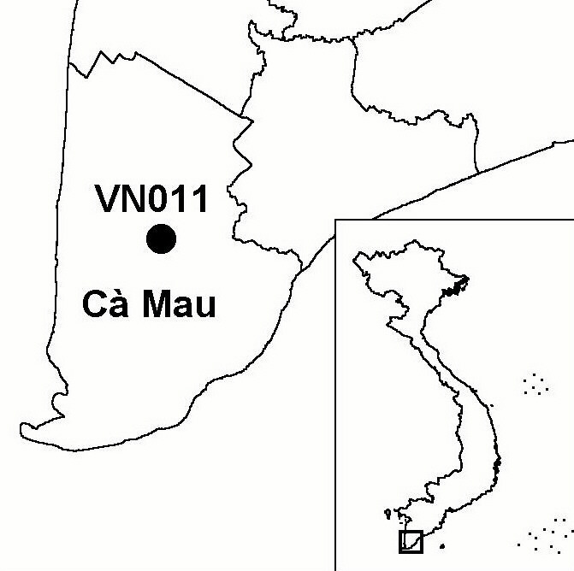
Province(s): Ca Mau
PA Status: None

Latitude: 9º06'N
Longitude: 105º05'E
Area: 2 ha
Altitude Range: 0-2 m asl

EBA / SA:

None
Priority Landscape:
None

General Description

The IBA comprises Ca Mau Bird Sanctuary, which is located within a 'culture park' in the suburbs of Ca Mau town. The bird sanctuary was established and is managed by the town people's committee. The vegetation at the site is a mixture of mangrove and bamboo, which supports breeding colonies of a number of common waterbirds¹.

Bird Fauna: Key Features

During a survey in August 1999, maximum counts of 1,500 Little Egrets Egretta garzetta, 1,000 Cattle Egrets Bubulcus ibis and 150 Black-crowned Night Herons Nycticorax nycticorax were made¹. Of most significance was the count of 1,500 Little Cormorants Phalacrocorax niger, which represents over 1% of the biogeographic population of this species. However, anecdotal reports indicate that bird numbers at the IBA have declined severely in recent years.

Species | IBA  Criteria | Global Threat Status | Other  IBAs | Notes
Oriental Darter  Anhinga melanogaster | A1 | NT | 9 | A single individual was recorded in August 1999¹.
Little Cormorant  Phalacrocorax niger | A4i |  | 1 | A total of 1,500 individuals were recorded in August 1999¹.

Biome Restricted Species: The site does not qualify under criterion A3. See Appendix 4 for details.

Secondary Criteria

The site does not qualify under any secondary criterion.

Threats to Biodiversity

The breeding colonies at Ca Mau IBA are under severe threat, as a result of the site's location within an urban area. Conversion of adjacent areas of natural and semi-natural habitat have led to hydrological changes at the site, with the result that bird numbers have, reportedly, declined significantly in recent years. Another threat is disturbance caused by the large numbers of visitors to the culture park in which the bird sanctuary is situated.
Threat | Severity
Disturbance to birds | ● ●
Industrial / urban development | ● ● ●
Recreation / tourism | ● ●

Conservation Actions

- The site is not under any formal protected area designation.

Recommendations

- The IBA should be incorporated into local planning processes for land-use and development activities, in order that potentially negative impacts on the site can be mitigated.
- The activities of visitors to the site should be carefully controlled, particularly during the breeding season, to minimise disturbance to breeding birds.
- Awareness raising activities should be implemented to promote understanding of the values and fragility of the IBA among the local community and visitors to the site.

References

1. Buckton, S. T., Nguyen Cu, Nguyen Duc Tu and Ha Quy Quynh (1999) The conservation of key wetland sites in the Mekong Delta. Hanoi: Birdlife International Vietnam Programme.

