Chu M'Lanh Criteria: A1 & A3

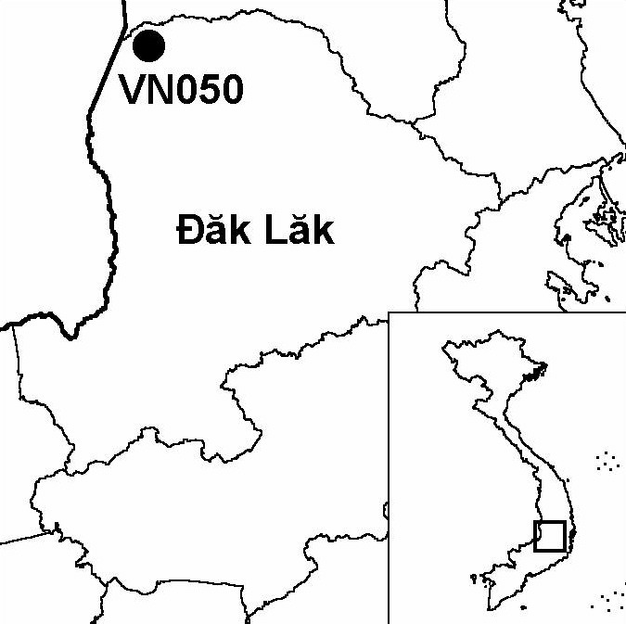
Province(s): Dak Lak
PA Status: National Park

Latitude: 13º7'N
Longitude: 107º43'E
Area: 54,563 ha
Altitude Range: 100-502 m asl

EBA / SA:

None
Priority Landscape:
DF4 - Eastern Plains Dry Forests

General Description

Situated in the Mekong basin, on the international border with Cambodia, the IBA is centred on a ridge of low hills, running east-west, to the north of the Srepok river. To the north of these hills, the terrain is relatively flat, around 200 m in elevation, and drained by the Dak Rue stream, a tributary of the Srepok river. The dominant vegetation type at Chu M'Lanh is deciduous forest, although the IBA also supports smaller areas of evergreen or semi-evergreen forest, mainly on hills and along watercourses, and patches of secondary scrub. The IBA was included within an extension to Yok Don National Park approved in 2001. To the west, Chu M'Lanh IBA is contiguous with Upper Srepok Catchment IBA in Cambodia, while, to the south, it is contiguous with Yok Don IBA. Chu M'Lanh IBA does not include the Srepok river, both banks of which are included within Yok Don IBA.

Bird Fauna: Key Features

The avifauna of Chu M'Lanh IBA is characteristic of the dry forests of central Indochina, and all five of the globally threatened and near-threatened bird species believed to regularly occur at the IBA in significant numbers are typical components of the dry forest ecosystem: Green Peafowl Pavo muticus, Lesser Adjutant Leptoptilos javanicus, White-rumped Vulture Gyps bengalensis, Red-headed Vulture Sarcogyps calvus and White-rumped Falcon Polihierax insignis. Green Peafowl and Lesser Adjutant are dependent upon water courses within the forest. White-rumped and Red-headed Vultures have both declined drastically in Vietnam in recent decades, and are now largely restricted to areas along the Cambodian border. Indeed, it is possible that Vietnam no longer supports a breeding population of either species¹. Neither species has been confirmed to breed at the IBA.

Species | IBA  Criteria | Global Threat Status | Other  IBAs | Notes
White-rumped Vulture  Gyps bengalensis | A1, A3 | CR | 1 | The species is believed to be a very rare resident and non-breeding visitor². Single birds were seen on four occasions during February 1998³.
Green Peafowl  Pavo muticus | A1, A3 | VU | 8 | Footprints of single birds were seen at several locations between June and July 1997⁴. During February 1998, at least 37 individuals were recorded at nine locations³.
†Sarus Crane  Grus antigone | A1 | VU | 4 | A fully grown immature was observed in a roadside pool in June 1997⁴. The species is probably a rare passage migrant through the site, and it is unlikely that the site regularly supports a significant population².
Lesser Adjutant  Leptoptilos javanicus | A1 | VU | 7 | A single bird was seen in June 1997⁴. The species was observed on several occasions during February 1998, including a group of 10 near Border Army Station Two³.
Red-headed Vulture  Sarcogyps calvus | A1, A3 | NT | 3 | The species is believed to be a very rare resident and non-breeding visitor². Two single birds and a pair were seen in February 1998³.
White-rumped Falcon  Polihierax insignis | A1, A3 | NT | 4 | The species is a scare resident². The species was recorded almost daily during a survey in June and July 1997⁴.

Notes: † = not confirmed to regularly occur in significant numbers.

Biome Restricted Species: The site qualifies under criterion A3 because it supports 19 species restricted to the Indo-Malayan Tropical Dry Zone (Biome 11). See Appendix 4 for details.

Secondary Criteria

Species Status Species Status
Northern Pigtail Macaque Macaca leonina⁴ VU Silver Langur Trachypithecus villosus⁴ DD
Rhesus/ Long-tailed Macaque Gaur Bos gaurus⁴ VU
Macaca mulatta / fascicularis⁴ NT Banteng Bos javanicus⁴ EN

Threats to Biodiversity

Prior to the extension of Yok Don National Park in 2001, Chu M'Lanh IBA was under state forest enterprise management, and areas of forest within the IBA were subjected to commercial logging until at least as recently as 1997⁴. While commercial logging may have resulted in temporary habitat disturbance and some degradation, the major on-going impacts on biodiversity are likely to be increased risk of fire, increased access to forest resources, and spontaneous in-migration into areas opened up by logging roads.

Currently, the biggest single threat to biodiversity at Chu M'Lanh is infrastructure development, particularly the planned construction of a road along the international border with Cambodia. The construction of this road might facilitate access to forest resources and act as a focus for human settlement within the IBA. The latter is of particular concern in the context of high levels of migration into and within Dak Lak province. However, the purpose of the road may only be for patrolling by the border army, and, providing that strict controls on entry into the border area are maintained, the impacts of this infrastructure development can be mitigated.
Threat | Severity
Agricultural intensification / expansion | ● ●
Commercial timber extraction | ●
Fire | ●
Forest grazing | ●
Hunting | ● ●
Infrastructure development | ● ●
Selective logging / cutting | ●

Conservation Actions

Chu M'Lanh IBA was included within an extension to Yok Don National Park approved in September 2001, and, subsequently, the IBA has been managed with the principal objective of biodiversity conservation².
- Yok Don National Park is currently the focus of a full-scale GEF project entitled Creating Protected Areas for Resource Conservation Using Landscape Ecology (PARC), which began implementation in 1999².

Recommendations

- Plans to construct a road to the west of the IBA, along the international border with Cambodia, are wholly incompatible with the objectives of biodiversity conservation and in direct contravention of the management regulations of Yok Don National Park, and should, therefore, be abandoned.
- All other planned infrastructure developments at the national park should be subjected to Environmental Impact Assessment, and appropriate mitigation measures should be implemented.
- Further human settlement within and immediately adjacent to the IBA should be strictly controlled.
- The conservation management planning and law enforcement capacity of national park staff should be strengthened².
- Mechanisms facilitating dialogue between different stakeholders at the IBA should be strengthened, in order to promote land-use and development planning compatible with maintenance of the integrity of the site.

References

1. Eames, J. C. and Tordoff, A. W. (in prep.) Recent records and a conservation status review of some threatened and near-threatened bird species in Vietnam.
2. Eames, J. C. and Nguyen Duc Tu. (2002) An interim biodiversity report for Yok Don National Park, Dak Lak province, Vietnam. Unpublished report to the Vietnam PARC Project, Yok Don Component.
3. Brickle, N. W., Nguyen Cu, Ha Quy Quynh, Nguyen Thai Tu Cuong and Hoang Van San (1998) The status and distribution of Green Peafowl Pavo muticus in Dak Lak province, Vietnam. Hanoi: BirdLife International Vietnam Programme.
4. Le Xuan Canh, Pham Trong Anh, Duckworth, J. W., Vu Ngoc Thanh and Lic Vuthy (1997) A survey of large mammals in Dak Lak province, Vietnam. Hanoi: WWF Indochina Programme and IUCN.

