Chu Prong Criteria: A1 & A3

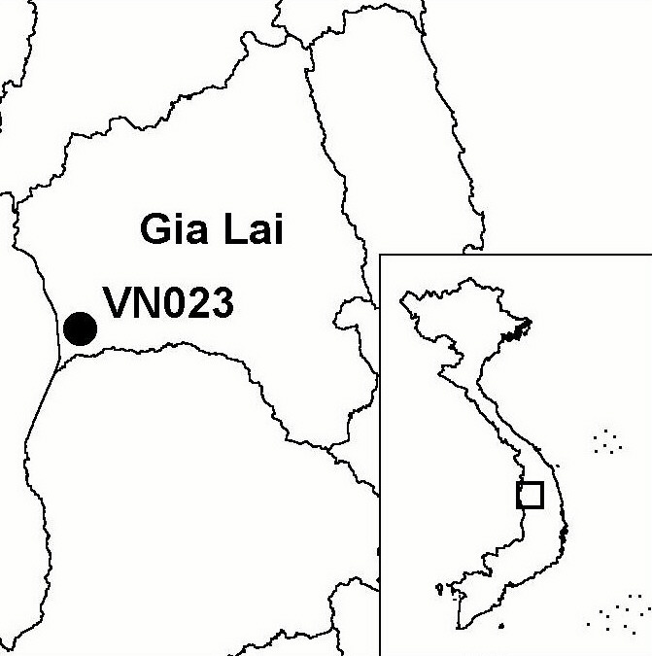
Province(s): Gia Lai
PA Status: None

Latitude: 13º28'N
Longitude: 107º43'E
Area: 50,104 ha
Altitude Range: 70-732 m asl

EBA / SA:

None
Priority Landscape:
DF4 - Eastern Plains Dry Forests

General Description

The IBA comprises Chu Prong proposed nature reserve, which is situated in the Central Highlands, on the international border with Cambodia. The topography of most of the IBA is relatively flat, with an average elevation of around 200 m asl, although there is an area of low mountains in the north-west. The IBA supports a mosaic of lowland deciduous forest, lowland semi-evergreen forest, evergreen riverine forest and seasonally inundated grassland. All forest areas within the IBA have been disturbed by human activities, including timber extraction, firewood collection, and wartime spraying of defoliants. In addition, significant areas of forest have been converted into agricultural land^{1,2}. Most people living in and around the IBA belong to the Gia Rai, Muong and Kinh ethnic groups². To the south, Chu Prong IBA borders Ya Lop IBA in Dac Lac province. The two IBAs lie on opposite banks of the Ya Lop river, one of the most extensively forested rivers in the Central Highlands.

Bird Fauna: Key Features

Chu Prong IBA is one of the few sites in Vietnam to support an intact mosaic of natural habitats characteristic of the dry forests of central Indochina. For this reason, the avifauna of Chu Prong shares many affinities with those of the dry forests of eastern and northern Cambodia and southern Laos. Typical components of the avifauna present at Chu Prong include Black-headed Woodpecker Picus erythropygius, White-rumped Falcon Polihierax insignis, Rufous-winged Buzzard Butastur liventer, White-browed Fantail Rhipidura aureola and Brown Prinia Prinia polychroa. Chu Prong IBA supports populations of a number of globally threatened and near-threatened species, many of which are associated with permanent watercourses, which are widespread at the IBA. These species include Green Peafowl Pavo muticus, Lesser Adjutant Leptoptilos javanicus and Grey-headed Fish Eagle Ichthyophaga ichthyaetus. In addition, Germain's Peacock Pheasant Polyplectron germaini, a restricted-range species, has been provisionally recorded at the IBA. If the occurrence of this species is confirmed, the IBA will qualify for inclusion within the South Vietnamese Lowlands Endemic Bird Area.

Species | IBA  Criteria | Global Threat Status | Other  IBAs | Notes
[Germain's Peacock Pheasant  Polyplectron germaini] | A1, A2 | VU | 5 | A bird, provisionally identified as this species, was heard calling in evergreen forest at 400 m asl in April 2000².
Green Peafowl  Pavo muticus | A1, A3 | VU | 8 | Single males were heard calling on at least three seperate occasions at three sites along the Ya Lop river, between February and April 2000².
[Spot-billed Pelican  Pelecanus philippensis] | A1 | VU | 7 | The species is provisionally recorded based on reports by local people².
Lesser Adjutant  Leptoptilos javanicus | A1 | VU | 7 | A single bird was observed feeding in grassland 4 km from the Ya Mo river between February and April 2000².
Great Hornbill  Buceros bicornis | A1 | NT | 13 | The species was recorded between February and April 2000².
Brown Hornbill  Anorrhinus tickelli | A1, A3 | NT | 16 | A single individual was observed along the Ya Lop river between February and April 2000².
Grey-headed Fish Eagle  Ichthyophaga ichthyaetus | A1 | NT | 8 | A pair were observed in flight between the Ya Lop and Ya Mo rivers in April 2000². The species was also separately recorded at ponds beside the Ya Lop river between February and April 2000².
White-rumped Falcon  Polihierax insignis | A1, A3 | NT | 4 | Single birds were observed on several occasions along the Ya Mo river in April 2000².

Notes: [ ] = unconfirmed record.

Biome Restricted Species: The site qualifies under criterion A3 because it supports 10 species restricted to the Indochinese Tropical Moist Forests (Biome 09) and 16 species restricted to the Indo-Malayan Tropical Dry Zone (Biome 11). See Appendix 4 for details.

Secondary Criteria

Species Status Species Status
Pygmy Loris Nycticebus pygmaeus² VU [Giant Asian Pond Turtle Heosemys grandis]² VU
Long-tailed Macaque Macaca fascicularis² NT Elongated Tortoise Indotestudo elongata² EN
[Stump-tailed Macaque Macaca arctoides]² VU [Asiatic Softshell Turtle Amyda cartilaginea]² VU
Black-shanked Douc Pygathrix nigripes² EN Brow-antlered Deer Cervus eldii² VU
Silver Langur Trachypithecus villosus² DD Gaur Bos gaurus² VU
[Buff-cheeked Gibbon Nomascus gabriellae]² VU Banteng Bos javanicus² EN
[Siamese Crocodile Crocodylus siamensis]² CR Southern Serow Naemorhedus sumtraensis² VU
[Asian Box Turtle Cuora amboinensis]² VU

Notes: [ ] = unconfirmed record.

Threats to Biodiversity

The human population density in and around the IBA is relatively low, as a result of which the pressure placed by local communities on natural resources is low relative to that in other areas in the Central Highlands. However, people from outside the area, including military personnel, visit the IBA in significant numbers to hunt and exploit forest products. As a result, hunting pressures on populations of many key mammal and bird species are no longer sustainable. An associated threat is deliberate burning of the forest by hunters^{1,2}.

Shifting cultivation is also taking place within the IBA, with the result that natural habitats are being fragmented. The rate of forest clearance is increasing as a result of population increase in the area, mainly due to the settlement of migrants from northern Vietnam^{1,2}. It is likely that the rate of forest clearance will increase still further in the future, with possibly irreversible impacts on the integrity of the IBA, as there exist plans to resettle 10,000 people displaced by the Song Da dam into Chu Prong district.
Threat | Severity
Agricultural intensification / expansion | ● ● ●
Fire | ● ●
Hunting | ● ●
Infrastructure development | ●
Selective logging / cutting | ● ●

Conservation Actions

- In 2001, a feasibility study for the establishment of a protected area at Chu Prong was conducted, and strongly recommended the establishment of a 50,104 ha nature reserve².

Recommendations

- Chu Prong should be decreed as a nature reserve by the government of Vietnam, and a management board should be established.
- Effective controls on hunting, timber extraction, clearance of forest for agriculture and forest fire should be introduced.
- An Environmental Impact Assessment should be carried out prior to the resettlement of people displaced by the Song Da dam into Chu Prong district, and appropriate mitigation measures should be introduced. These may include restrictions on resettlement within the proposed nature reserve and buffer zone.
- An environmental awareness campaign should be conduct among local communities and local authorities, in order to generate support for the conservation of the IBA and promote its incorporation into local land-use plans.

References

1. BirdLife International and the Forest Inventory and Planning Institute (2001) Sourcebook of existing and proposed protected areas in Vietnam. Hanoi: BirdLife International Vietnam Programme and the Forest Inventory and Planning Institute.
2. Tran Hieu Minh, Le Trong Trai, Le Van Cham and Nguyen Van Sang (2001) [A feasibility study for the establishment of Chu Prong Nature Reserve, Gia Lai province, Vietnam.] Hanoi: BirdLife International Vietnam Programme and the Forest Inventory and Planning Institute. (In Vietnamese.)

