Cuc Phuong Criteria: A1, A2 & A3

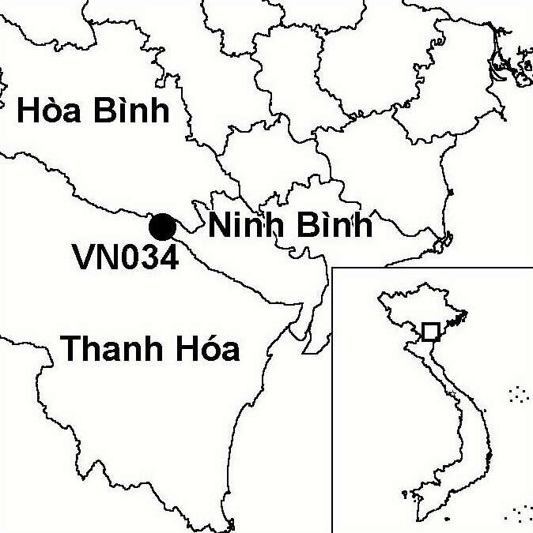
Province(s): Ninh Binh, Hoa Binh and
Thanh Hoa
PA Status: National Park

Latitude: 20º19'N
Longitude: 105º37'E
Area: 22,200 ha
Altitude Range: 50-648 m asl

EBA / SA:

Annamese Lowlands EBA
Priority Landscape:
NA 1 - Northern Indochina Limestone

General Description

The IBA comprises Cuc Phuong National Park, which is located in the Annamese lowlands. The topography of the IBA is dominated by a wide belt of limestone karst, which runs from north-west to south-east. This belt is bisected by a central valley, where the topography is flatter. The natural vegetation of the IBA is dominated by limestone forest, although this has been cleared around the edges of the IBA and replaced by secondary vegetation, mainly scrub. At the time of establishment of the national park, there were a number of ethnic minority villages within the boundaries, mainly along the central valley. Most of these villages have now been relocated into the buffer zone¹.

Bird Fauna: Key Features

Although Cuc Phuong IBA is situated within the Annamese Lowlands Endemic Bird Area (EBA), it only supports one of the nine restricted-range species found in this EBA: Short-tailed Scimitar Babbler Jabouilleia danjoui². This may be explained partly by the IBA's location at the northern extremity of the EBA, outside of the natural range of many of the restricted-range species. Another factor may be the high past and current hunting pressure at the IBA, which may have resulted in the extirpation of a number of species. Cuc Phuong IBA supports a number of globally near-threatened species, including Chestnut-necklaced Partridge Arborophila charltonii, Red-collared Woodpecker Picus rabieri and Brown Hornbill Anorrhinus tickelli. However, the densities of these species at the IBA appear lower than at certain other sites in the Annamese Lowlands EBA. Perhaps the greatest significance of Cuc Phuong IBA is the large number of biome-restricted species found at the site, including some that are found at few other sites in Vietnam, such as Eared Pitta Pitta phayrei, Black-breasted Thrush Turdus dissimilis and Limestone Wren Babbler Napothera crispifrons².

Species | IBA  Criteria | Global Threat Status | Other  IBAs | Notes
†Imperial Eagle  Aquila heliaca | A1 | VU | 2 | One bird was observed in late December 1999³. It is unlikely that the site regularly supports a significant population.
Chestnut-necklaced Partridge  Arborophila charltonii | A1 | NT | 7 | The species is an uncommon to fairly common resident, with numerous records since April 1988⁴.
Red-collared Woodpecker  Picus rabieri | A1, A3 | NT | 11 | One bird was seen at Cuc Phuong in April 1999⁵.
Brown Hornbill  Anorrhinus tickelli | A1, A3 | NT | 16 | The species is a scarce resident with occasional records of single birds and small groups since April 1988⁴.
Short-tailed Scimitar Babbler  Jabouilleia danjoui | A1, A2 | NT | 17 | A single individual was recorded in February 1995⁶.
Notes: † = not confirmed to regularly occur in significant numbers.

Biome Restricted Species: The site qualifies under criterion A3 because it supports 29 species restricted to the Sino-Himalayan Subtropical Forests (Biome 08) and 18 species restricted to the Indochinese Tropical Moist Forests (Biome 09). See Appendix 4 for details.

Secondary Criteria

Species Status Species Status
Delacour's Langur Trachypithecus delacouri¹ CR Keeled Box Turtle Pyxidea mouhotii⁷ EN

Threats to Biodiversity

Due to the limestone karst topography, the rate of conversion of forest to agriculture is currently very low. However, habitat degradation remains a major threat to biodiversity at Cuc Phuong IBA, due to unsustainable exploitation of timber and other forest products by local communities. The buffer zone of the national park is home to around 50,000 people, many of whom depend upon forest products, such as timber and firewood. As well as resulting in habitat degradation, unsustainable exploitation of forest products also directly threatens populations of species of high economic value, such as turtles. Besides direct exploitation of natural resources, another major threat to biodiversity at Cuc Phuong IBA is unsustainable tourism development. In recent years, Cuc Phuong has become a major destination for domestic tourists. Apart from the direct impacts of the large numbers of tourists, in the form of litter, excessive noise and collection of plants and animals, development of tourist infrastructure has had serious impacts on biodiversity. For example, artificial lakes and a swimming pool have been constructed inside the national park, resulting in forest clearance and altered hydrology¹.
Threat | Severity
Agricultural intensification / expansion | ●
Hunting | ● ●
Infrastructure development | ● ●
Recreation / tourism | ● ●
Selective logging / cutting | ●
Unsustainable exploitation of NTFPs | ● ●
The third major threat to biodiversity at Cuc Phuong IBA is the construction of National Highway 2, which will bisect western parts of the IBA. The construction of this road could facilitate further exploitation of forest products and human settlement inside the IBA. Indeed, initial construction surveys and preparation have already led to incidents of hunting by workers.

Conservation Actions

- Cuc Phuong was decreed as a protected area by the government of Vietnam in 1962¹.
- Cuc Phuong was upgraded to national park status in 1966, and a management board was established in the same year¹.
- During the late 1980s and early 1990s, seven villages were relocated from within the national park to the buffer zone.
- Between 1996 and 2002, Fauna and Flora International (FFI), in collaboration with the national park management board, implemented the Cuc Phuong Conservation Project, with the objective of supporting natural resource conservation within the national park¹.
- Frankfurt Zoological Society have established an endangered primate rescue centre at Cuc Phuong, which receives primates confiscated from the wildlife trade, and carries out captive breeding and veterinary research¹.
- The German Economic Development Programme (DED) is implementing a series of micro-interventions, comprising various alternative income generating activities, in the buffer zone of the national park¹.
- The University of Illinois is implementing a medicinal plant conservation project at Cuc Phuong, comprising several conservation, research and community development activities.
- A medium-sized GEF project focussing on the Cuc Phuong-Pu Luong limestone range has been developed by FFI and the Forest Protection Department (FPD) of the Ministry of Agriculture and Rural Development (MARD), and is currently awaiting implementation.

Recommendations

- Enforcement of protected area management regulations, particularly controls on hunting, timber extraction and NTFP collection, should be strengthened.
- Tourism should be developed in a sustainable manner in order that negative impacts on biodiversity are minimised and that biodiversity conservation remains the principal management objective of the national park. In particular, there should be no further development of tourism infrastructure within the core zone of the national park.
- The existing progamme of conservation awareness in the buffer zone of the national park should be maintained and strengthened.
- Small-scale community development initiatives should be implemented in the buffer zone of the national park, particularly in Yen Thuy and Lac Son districts, Hoa Binh province, in order to reduce dependence of local communities on natural resources.
- A monitoring system should be introduced at the national park, to monitor changes in habitats, populations of key species and threats.
- Prior to the construction of National Highway 2 through the IBA, an Environmental Impact Assessment should be conducted, and mitigation measures should be implemented, including introducing strict controls on human settlement and exploitation of forest products.

References

1. BirdLife International and the Forest Inventory and Planning Institute (2001) Sourcebook of existing and proposed protected areas in Vietnam. Hanoi: BirdLife International Vietnam Programme and the Forest Inventory and Planning Institute.
2. Tordoff, A. W. (unpublished) The birds of Cuc Phuong National Park. Unpublished list of birds.
3. Robson, C. R. (2000) From the field. OBC Bulletin 31: 49-57.
4. Robson, C. R., Eames, J. C., Wolstencroft, J. A., Nguyen Cu and Truong Van La (1989) Recent records of birds from Vietnam. Forktail 5: 71-97.
5. Eames, J. C. and Tordoff, A. W. (in prep.) Recent records and a conservation status review of some threatened and near-threatened bird species in Vietnam.
6. Robson, C. R. (1995) From the field. OBC Bulletin 21: 68-73.
7. D. Hendrie in litt. 2002.

Chestnut-necklaced Partridge Arborophila charltonii

