Che Tao Criteria: A1, A2 & A3

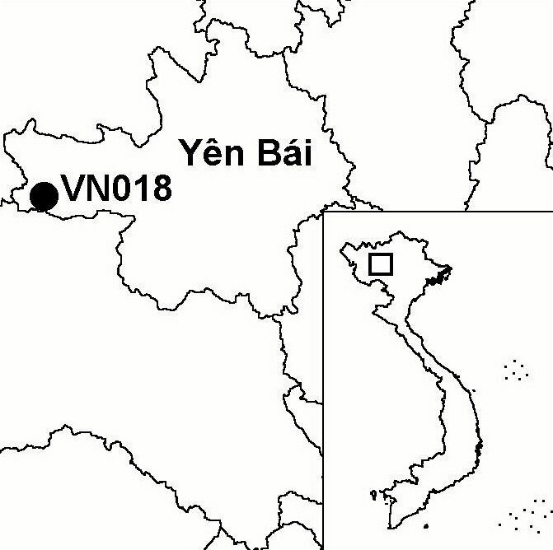
Province(s): Yen Bai and Son La
PA Status: None

Latitude: 21º42'N
Longitude: 104º02'E
Area: 16,000 ha
Altitude Range: 260-2,512 m asl

EBA / SA:

Fan-Si-Pan and Northern Laos SA
Priority Landscape:
None

General Description

Che Tao IBA is situated in the Hoang Lien mountains of northern Vietnam. The IBA is centred on Che Tao commune, Mu Cang Chai district, Yen Bai province but also includes contiguous forest areas. The topography of the IBA is dominated by a horseshoe of mountains which form the boundary of Che Tao commune. There are many peaks above 2,000 m asl in this horseshoe, while elevations in the central valley are generally below 1,500 m asl. Although forest at lower elevations has been extensively cleared for shifting cultivation, the IBA still supports significant areas of upper and lower montane evergreen forest. Large areas have been degraded by timber extraction but more remote areas are pristine and show no signs of human activity¹. Che Tao is believed to support the largest population of Black Gibbon Nomascus concolor remaining in Vietnam³.

Bird Fauna: Key Features

The IBA is notable for its intact montane avifauna. Surveys to date have recorded 107 bird species at Che Tao, although the current inventory is undoubtedly incomplete¹. The avifauna of the site bears strong similarity with that of Fan Si Pan and Van Ban IBAs. Che Tao is the only site in Vietnam from where there has been a confirmed record of Temminck's Tragopan Tragopan temmincki in the last 70 years². Recent field records of Rufous-necked Hornbill Aceros nipalensis at the site are especially significant, as this globally threatened species has recently been recorded at only one other site in Vietnam: Pu Mat IBA.

Species | IBA  Criteria | Global Threat Status | Other  IBAs | Notes
Rufous-necked Hornbill  Aceros nipalensis | A1, A3 | VU | 1 | Four records of this species were made in lower montane evergreen forest, between 1,200 and 1,800 m asl, in April 2001¹. All were of single males, with the exception of one record, which may have involved two males¹. Reports from local people suggest a total population of 28 to 37 birds¹.
Yellow-billed Nuthatch  Sitta solangiae | A1, A2 | NT | 11 | A single bird was seen in upper montane evergreen forest, at c.2,100 m asl, in September or October 2000³.
Broad-billed Warbler  Tickellia hodgsoni | A2 |  | 2 | A single individual and two pairs were seen in upper montane evergreen forest, at 2,100 m asl, in April 2001¹.

Biome Restricted Species: The site qualifies under criterion A3 because it supports 13 species restricted to the Sino-Himalayan Temperate Forests (Biome 07). See Appendix 4 for details.

Secondary Criteria

Species Status Species Status
Assamese Macaque Macaca assamensis⁴ VU [Black-breasted Leaf Turtle Geoemyda spengleri]^{3,4} EN
Rhesus Macaque M. mulatta⁴ NT [Impressed tortoise Manouria impressa]^{1,4} VU
Stump-tailed Macaque M. arctoides⁴ VU Calocedrus macrolepis^{3,4} VU
Black Gibbon Nomascus concolor^{1,3} EN Fokienia hodginsii^{1,3,4} NT
[Big-headed Turtle Platysternon megacephalum]^{1,4} EN Southern Serow Naemorhedus sumatraensis^{3,4} VU

Notes: [ ] = unconfirmed record.
Threats to Biodiversity

The major threat to biodiversity at Che Tao is hunting, although this appears to have declined somewhat following the initiation of a community-based conservation project. Other major threats are habitat degradation and loss, due to forest clearance for agriculture, selective timber extraction and forest fire¹. These risks are likely to increase in the future as a result of infrastructure development projects. Firstly, there exist plans to construct roads into the IBA, which would facilitate the exploitation of valuable timber trees in remote parts of the site. This would be a particular problem for Rufous-necked Hornbill, which nests in large trees. Secondly, the construction of the Song Da dam is forcing the resettlement of households from the inundation zone into areas close to Che Tao IBA in Son La province, thereby increasing pressure on the natural resources of the site.
Threat | Severity
Agricultural intensification / expansion | ● ●
Fire | ● ●
Hunting | ● ● ●
Infrastructure development | ● ● ●
Selective logging / cutting | ● ●

Conservation Actions

- Under the auspices of the project Community-based Conservation of the Hoang Lien Mountains Ecosystem, the Fauna & Flora International (FFI) Vietnam Programme and Yen Bai Provincial Forest Protection Department are currently implementing a programme of conservation initiatives at Che Tao. Activities to date include biological and human ecological surveys, community-based initiatives, environmental awareness raising, and establishment of a new protected area. In 2003, FFI will expand its Hoang Lien project to incorporate poverty alleviation interventions focusing on community-based natural resources management, together with further protected area development and landscape-scale approaches, culminating in the gazettement of a Man and the Biosphere Reserve.

Recommendations

- On-going community-based conservation measures should be continued, strengthened and extended to parts of the IBA in Son La province.
- Che Tao should be placed under an appropriate protected area designation, a management board should be established, and controls on hunting and timber extraction should be enforced.
- There should be no further road construction within the IBA.
- No households from the inundation zone of the Song Da dam should be resettled close to the IBA.

References

1. Tordoff, A. W., Le Trong Dat and Hardcastle, J. (2001) A rapid biodiversity survey of Che Tao commune, Mu Cang Chai district, Yen Bai province, Vietnam. Unpublished report to the BirdLife International Vietnam Programme and the Fauna & Flora International Indochina Programme.
2. Eames, J. C. and Tordoff, A. W. (in prep) Recent records and a conservation status review of some threatened and near-threatened bird species in Vietnam.
3. Long, B., Tallents, L. and Tran Dinh Nghia (2000) The biological diversity of Che Tao commune, Yen Bai province, Vietnam. Unpublished report to the Fauna & Flora International Indochina Programme.
4. Fauna & Flora International Vietnam Programme (in prep.) An investment plan for the establishment of Mu Cang Chai Species/Habitat Conservation Area. Hanoi: Fauna & Flora Vietnam Programme.
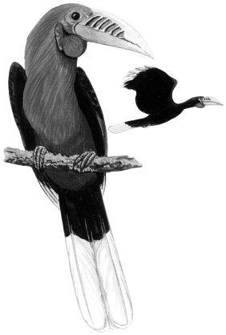

Rufous-necked Hornbill Aceros nipalensis

