Cong Troi Criteria: A1, A2 & A3
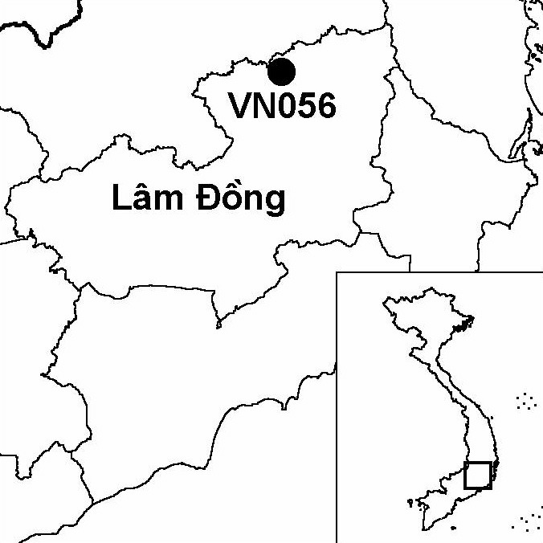

Province(s): Lam Dong
PA Status: None

Latitude: 12º09'N
Longitude: 108º20'E
Area: 28,000 ha
Altitude Range: 1,000-1,628 m asl

EBA / SA:

Da Lat Plateau EBA
Priority Landscape:
SA 3 - Southern Annamites Main Montane Block

General Description

The IBA comprises a ridge of gently sloping mountains on the Da Lat plateau, centred on Mount Cong Troi. Cong Troi IBA lies outside of Bi Dup-Nui Ba Nature Reserve, and borders Lang Bian IBA to the west. At higher elevations, the IBA supports extensive areas of lower montane evergreen forest, while, at lower elevations, on south-facing slopes, the IBA supports coniferous forest. There are also extensive areas of secondary scrub and bamboo present, which have developed after clearance of forest and disturbance.

Bird Fauna: Key Features

Cong Troi IBA is situated within the Da Lat Plateau Endemic Bird Area (EBA), and supports five of the eight bird species that define this EBA: Collared Laughingthrush Garrulax yersini, Black-hooded Laughingthrush G. milleti, White-cheeked Laughingthrush G. vassali, Yellow-billed Nuthatch Sitta solangiae and Vietnam Greenfinch Carduelis monguilloti.

Species | IBA  Criteria | Global Threat Status | Other  IBAs | Notes
Collared Laughingthrush  Garrulax yersini | A1, A2 | EN | 5 | At least eight birds were observed at elevations between 1,500 and 1,700 m asl in May 1991¹.
Yellow-billed Nuthatch  Sitta solangiae | A1, A2 | NT | 11 | The species was recorded on several occasions during May 1991^{1,2}.
Black-hooded Laughingthrush  Garrulax milleti | A1, A2 | NT | 8 | A flock of up to 10 birds was observed twice in evergreen forest at approximately 1,000 m asl in May 1991^{1,2}.
Vietnam Greenfinch  Carduelis monguilloti | A1, A2 | NT | 4 | Several birds were observed in May 1991^{1,2}.
White-cheeked Laughingthrush  Garrulax vassali | A2 |  | 8 | One bird was recorded at 1,700 m asl and a flock of at least 35 birds was recorded at 1,510 m asl in May 1991¹.

Biome Restricted Species: The site qualifies under criterion A3 because it supports 24 species restricted to the Sino-Himalayan Subtropical Forests (Biome 08). See Appendix 4 for details.

Secondary Criteria

Species Status
Southern Serow Naemorhedus sumatraensis³ VU

Threats to Biodiversity

One of the major threats to biodiversity at Cong Troi IBA is loss of forest, as a result of shifting cultivation and associated fires. This threat has already resulted in extensive habitat loss at lower elevations. Other threats include hunting and over-exploitation of non-timber forest products, especially firewood and charcoal. These threats are compounded by the fact that Cong Troi is currently not designated as a protected area.
Threat | Severity
Agricultural intensification / expansion | ● ●
Fires | ● ●
Hunting | ● ●
Selective logging / cutting | ● ●
Unsustainable exploitation of NTFPs | ● ●

Conservation Actions

- None to date.

Recommendations

- The feasibility of conferring protected area status on Cong Troi IBA should be assessed, either as an extension to Bi Dup-Nui Ba Nature Reserve or as a separate protected area.
- The enforcement of forest management regulations at the IBA should be strengthened, with a particular focus on preventing further loss of forest cover and controlling hunting.
- A programme of extension activities should be implemented among local communities, aimed at raising awareness of the threat posed by fire, and promoting farming techniques that reduce the risk of accidental fire.

References

1. Robson, C. R., Eames, J. C., Nguyen Cu and Truong Van La (1993) Birds recorded during the third BirdLife/Forest Birds Working Group expedition in Vietnam. Forktail 9: 89-119.
2. Eames, J. C. (1995) Endemic birds and protected area development on the Da Lat plateau, Vietnam. Bird Conservation International 5(4): 491-523.
3. J. C. Eames personal observation.

Black-hooded Laughingthrush Garrulax milleti

