Chu Yang Sin Criteria: A1, A2 & A3

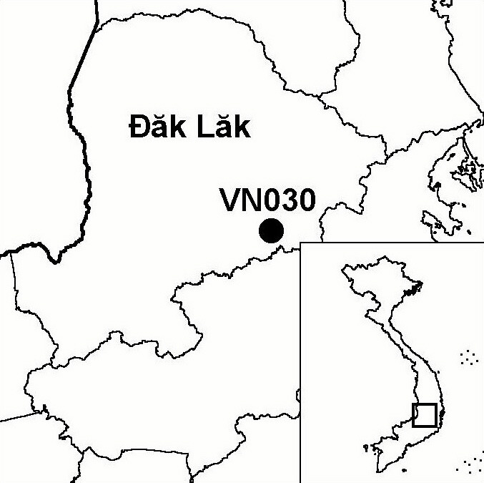
Province(s): Dak Lak
PA Status: National Park

Latitude: 12º23'N
Longitude: 108º27'E
Area: 59,278 ha
Altitude Range: 600-2,442 m asl

EBA / SA:

Da Lat Plateau EBA
Priority Landscape:
SA 3 - Southern Annamites Main Montane Block

General Description

The IBA comprises Chu Yang Sin National Park, which is situated in the north of the Da Lat plateau. The topography of the IBA is mountainous, and dominated by Mount Chu Yang Sin, which, at 2,442 m asl, is the highest point on the Da Lat plateau. The IBA supports a large area of natural forest, which is contiguous with extensive natural forest areas elsewhere on the Da Lat plateau. Below 800 m asl, the IBA supports lowland semi-evergreen forest. Above this elevation, the IBA supports a range of montane evergreen forest formations, including elfin forest formations on mountain summits and ridge crests¹. To the south, Chu Yang Sin IBA is contiguous with Lang Bian IBA in Lam Dong province.

Bird Fauna: Key Features

Chu Yang Sin IBA is a key site for the conservation of restricted-range bird species. The IBA supports seven of the eight restricted-range species that define the Da Lat Plateau Endemic Bird Area (EBA), as well as two of the three species that define the South Vietnamese Lowlands EBA. Most notable among the restricted-range species found at the IBA are Grey-crowned Crocias Crocias langbianis and Collared Laughingthrush Garrulax yersini, two globally endangered species with global ranges confined to the Da Lat plateau. For both species, Chu Yang Sin IBA is believed to be the site with the greatest potential for their long-term conservation.

Species | IBA  Criteria | Global Threat Status | Other  IBAs | Notes
Collared Laughingthrush  Garrulax yersini | A1, A2 | EN | 5 | The species was recorded on several occasions, at elevations between 1,470 and 2,442 m asl, during January 1994 and March 1995^{2,3}.
Grey-crowned Crocias  Crocias langbianis | A1, A2 | EN | 1 | The species was recorded at 1,615 m asl in January 1994². The species was recorded on several occasions, between 920 and 1,130 m asl, during March and April 1995³.
Germain's Peacock Pheasant  Polyplectron germaini | A1, A2 | VU | 4 | Feathers belonging to this species were found, single birds were heard calling, and a single bird was observed during March 1995³.
Great Hornbill  Buceros bicornis | A1 | NT | 13 | The species was observed in March 1995⁴.
Blyth's Kingfisher  Alcedo hercules | A1, A3 | NT | 8 | One bird was observed along the Ea K'Tour river at 500 m asl in January 1994². Two birds were seen at the same location in March 1995³.
Yellow-billed Nuthatch  Sitta solangiae | A1, A2 | NT | 11 | Two pairs were observed at 1,100 and 1,330 m asl in January 1994². Up to four birds were observed at c.1,000 m asl in April 1995³.
Black-hooded Laughingthrush  Garrulax milleti | A1, A2 | NT | 8 | The species was recorded on several occasions between 1,000 and 1,540 m asl during January 1994². Flocks of between three and eight individuals were seen on six days and the species was heard on six other days between March and April 1995³.
Short-tailed Scimitar Babbler  Jabouilleia danjoui | A1, A2 | NT | 17 | The species was recorded on five occasions, between 800 and 1,860 m asl, during January 1994². The species was observed on three occasions during March and April 1995³.
White-cheeked Laughingthrush  Garrulax vassali | A2 |  | 8 | Two flocks were observed at 1,010 and 1,700 m asl in January 1994². The species was observed on 13 occasions, between 900 and 1,700 m asl, during March and April 1995⁵. The population of this species at Chu Yang Sin has been estimated at 30,410 individuals⁵.
Grey-faced Tit Babbler  Macronous kelleyi | A2 |  | 12 | The species was recorded at c.1,000 m asl in April 1995³.

Biome Restricted Species: The site qualifies under criterion A3 because it supports 35 species restricted to the Sino-Himalayan Subtropical Forests (Biome 08) and eight species restricted to Indochinese Tropical Moist Forests (Biome 09). See Appendix 4 for details.

Secondary Criteria

Species Status Species Status
[Pygmy Loris Nycticebus pygmaeus]⁶ DD [Pinus dalatensis]⁶ VU
[Rhesus Macaque Macaca mulatta]⁶ NT [Pinus krempfii]⁶ VU
[Long-tailed Macaque Macaca fascicularis]⁶ NT [Fokienia hodginsii]⁶ NT
[Stump-tailed Macaque Macaca arctoides]⁶ VU [Podocarpus neriifolius]⁶ DD
[Silver Langur Trachypithecus villosus]⁶ DD [Asian Elephant Elephas maximus]⁶ EN
[Black-shanked Douc Pygathrix nigripes]⁶ EN [Gaur Bos gaurus]⁶ VU
[Asian Box Turtle Cuora amboinensis]⁶ VU [Southern Serow Naemorhedus sumatraensis]⁶ VU
[Asiatic Softshell Turtle Amyda cartilaginea]⁶ VU

Notes: [ ] = unconfirmed record.

Threats to Biodiversity

Due to the remoteness of the site, the inaccessibility of many high-elevation forest areas and the low human population density in the surrounding area, current threats to biodiversity at Chu Yang Sin IBA are relatively low. A potential future threat is posed by population expansion in the buffer zone of Chu Yang Sin National Park, particularly as a result of the settlement of migrants from northern Vietnam. Such a population increase may lead to increased pressure on the natural resources of the IBA, in the form of hunting, logging and NTFP collection, and clearance of forest for agriculture¹.
Threat | Severity
Agricultural intensification / expansion | ●
Fire | ●
Hunting | ●
Selective logging / cutting | ●
Unsustainable exploitation of NTFP's | ●

Conservation Actions

- Chu Yang Sin Nature Reserve was decreed in 1986 and a management board was established in 1997, following approval of a revised investment plan¹.
- A medium-sized GEF project focusing on Chu Yang Sin IBA has been developed by BirdLife International and Dak Lak Provincial Department of Agriculture and Rural Development and is currently awaiting approval. The main objective of this project is to promote biodiversity conservation at the site¹.
- Chu Yang Sin was upgraded to national park status by the government of Vietnam in July 2002.

Recommendations

- Settlement of in-migrants into the buffer zone of Chu Yang Sin National Park should be strictly controlled.
- Environmental considerations should be incorporated into land-use and development plans for the wider area, in order to ensure that future development is compatible with the conservation of the biological resources of the IBA.
- Enforcement of protected area management regulations should be maintained and strengthened through capacity building of the national park management board.

References

1. BirdLife International and the Forest Inventory and Planning Institute (2001) Sourcebook of existing and proposed protected areas in Vietnam. Hanoi: BirdLife International Vietnam Programme and the Forest Inventory and Planning Institute.
2. Eames, J. C. (1995) Endemic birds and protected area development on the Da Lat plateau, Vietnam. Bird Conservation International 5(4): 491-523.
3. Eames, J. C. and Tordoff, A. W. (in prep.) Recent records and a conservation status review of some threatened and near-threatened bird species in Vietnam.
4. Eames, J. C. Personal observation.
5. Hill, M., Eames, J. C., Le Trong Trai and Nguyen Cu (2001) Population sizes, status and habitat associations of
forest birds in Chu Yang Sin Nature Reserve, Dak Lak province, Vietnam. Bird Conservation International 11(1):49-70.
6. Anon. (1997) [Investment plan for Chu Yang Sin Nature Reserve, Dak Lak province.] Buon Ma Thuot: Dak Lak Provincial Department of Agriculture and Rural Development. (In Vietnamese.)

Collared Laughingthrush Garrulax yersini

