Dak Dam Criteria: A1 & A2
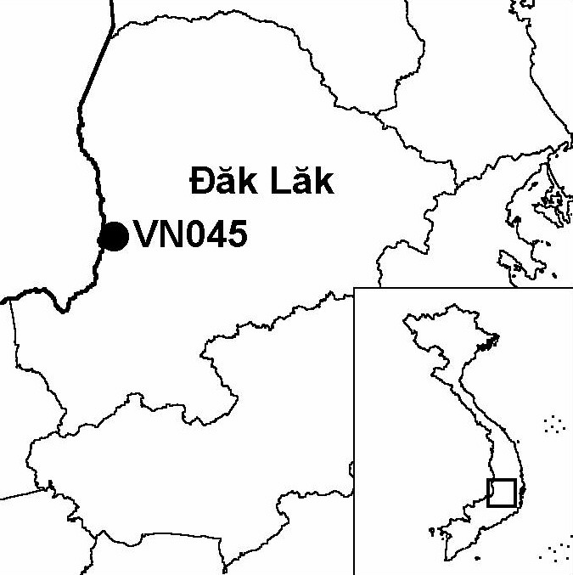

Province(s): Dak Lak
PA Status: None

Latitude: 12º30'N
Longitude: 107º35'E
Area: 10,000 ha
Altitude Range: 300-930 m asl

EBA / SA:

None
Priority Landscape:
DF 4 - Eastern Plains Dry Forest

General Description

The IBA is situated in the Mekong basin, and comprises the Dak Dam stream, a tributary of the Srepok river, and associated forest areas on the eastern bank. Dak Dam IBA supports a significant stretch of relatively undisturbed riverine forest, one of the most threatened habitat types in Vietnam. The major vegetation types at the IBA are deciduous forest and semi-evergreen forest, although the riverine forest has a greater evergreen component. The Dak Dam stream forms the international border between Vietnam and Cambodia, as well as the western boundary of Yok Don National Park^{1,2}; the stretch within the national park is included within Yok Don IBA. To the west, Dak Dam IBA is contiguous with Upper Srepok Catchment IBA in Cambodia.

Bird Fauna: Key Features

While Dak Dam IBA has been the focus of relatively little ornithological survey to date, three globally threatened and one globally near-threatened species have been confirmed to occur. Most significantly, Dak Dam IBA is one of only three sites in Vietnam from where there are recent confirmed records of the globally endangered White-winged Duck Cairina scutulata, and the only one that is likely to regularly support a significant population. Further survey work at the IBA may reveal the presence of other bird species of conservation concern.

Species | IBA  Criteria | Global Threat Status | Other  IBAs | Notes
White-winged Duck  Cairina scutulata | A1 | EN | 2 | A pair was seen along the Dak Dam stream on four consecutive days in April 1998^{1,3}.
Green Peafowl  Pavo muticus | A1, A3 | VU | 8 | Up to 14 birds were heard over a four-day period in April 1998¹.
Pale-capped Pigeon  Columba punicea | A1, A3 | VU | 5 | A pair of birds was observed along the Dak Dam stream in April 1998^{1,3}.
Siamese Fireback  Lophura diardi | A1, A3 | NT | 13 | A single bird was observed in deciduous forest near the Dak Dam stream in April 1998^{1,3}.
Grey-faced Tit Babbler  Macronous kelleyi | A2 |  | 12 | The species was recorded in April 1998^{1,3}.

Biome Restricted Species: The site does not qualify under criterion A3. See Appendix 4 for details.

Secondary Criteria

Species Status Species Status
Long-tailed Macaque Macaca fascicularis¹ NT Gaur Bos gaurus¹ VU
[Asian Elephant Elephas maximus]¹ EN Banteng Bos javanicus¹ EN

Notes: [ ] = unconfirmed record.

Threats to Biodiversity
Threat | Severity
Agricultural intensification / expansion | ● ●
Aquaculture / fisheries | ●
Forest grazing | ●
Hunting | ●
Infrastructure development | ● ●
Selective logging / cutting | ● ●
Unsustainable exploitation of NFTPs | ●
The major threats to biodiversity at the IBA are timber extraction and clearance of forest for agriculture³. Other threats are hunting, unsustainable exploitation of NTFPs and fishing, which is a potential source of disturbance to species dependent on riverine habitats. At the current time, however, most of these threats are potential rather than actual, as the border army strictly control human access into the IBA³.

Conservation Actions

- None to date.

Recommendations

- Yok Don National Park should be extended to the south to include the Dak Dam stream and adjacent areas of habitat. Areas of habitat on the western bank of the Dak Dam stream, in Cambodia, should also be placed under appropriate conservation management.
- Existing controls on human access into the border zone should be maintained. In particular, there should be no human settlement along the border road.
- Further surveys should be conducted to assess the status and distribution of globally threatened bird and mammal species and to evaluate threats to the sites biodiversity, and the findings should be used as a basis for formulating appropriate management recommendations and identifying protected area boundaries.

References

1. Brickle, N. W., Nguyen Cu, Ha Quy Quynh, Nguyen Thai Tu Cuong and Hoang Van San (1998) The status and distribution of Green Peafowl Pavo muticus in Dak Lak province, Vietnam. Hanoi: BirdLife International Vietnam Programme.
2. Le Xuan Canh, Pham Trong Anh, Duckworth, J. W., Vu Ngoc Thanh and Lic Vuthy (1997) A survey of large mammals in Dak Lak province, Vietnam. Hanoi: WWF/ IUCN.
3. N. W. Brickle, in litt. 2002.
4. Eames, J. C. and Nguyen Duc Tu. (2002) An interim biodiversity report for Yok Don National Park, Dak Lak province, Vietnam. Unpublished report to the Vietnam PARC Project, Yok Don Component.

White-winged Duck Cairina scutulata

