Du Gia Criteria: A1 & A3

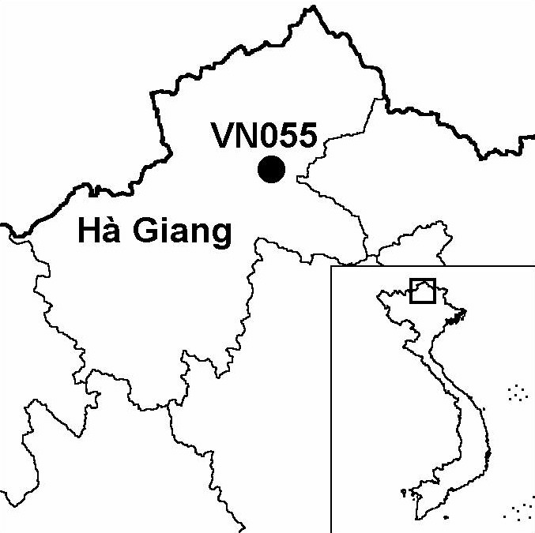
Province(s): Ha Giang
PA Status: None

Latitude: 22º54'N
Longitude: 105º12'E
Area: 24,293 ha
Altitude Range: 400-2,275 m asl

EBA / SA:

None
Priority Landscape:
None

General Description

The IBA comprises Du Gia proposed nature reserve in north-eastern Vietnam. The topography of the IBA is steep and mountainous, and dominated by Mount Pu Tha Ca (2,275 m asl) in the centre of the IBA and Mount Muong Cha (1,773 m asl) in the south-east. The broad valleys at the base of Mount Phu Tha Ca, at elevations between 400 and 600 m asl, are settled by members of the Hmong ethnic group, and are cultivated, mainly with maize. Above the cultivated areas, between 600 and 900 m asl, the forest has been entirely cleared and replaced by secondary vegetation. Lower montane evergreen forest is distributed at elevations between 900 and 1,800 m asl, although, below 1,500 m asl, most of the forest has been degraded by selective timber extraction. Upper montane evergreen forest is distributed at elevations above 1,800 m asl¹. Du Gia IBA is notable because it is one of the few sites in the world to support a population of Tonkin Snub-nosed Monkey Rhinopithecus avunculus, a critically endangered species, which is endemic to northern Vietnam².

Bird Fauna: Key Features

The bird community of Du Gia IBA is characteristic of montane evergreen forest in northern Vietnam. However, as surveys to date have concentrated on lower montane evergreen forest, the composition of the upper montane bird fauna remains largely unknown. The most frequently recorded species in lower montane evergreen forest include Golden-throated Barbet Megalaima franklinii, Red-headed Trogon Harpactes erythrocephalus, Grey-headed Canary Flycatcher Culicicapa ceylonensis, Mountain Bulbul Hypsipetes mcclellandii, Blue-winged Minla Minla cyanouroptera, Grey-cheeked Fulvetta Alcippe morrisonia, Long-tailed Sibia Heterophasia picoides, Whiskered Yuhina Yuhina flavicollis and Black-throated Sunbird Aethopyga saturata. One of the most notable components of the bird fauna of Du Gia is Beautiful Nuthatch Sitta formosa, a globally vulnerable species that is known from only three other sites in Vietnam¹.

Species | IBA  Criteria | Global Threat Status | Other  IBAs | Notes
Beautiful Nuthatch  Sitta formosa | A1, A3 | VU | 3 | A single bird was observed at 1,400 m asl on Mount Pu Tha Ca in March 2000³. A single bird was observed at c.1,100 m asl on Mount Moung Cha in April 2000³. Single birds were observed in mixed species flocks at 1,600 and 1,850 m asl on Mount Phu Tha Ca in May 2002¹.
Yellow-vented Warbler  Phylloscopus cantator | A2 |  | 0 | A single bird was observed at c.900 m asl on Mount Muong Cha in April 2000³. There is no evidence that the species breeds at the site, and, therefore, the site probably does not qualify for inclusion within the Eastern Himalayas EBA.

Biome Restricted Species: The site qualifies under criterion A3 because it supports 35 species restricted to the Sino-Himalayan Subtropical Forests (Biome 08). See Appendix 4 for details.

Secondary Criteria

Species Status Species Status
Tonkin Snub-nosed Monkey [Fokienia hodginsii]⁴ NT
Rhinopithecus avunculus² CR

Notes: [ ] = unconfirmed record.

Threats to Biodiversity

In the short term, the biggest threat to biodiversity at Du Gia IBA is hunting, which presents a particular threat to the population of Tonkin Snub-nosed Monkey. In the longer term, habitat degradation and loss are the biggest threats to bird conservation at the IBA. The major causes of habitat degradation and loss are clearance of forest for agriculture, fire, and over-exploitation of timber and NTFPs.
Threat | Severity
Agricultural intensification / expansion | ● ●
Fire | ● ●
Hunting | ● ● ●
Selective logging / cutting | ● ●
Unsustainable exploitation of NTFPs | ● ●

Conservation Actions

An investment plan for Du Gia was prepared in early 1994, and proposed establishing a 24,239 ha nature reserve⁵. After the approval of this investment plan by the Ministry of Agriculture and Rural Development and Ha Giang Provincial People's Committee, a management board was established in November 1994⁵.

Recommendations

- Du Gia should be decreed as a nature reserve by the government of Vietnam.
- The capacity of the nature reserve management board should be strengthened, through the provision of additional staff, training and funds¹.
- Strict controls should be placed on extraction of timber and NTFPs, especially from areas known to support Tonkin Snub-nosed Monkey.
- National social forestry programmes should be extended, in order to increase the involvement of local communities in forest protection and provide an alternative source of forest products.
- An integrated programme of anti-hunting activities should be initiated, including conservation awareness raising, controls on wildlife trade, and community-based anti-hunting patrols.
- Additional surveys should be conducted to assess the status and distribution key species at the site, in order to provide a basis for targeted conservation interventions.

References

1. Le Manh Hung, Tran Thieu Du and Vu Huu Trac (2002) A rapid field survey of Xin Man and Yen Minh districts, Ha Giang Province, Vietnam. Unpublished report to the BirdLife International Vietnam Programme and the Institute of Ecology and Biological Resources.
2. Le Khac Quyet, pers. comm.
3. Vogel, C. J., Sweet, P. R., Le Manh Hung and Hurley, M. M. (submitted, Forktail) Ornithological records from Ha Giang province, Vietnam.
4. Dinh Van Manh (1994) [Investment plan for Du Gia Nature Reserve, Ha Giang province]. Hanoi: Forest Inventory and Planning Institute. (In Vietnamese.)
5. BirdLife International and the Forest Inventory and Planning Institute (2001) Sourcebook of existing and proposed protected areas in Vietnam. Hanoi: BirdLife International Vietnam Programme and the Forest Inventory and Planning Institute.

