Dakrong Criteria: A1, A2 & A3

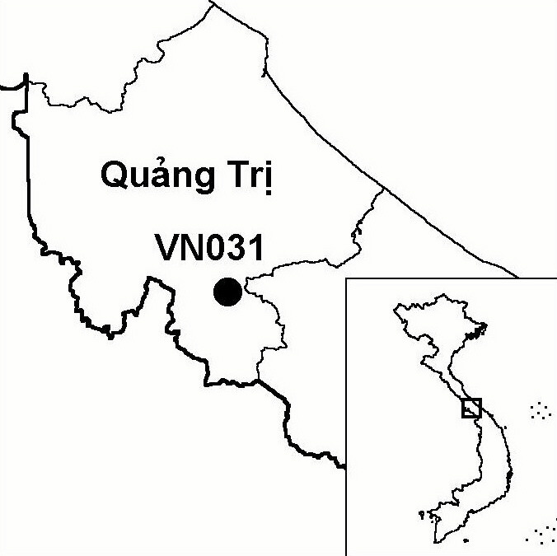
Province(s): Quang Tri
PA Status: None

Latitude: 16º31'N
Longitude: 107º01'E
Area: 40,526 ha
Altitude Range: 300-1,102 m asl

EBA / SA:

Annamese Lowlands EBA
Priority Landscape:
CA 1 - Central Annamites

General Description

The IBA is situated in the Annamese lowlands and comprises Dakrong proposed nature reserve. The topography of the IBA is characterised by hills and low mountains. Prior to the Second Indochina War, the IBA supported extensive areas of lowland evergreen forest and lower montane evergreen forest. However, wartime spraying of defoliants, the practice of shifting cultivation by local communities, and a long history of over-exploitation of natural resources have resulted in the forest becoming heavily degraded and fragmented. Currently, primary forest only covers around 60% of the IBA. However, most fragments of primary forest are relatively large and contiguous with areas of mature secondary forest¹. To the east, Dakrong IBA is contiguous with Phong Dien IBA in Thua Thien Hue province.

Bird Fauna: Key Features

Dakrong IBA supports five of the nine restricted-range species found in the Annamese Lowlands Endemic Bird Area (EBA). Most significantly, Dakrong IBA, together with the neighbouring Phong Dien IBA, supports what is possibly the largest remaining population of the globally endangered Edwards's Pheasant Lophura edwardsi in the world. In 2000, Imperial Pheasant L. imperialis, another pheasant species endemic to central Vietnam, was recorded at Dakrong IBA. However, recent taxonomic research indicates that Imperial Pheasant may not be a true species but, rather, a hybrid between Edwards's Pheasant or Vietnamese Pheasant L. hatinhensis and Silver Pheasant L. nycthemera².

Species | IBA  Criteria | Global Threat Status | Other  IBAs | Notes
Edwards's Pheasant  Lophura edwardsi | A1, A2 | EN | 2 | A pair were trapped by local people in December 1996. Four birds were trapped by local hunters between 50 and 300 m asl in December 1997. Two individuals were caught by local hunters, who also reported seeing a flock of 8 to 10, between the end of 1997 and the beginning of 1998¹.
Crested Argus  Rheinardia ocellata | A1, A2 | VU | 15 | The species was recorded between June and July 1998¹.
Siamese Fireback  Lophura diardi | A1, A3 | NT | 13 | The species was recorded between June and July 1998¹.
[Brown Hornbill  Anorrhinus tickelli] | A1, A3 | NT | 17 | The species was provisionally recorded between June and July 1998¹.
Blyth's Kingfisher  Alcedo Hercules | A1, A3 | NT | 8 | The species was recorded between June and July 1998¹.
Short-tailed Scimitar Babbler  Jabouilleia danjoui | A1, A2 | NT | 17 | The species was recorded between June and July 1998¹.
Imperial Pheasant  Lophura imperialis | A1, A2 | DD | 2 | A juvenile male was caught in the watershed of the Long An stream, near Mount Dong Che in February 2000³.
Annam Partridge  Arborophila merlini | A2 |  | 4 | The species was recorded between June and July 1998¹.
Notes: [ ] = unconfirmed record.

Biome Restricted Species: The site qualifies under criterion A3 because it supports 14 species restricted to the Indochinese Tropical Moist Forests (Biome 09). See Appendix 4 for details.

Secondary Criteria

Species Status Species Status
*Northern Slow Loris Nycticebus bengalensis¹ DD [Chinese Three-striped Box Turtle Cuora trifasciata]¹ CR
*Northern Pigtail Macaque Macaca leonina¹ VU [Wattle-necked Softshell Turtle Palea steindachneri]¹ EN
*Rhesus Macaque Macaca mulatta¹ NT [Chinese Softshell Turtle Pelodiscus sinensis]¹ VU
*Stump-tailed Macaque Macaca arctoides¹ VU Podocarpus neriifolius DD
*Red-shanked Douc Pygathrix nemaeus nemaeus¹ EN [Gaur Bos gaurus]¹ VU
*White-cheeked Gibbon Nomascus leucogenys¹ VU [Southern Serow Naemorhedus sumatraensis]¹ VU
[Big-headed Turtle Platysternon megacephalum]¹ EN [Saola Pseudoryx nghetinhensis]¹ EN
[Indochinese Box Turtle Cuora galbinifrons]¹ CR

Notes: [ ] = unconfirmed record; * = recorded during a survey of Dakrong and Phong Dien IBAs but, due to a lack of locality data, it is uncertain whether the species occurs within the IBA or not.

Threats to Biodiversity

One of the biggest threats to biodiversity at Dakrong IBA is hunting, particularly the use of snares. Snaring is an indiscriminate activity with potentially severe impacts on ground-dwelling birds, such as Edwards's Pheasant, Crested Argus Rheinardia ocellata and Annam Partridge Arborophila merlini. Recent research conducted at Phong Dien IBA revealed that snaring is often associated with rattan collection⁴. Other threats to biodiversity at the IBA include small-scale timber extraction, clearance of forest for agriculture, mining and livestock grazing.
Threat | Severity
Agricultural intensification / expansion | ●
Forest grazing | ●
Hunting | ● ● ●
Selective logging / cutting | ● ●
Unsustainable exploitation of NTFPs | ●

Conservation Actions

- An investment plan for Dakrong was prepared in 2000, which proposed establishing a 40,526 ha nature reserve at the site. This investment plan was approved by Quang Tri Provincial People's Committee in 2000 and by the Ministry of Agriculture and Rural Development in 2001⁵. To date, however, the establishment of a nature reserve at Dakrong has not been decreed by the government of Vietnam.

Recommendations

- Dakrong should be decreed as a nature reserve, a management board should be established, and protected area management regulations should be enforced, particularly controls on hunting.
- Local communities should be involved in forest protection and management.
- Environmental awareness activities should be implemented among local communities.
- Further studies should be conducted to assess the habitat requirements of Edwards's Pheasant.

References

1. Le Trong Trai, Richardson, W. J., Le Van Cham, Tran Hieu Minh, Tran Quang Ngoc, Nguyen Van Sang, Monastyrskii, A. L. and Eames, J. C. (1999) A feasibility study for the establishment of Phong Dien (Thua Thien Hue province) and Dakrong (Quang Tri province) Nature Reserves, Vietnam. Hanoi: BirdLife International Vietnam Programme and the Forest Inventory and Planning Institute.
2. Garson, P. (2001) Pheasant taxonomy: a cunning way to remove species from the Red List! OBC Bulletin 33: 52.
3. Eames, J. C. and Tordoff, A. W. (in prep.) Recent records and a conservation status review of some threatened and near-threatened bird species in Vietnam.
4. Tran Quang Ngoc, Nguyen Van Vinh, Le Trong Trai, Phan Thanh Ha, Le Ngoc Tuan and Dang Thang Long (2002) Understanding the impacts of hunting on Edwards's Pheasant Lophura edwardsi at Phong Dien Nature Reserve, Vietnam: towards a strategy for managing hunting activities. Unpublished report to the Whitley Awards Foundation.
5. BirdLife International and the Forest Inventory and Planning Institute (2001) Sourcebook of existing and proposed protected areas in Vietnam. Hanoi: BirdLife International Vietnam Programme and the Forest Inventory and Planning Institute.

