Fan Si Pan Criteria: A1, A2 & A3

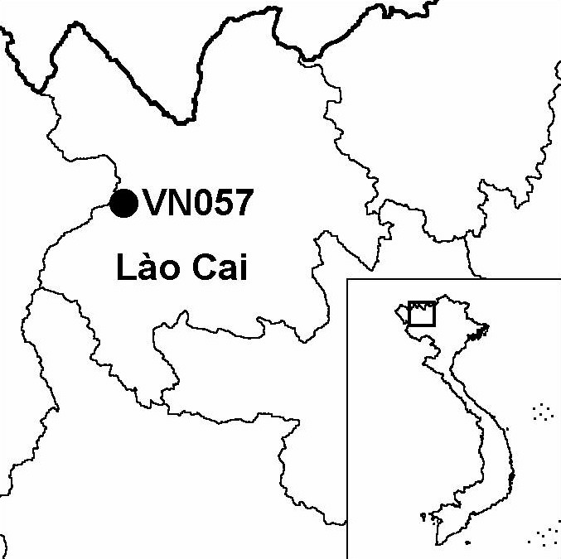
Province(s): Lao Cai and Lai Chau
PA Status: National Park

Latitude: 22º16'N
Longitude: 103º53'E
Area: 49,584 ha
Altitude Range: 380-3,143 m asl

EBA / SA:

Fan Si Pan and Northern Laos SA
Priority Landscape:
None

General Description

The IBA is centred on Mount Fan Si Pan in the Hoang Lien mountains, which, at 3,143 m asl, is the highest peak in Vietnam. The IBA comprises Hoang Lien Son National Park in Lao Cai province and Hoang Lien Son-Lai Chau proposed nature reserve in Lai Chau province. The topography of the IBA is dominated by a high ridge of mountains including several peaks above 2,800 m asl. The major natural habitat types at the IBA are lower montane evergreen forest and upper montane evergreen forest. At higher elevations, on ridge crests, there are extensive elfin forest formations dominated by conifers and Rhododendron spp. At lower elevations, the natural vegetation has been extensively cleared by shifting cultivation and forest fire, and replaced by secondary bamboo and scrub. Almost no natural forest remains below 1,000 m asl^{1,2}.

Bird Fauna: Key Features

Recorded bird species richness at Fan Si Pan IBA is higher than at any other site in Vietnam, with 347 species being recorded to date², although this may, in part, reflect the high levels of historical and recent survey effort. Fan Si Pan IBA supports the largest number of biome-restricted species of any IBA in Vietnam, including 17 species not recently recorded at any other IBA: Chestnut Thrush Turdus rubrocanus, Gould's Shortwing Brachypteryx stellata, White-browed Bush Robin Tarsiger indicus, Blue-fronted Robin Cinclidium frontale, Crested Finchbill Spizixos canifrons, Buff-barred Warbler Phylloscopus pulcher, White-throated Laughingthrush Garrulax albogularis, Black-faced Laughingthrush G. affinis, Red-faced Liocichla Liocichla phoenicea, Spot-breasted Scimitar Babbler Pomatorhinus erythrocnemis, White-collared Yuhina Yuhina diademata, Ashy-throated Parrotbill Paradoxornis alphonsianus, Yellow-bellied Flowerpecker Dicaeum melanoxanthum, Black-headed Greenfinch Carduelis ambigua, Dark-breasted Rosefinch Carpodacus nipalensis, Scarlet Finch Haematospiza sipahi and Brown Bullfinch Pyrrhula nipalensis.

All four of the restricted-range species that define the Fan Si Pan and Northern Laos Secondary Area have been recorded at the IBA. However, there are recent confirmed records of only two of these species: Broad-billed Warbler Tickellia hodginsi and Red-winged Laughingthrush Garrulax formosus². The other two restricted-range species, Ward's Trogon Harpactes wardi and Yellow-billed Nuthatch Sitta solangiae have not been confirmed at the IBA in the last 60 years, and it is possible that these species have become locally extinct as a result of habitat loss at lower elevations and hunting³. Fan Si Pan IBA is the only site in Vietnam from where there are recent confirmed records of the globally vulnerable Wood Snipe Gallinago nemoricola. In addition, the IBA is a bottleneck for migratory raptors, with nearly 2,000 counted during a two-week period in 1997⁴.

Species | IBA  Criteria | Global Threat Status | Other  IBAs | Notes
Wood Snipe  Gallinago nemoricola | A1 | VU | 0 | A single bird was recorded in October 1997. A single bird was recorded at 1,700 m asl in November 1997. Three single birds were observed in upper montane evergreen forest at c.2,500 m asl in February and March 1998³.
†Greater Spotted Eagle  Aquila clanga | A1 | VU | 2 | A total of fifteen birds were observed in passage in October 1997, and a single bird was observed in November 1997⁴. The site probably does not regularly support a significant population of this species.
Beautiful Nuthatch  Sitta formosa | A1, A3 | VU | 3 | The species has been recorded on several occasions in recent years, at elevations between 1,400 and 1,900 m asl^{2,3}.
†Japanese Paradise-flycatcher  Terpsiphone actrocaudata | A1 | NT | 1 | A single male, presumably a passage migrant, was observed in May 2000³. However, the site is unlikely to regularly support a significant population.
Broad-billed Warbler  Tickellia hodgsoni | A2 |  | 2 | The species has been recorded on a number of occasions in recent years in upper montane evergreen forest between 2,100 and 2,400 m asl^{2,3}.
Red-winged Laughingthrush  Garrulax formosus | A2 |  | 0 | The species was recorded in upper montane evergreen forest at 2,650 m asl in December 1996⁵.

Notes: † = not confirmed to regularly occur in significant numbers.

Biome Restricted Species: The site qualifies under criterion A3 because it supports 39 species restricted to the Sino-Himalayan Temperate Forests (Biome 07) and 69 species restricted to the Sino-Himalayan Subtropical Forests (Biome 08). See Appendix 4 for details.

Secondary Criteria

Species Status Species Status
[Pygmy Loris Nycticebus pygmaeus]² VU Fokienia hodgsinii^{2,6} NT
[Assamese Macaque Macaca assamensis]² VU Podocarpus neriifolius⁶ DD
[Rhesus Macaque Macaca mulatta]² NT Amentotaxus argotaenia var. argotaenia⁶ VU
[Stump-tailed Macaque Macaca arctoides]² VU Amentotaxus yunnanensis⁶ VU
Black Gibbon Nomascus concolor² EN Taxus wallichiana⁶ DD
Calocedrus macrolepis⁶ VU Southern Serow Naemorhedus sumatraensis^{2,5} VU

Notes: [ ] = unconfirmed record.

Threats to Biodiversity

The major threats to biodiversity at Fan Si Pan IBA are over-exploitation of natural resources, clearance of land for agriculture, accidental fire and hunting. Clearance of land for cultivation and associated forest fires are resulting in habitat loss. The habitat type most threatened is lower montane evergreen forest, which has already been significantly reduced in extent. Remaining areas of natural habitat at all elevations are being degraded by selective timber extraction, collection of firewood and establishment of cardamom plantations².

Another major threat to biodiversity is hunting, both for domestic consumption and to supply the wildlife trade. Hunting pressure is widespread and intense throughout the IBA, and targets even the smallest vertebrate species. It is likely that hunting pressure, combined with habitat loss at lower elevations, has already resulted in the local extinction of Rufous-necked Hornbill Aceros nipalensis, a globally threatened species that is known historically from the site².

Finally, a potential threat to biodiversity at the IBA is tourism development. The IBA is located close to the major tourist destination of Sa Pa, from where treks are organised to the summit of Mount Fan Si Pan, increasing the risk of accidental fires. In addition, there exist plans to construct a road to the summit of Mount Fan Si Pan, which would lead to habitat loss and facilitate access to the forest by hunters and illegal loggers.
Threat | Severity
Agricultural intensification / expansion | ● ●
Fire | ● ● ●
Forest grazing | ●
Hunting | ● ● ●
Infrastructure development | ● ●
Recreation / tourism | ● ●
Selective logging / cutting | ● ●

Conservation Actions

- The establishment of Hoang Lien Son Nature Reserve in Lao Cai province was decreed by the government of Vietnam in 1986, and, subsequently, a management board was established¹.
- In July 2002, Hoang Lien Son Nature Reserve and adjacent forest areas in Than Uyen district were upgraded to national park status.
- An investment plan to establish a nature reserve encompassing contiguous forest areas in Lai Chau province was prepared in 2000, although, to date, it has not been approved at the provincial or ministerial level¹.
- In 1998, Frontier-Vietnam initiated an environmental education programme in Sa Pa district, focusing on the IBA¹.
- Sa Pa district was selected as a case-study for the IUCN Capacity Building for Sustainable Tourism Initiatives Project¹.
- Frontier-Vietnam are currently implementing a pilot project to investigate the potential of medicinal plant cultivation as an alternative source of income for ethnic minority people living in and around the IBA¹.
- With funding from the Asia Development Assistance Facility, Forest Herbs Research Ltd., Frontier-Vietnam and Lao Cai Provincial People's Committee have developed the Medicinal Plant Innovation Project, which will be implemented over a two year period beginning in December 2002.

Recommendations

- Enforcement of national park management regulations, particularly controls on hunting and clearance of forest for agriculture should be strengthened.
- The capacity of national park staff in the fields of conservation management planning and protected area management should be strengthened³.
- A programme of education and extension should be implemented to raise awareness of the threat of forest fire and to demonstrate practical techniques to mitigate this threat³.
- The boundaries of the national park should be revised to exclude areas of agricultural land and human habitation, and include areas of natural habitat to the north³.
- Existing social forestry schemes involving local communities in forest protection and natural forest regeneration should be expanded, with a particular focus on areas of lower montane evergreen forest, the most threatened habitat type at the IBA³.
- Plans to construct a road to the summit of Mount Fan Si Pan are incompatible with biodiversity conservation and in direct contravention of national park management regulations and should be abandoned.
- In the context of the recent upgrade of Hoang Lien Son to national park status and the increasing numbers of tourists visiting the area, measures should be implemented to promote the sustainable development of tourism, in order to minimise potential negative environmental impacts, and to provide an alternative source of income for local communities that depend upon the natural resources of the IBA.
- The investment plan for Hoang Lien Son-Lai Chau Nature Reserve should be approved, and a management board should be established.

References

1. BirdLife International and the Forest Inventory and Planning Institute (2001) Sourcebook of existing and proposed protected areas in Vietnam. Hanoi: BirdLife International Vietnam Programme and the Forest Inventory and Planning Institute.
2. Tordoff, A. W., Swan, S. R., Grindley, M. and Siurua, H. (1999) Hoang Lien Nature Reserve: biodiversity survey and conservation evaluation 1997/1998. London: Society for Environmental Exploration.
3. Eames, J. C. and Tordoff, A. W. (in prep.) Recent records and a conservation status review of some threatened and near-threatened bird species in Vietnam.
4. Tordoff, A. W. (2002) Raptor migration at Hoang Lien Nature Reserve, Vietnam. Forktail 18: 35-39.
5. Korzun, L. P. and Kalyakin, M. V. (1998) [Materials of zoological and botanical studies in Fan Si Pan summit area (North Vietnam)]. Moscow and Hanoi: Vietnam-Russia Tropical Centre. (In Russian.)
6. Nguyen Nghia Thin and Nguyen Thi Thoi (1998) Diversity of vascular plants in high mountains: Sa Pa - Fan Si Pan. Hanoi: Hanoi National University Publishing House. (In Vietnamese.)

Wood Snipe Gallinago nemoricola

