Foreword

In recent years, Vietnam has captivated the world through the discovery of a remarkable series of new bird and mammal species. Sadly, however, as in many other regions of the world, rapid population growth and economic development are threatening the rich biodiversity for which Vietnam is so rightly famed. As a result, the need for accurate information on the country's biodiversity in a form accessible to decision makers becomes ever more urgent.

To address this need, the Research Institute of Ecology and Biological Resources and BirdLife International in Indochina, has undertaken the project Improved Conservation Planning through Institutional Strengthening in Cambodia, Laos and Vietnam. One of its main outputs of this project, which was supported by Danida (Danish International Development Assistance), has been the publication of the Directory of Important Bird Areas in Vietnam. The directory describes a network of Important Bird Areas (IBAs), the protection of which would go a long way towards the conservation of biodiversity and the wider environment in Vietnam. The directory draws attention to on-going conservation efforts at IBAs. The directory also highlights the need for continued and intensified conservation effort throughout the IBA network.

It is my hope that this directory will be of use for government agencies, donors and NGOs. On behalf of the Royal Danish Embassy, I warmly congratulate the Research Institute of Ecology and Biological Resources and BirdLife International in Indochina for their efforts.
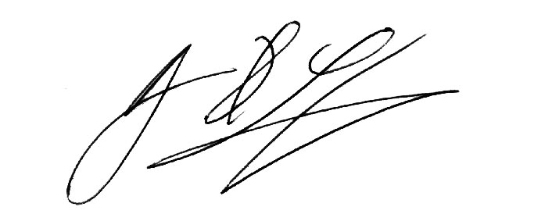

Bjarne H. Sørensen
Ambassador of Denmark
Hanoi

