Ha Nam Criteria: A1 & A4i

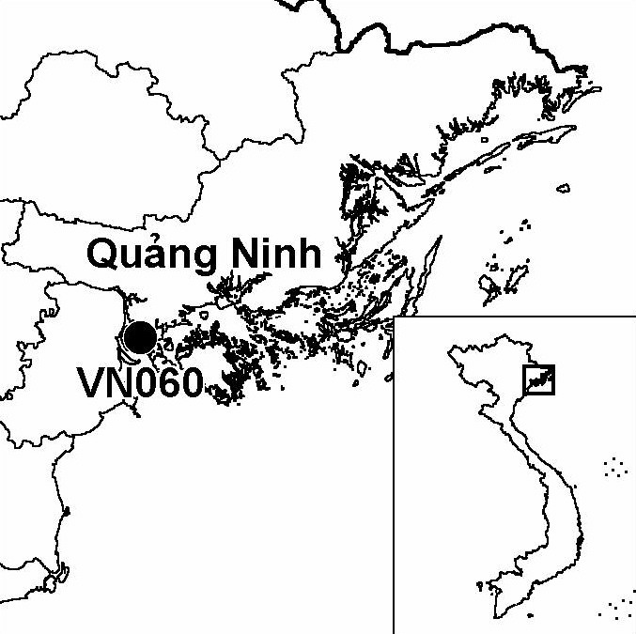
Province(s): Quang Ninh
PA Status: None

Latitude: 20º52'N
Longitude: 106º49'E
Area: 5,000 ha
Altitude Range: 0-2 m asl

EBA / SA:

None
Priority Landscape:

None

General Description

The IBA is centred on Ha Nam island, which is situated at the mouth of the Bach Dang river, the northernmost estuary in the Red River Delta. Ha Nam island is linked to the mainland via a bridge, and is ringed by a sea dyke, within which the land use is dominated agriculture and habitation. Outside of the sea dyke, on the southern and western sides of the island, there are numerous shrimp ponds, many of which contain mangrove. The IBA comprises these shrimp ponds, together with areas of unenclosed mangrove and intertidal mudflats in the mouth of the Bach Dang river. The aquacultural ponds are currently under the management of a number of aquacultural enterprises¹.

Bird Fauna: Key Features

The avifauna of Ha Nam IBA is relatively little known, as there have only been two brief surveys of the site to date. However, small numbers of the globally endangered Black-faced Spoonbill Platalea minor were recorded on both occasions, indicating that the IBA may regularly support a significant population of this species, and the results of the surveys indicate that Ha Nam is an important wintering area for migratory waterbirds. For example, a count of 150 Great Cormorant Phalacrocorax carbo made in January 2002 is the largest recent count of this nationally threatened species in Vietnam. In addition, the site supports nationally significant wintering populations of Northern Pintail Anas acuta, Eurasian Wigeon A. penelope and Black-headed Gull Larus ridibundus¹.

Species | IBA  Criteria | Global Threat Status | Other  IBAs | Notes
Black-faced Spoonbill  Platalea minor | A1, A4i | EN | 8 | Four juveniles were observed in a shrimp pond at the southern tip of Ha Nam island in December 2001. The following month, three juveniles were seen at the same site and the remains of a fourth were observed in the house of a local person¹.

Biome Restricted Species: The site does not qualify under criterion A3. See Appendix 4 for details.

Secondary Criteria

The site does not qualify under any secondary criterion.

Threats to Biodiversity

One of the major threats to biodiversity at Ha Nam IBA is hunting. Hunting with mist nets and taped calls is conducted for commercial purposes. In addition, people from outside of the district visit the site for sport hunting with guns. The former activity is a particular threat to migratory shorebirds, while the latter is a particular threat to
Threat | Severity
Aquaculture / fisheries | ● ●
Disturbance to birds | ●
Hunting | ● ● ●
ducks and other waterfowl. A second major threat to biodiversity is unsustainable aquacultural methods, which lead to die-back of mangrove within shrimp ponds, resulting in a loss of roosting habitat for migratory waterbirds. A third major threat is unsustainable fishing methods, such as electro-fishing and fishing with explosives, which may have negative impacts upon waterbird populations through disturbance and depletion of fish stocks¹.

Conservation Actions

With the support of BirdLife International and Quang Ninh Provincial Department of Science, Technology and Environment, an IBA support group was established on Ha Nam island in August 2002. This support group brings together local stakeholders to discuss environmental problems at the IBA and identify solutions.
- In 2002, Yen Hung District People's Committee prepared local environmental management regulations, prohibiting hunting of birds and promoting sustainable aquacultural practices.

Recommendations

- Ha Nam meets the criteria for designation as a site of international importance for wetland conservation under the Ramsar Convention, and should, therefore, be designated as a Ramsar site.
- Measures are required to establish effective protection for the avifauna of the site, particularly during migration periods, and should include a strict prohibition on all forms of hunting and unsustainable fishing techniques¹.
- Measures should also be introduced to limit further expansion of aquaculture within mangrove areas and promote sustainable aquacultural practices¹.
- Activities should be implemented to raise awareness among all stakeholders of the biodiversity and socio-economic values of the IBA, and to generate a sense of responsibility for the conservation of the IBA among the local community¹.
- The IBA Support Group established in 2002 should be actively supported, as a means to increase the involvement of local stakeholders in environmental management.
- Further surveys are required to identify the key areas for migratory birds within the IBA, and to develop a better understanding of the impacts of human activities¹.

References

1. Le Manh Hung, Nguyen Duc Tu, Tordoff, A. W. and Vu Hong Phuong (2002) A rapid bird survey of the coastal zone of Quang Ninh province, Vietnam. Unpublished report to the BirdLife International Vietnam Programme and the Institute of Ecology and Biological Resources.

Black-faced Spoonbill Platalea minor

