Kon Cha Rang Criteria: A1, A2 & A3

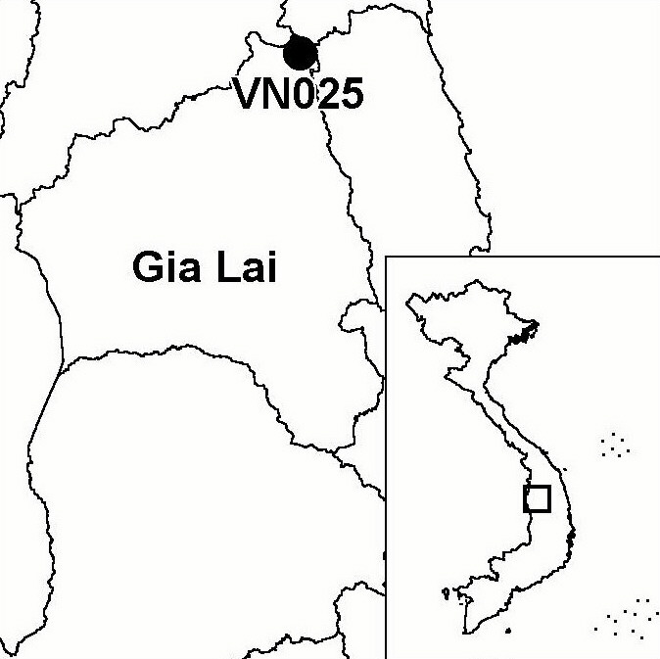
Province(s): Gia Lai
PA Status: Nature Reserve

Latitude: 14º31'N
Longitude: 108º35'E
Area: 15,900 ha
Altitude Range: 800-1,452 m asl

EBA / SA:

Kon Tum Plateau EBA
Priority Landscape:
CA1 - Central Annamites

General Description

The IBA is situated in the Central Highlands and comprises Kon Cha Rang Nature Reserve. The topography of the site is dominated by a mountainous plateau. Natural forest, principally lower montane evergreen forest, covers 98% of the IBA. The IBA supports significant stretches of intact riverine forest, the most significant of which are along the Kon river. Prior to 1975, there were several settlements of the Ba Na ethnic minority within the boundaries of what is now Kon Cha Rang Nature Reserve. Today, however, there is no permanent human settlement inside the IBA. Kon Cha Rang IBA is situated 12 km to the east of Kon Ka Kinh IBA, to which it is connected by intervening areas of forest. Although the two IBAs are designated as nature reserves, however, the intervening forest areas are under the management of state forest enterprises^{1,2}.

Bird Fauna: Key Features

Kon Cha Rang IBA supports a rich avifauna, including five of the nine restricted-range bird species that define the Kon Tum Plateau Endemic Bird Area. The forest at the IBA is in good condition, and supports populations of a number of globally threatened and near-threatened species, including Crested Argus Rheinardia ocellata, Great Hornbill Buceros bicornis and Blyth's Kingfisher Alcedo hercules. One of the most significant features of the site for the conservation of key bird species is the presence of extensive stretches of riverine forest, a habitat type that has been lost from most other parts of Vietnam, and one that is seriously under-represented within the national protected areas system³. The conservation importance of this habitat is highlighted by the fact that Kon Cha Rang IBA is one of only two sites in Vietnam known to support the globally threatened Masked Finfoot Heliopais personata.

Species | IBA  Criteria | Global Threat Status | Other  IBAs | Notes
Crested Argus  Rheinardia ocellata | A1, A2 | VU | 15 | A single female was observed and as many as 12 calling areas were located during a survey in May 1988⁴. The species was also recorded in March 1999².
Masked Finfoot  Heliopais personata | A1 | VU | 1 | Single birds were observed on the Kon river in May 1988 and March 1999^{1,4}.
Red-collared Woodpecker  Picus rabieri | A1, A3 | NT | 11 | A single male was observed at the site in May 1988⁴ and the species was also recorded in March 1999².
Great Hornbill  Buceros bicornis | A1 | NT | 13 | The species was recorded in March 1999².
Brown Hornbill  Anorrhinus tickelli | A1, A3 | NT | 16 | A single male was recorded in May 1988⁴ and the species was also recorded in March 1999².
Blyth's Kingfisher  Alcedo hercules | A1, A3 | NT | 8 | The species was recorded in March 1999².
Grey-headed Fish Eagle  Ichthyophaga ichthyaetus | A1 | NT | 8 | One adult was recorded in May 1988⁴ and the species was also recorded in March 1999².
Black-hooded Laughingthrush  Garrulax milleti | A1, A2 | NT | 8 | The species was recorded in March 1999².
Short-tailed Scimitar Babbler  Jabouilleia danjoui | A1, A2 | NT | 17 | The species was recorded in March 1999².
White-cheeked Laughingthrush  Garrulax vassali | A2 |  | 8 | The species was frequently seen in flocks of 20 or more birds during May 1988⁴ and was also recorded in March 1999².
Grey-faced Tit Babbler  Macronous kelleyi | A2 |  | 12 | A pair were observed nesting in May 1988⁴. The species was also recorded in March 1999².

Biome Restricted Species: The site qualifies under criterion A3 because it supports 16 species restricted to the Indochinese Tropical Moist Forests (Biome 09). See Appendix 4 for details.

Secondary Criteria

Species Status Species Status
Northern Slow Loris Nycticebus bengalensis² DD Buff-cheeked Gibbon Nomascus gabriellae² VU
Northern Pigtail Macaque Macaca leonina² VU Podocarpus neriifolius² DD
Stump-tailed Macaque Macaca arctoides² VU ['Indochinese' Hog Deer Axis porcinus annamiticus]² DD
Grey-shanked Douc Pygathrix nemaeus cinerea² DD Southern Serow Naemorhedus sumatraensis² VU

Notes: [ ] = unconfirmed record.

Threats to Biodiversity

Due to the remoteness of the site from permanent human settlement, the low human population density in the surrounding area, and the existence of adjacent areas of natural forest that can meet the subsitence needs of local communities for forest products, pressure on the natural resources of Kon Cha Rang IBA is very low, relative to other sites in Vietnam. However, the biodiversity of the IBA is under low levels of threat from hunting and over-exploitation of forest products. In the long-term, one of the biggest threats to biodiversity at the IBA is isolation from nearby areas of natural habitat, such as Kon Ka Kinh IBA, as a result of conversion of intervening forest areas to alternative land-uses. The impact of isolation on populations of key bird and mammal species would be potentially severe as the IBA is not, by itself, large enough to support viable populations of many of these species^{1,5}.
Threat | Severity
Agricultural intensification / expansion | ●
Hunting | ●
Other | ●

Conservation Actions

- Kon Cha Rang Nature Reserve was decreed by the government of Vietnam in 1986.
- A medium-sized GEF project entitled Making the Link: The Connection and Sustainable Management of Kon Ka Kinh and Kon Cha Rang Nature Reserves has been developed by Gia Lai Provincial People's Committee and BirdLife International and is currently awaiting approval¹.

Recommendations

- A management board for Kon Cha Rang Nature Reserve should be established.
- Sustainable forest management should be introduced into the intervening forest areas between Kon Cha Rang and Kon Ka Kinh IBAs.
- Permanent conservation areas, where no timber extraction is permittted, should be designated within the intervening state forest enterprises, in order to maintain a corridor of contiguous natural habitat between Kon Cha Rang and Kon Ka Kinh IBAs
- Human settlement into the buffer zone of Kon Cha Rang Nature Reserve should be strictly controlled.

References

1. BirdLife International and the Forest Inventory and Planning Institute (2001) Sourcebook of existing and proposed protected areas in Vietnam. Hanoi: BirdLife International Vietnam Programme and the Forest Inventory and Planning Institute.
2. Anon. (1999) [Investment plan for Kon Cha Rang Nature Reserve, Gia Lai province.] Hanoi: Forest Inventory and Planning Institute. (In Vietnamese.)
3. Wege, D. C. Long, A. J., Mai Ky Vinh, Vu Van Dung and Eames, J. C. (1999). Expanding the protected areas network in Vietnam for the 21st century: An analysis of the current system with recommendations for equitable expansion. Hanoi: BirdLife International Vietnam Programme and the Forest Inventory and Planning Institute.
4. Robson, C. R., Eames, J. C., Wolstencroft, J. A., Nguyen Cu and Truong Van La (1989) Recent records of birds from Vietnam. Forktail 5: 71-97.
5. Le Trong Trai, Le Van Cham, Tran Quang Ngoc and Tran Hieu Minh (2000) An investment plan for Kon Ka Kinh Nature Reserve, Gia Lai province, Vietnam: a contribution to the management plan. Hanoi: BirdLife International Vietnam Programme and the Forest Inventory and Planning Institute.

Masked Finfoot Heliopais personata

