Kon Ka Kinh Criteria: A1, A2 & A3

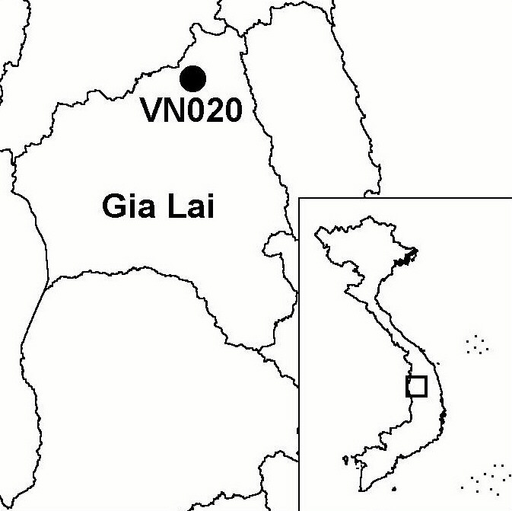
Province(s): Gia Lai
PA Status: Nature Reserve

Latitude: 14º20'N
Longitude: 108º22'E
Area: 41,710 ha
Altitude Range: 570-1,748 m asl

EBA / SA:

Kon Tum Plateau EBA
Priority Landscape:
CA1 - Central Annamites

General Description

The IBA comprises Kon Ka Kinh Nature Reserve, which is situated in the Central Highlands. The IBA has a mountainous topography, dominated by Mount Kon Ka Kinh (1,748 m asl). The IBA supports a range of habitat types, including lowland evergreen forest, lower montane evergreen forest and a small area of upper montane evergreen forest. In many areas, the forest has been degraded by timber extraction, and, at lower elevations, the forest has been extensively cleared by shifting cultivation and now supports a range of secondary vegetation types. Kon Ka Kinh IBA is situated 12 km to the west of Kon Cha Rang IBA and is connected by intervening areas of forest. However, while both IBAs are designated as nature reserves, intervening forest areas are under the management of state forest enterprises¹.

Bird Fauna: Key Features

Kon Ka Kinh IBA supports a rich and diverse montane avifauna, including six of the nine restricted-range bird species that define the Kon Tum Plateau Endemic Bird Area. Most notable among these species is Chestnut-eared Laughingthrush Garrulax konkakinhensis, which was discovered on Mount Kon Ka Kinh in 1999, becoming only the third species of bird to have been discovered in mainland South-East Asia during the last 30 years². The IBA is also important for the conservation of a number of globally near-threatened species, including Siamese Fireback Lophura diardi, Great Hornbill Buceros bicornis and Brown Hornbill Anorrhinus tickelli³.

Species | IBA  Criteria | Global Threat Status | Other  IBAs | Notes
Siamese Fireback  Lophura diardi | A1, A3 | NT | 13 | The species was recorded between February and April 1999³.
Great Hornbill  Buceros bicornis | A1 | NT | 13 | The species was recorded between February and April 1999³.
Brown Hornbill  Anorrhinus tickelli | A1, A3 | NT | 16 | The species was recorded between February and April 1999³.
Yellow-billed Nuthatch  Sitta solangiae | A1, A2 | NT | 11 | The species was recorded between February and April 1999³.
Black-hooded Laughingthrush  Garrulax milleti | A1, A2 | NT | 8 | The species was recorded between February and April 1999³.
Short-tailed Scimitar Babbler  Jabouilleia danjoui | A1, A2 | NT | 17 | The species was recorded between February and April 1999³.
White-cheeked Laughingthrush  Garrulax vassali | A2 |  | 8 | The species was recorded between February and April 1999³.
Chestnut-eared Laughingthrush  Garrulax konkakinhensis | A2 |  | 1 | The three type specimens of this species were collected on Mount Kon Ka Kinh between 1,600 and 1,700 m asl in April 1999².
Grey-faced Tit Babbler  Macronous kelleyi | A2 |  | 12 | The species was recorded between February and April 1999³.

Biome Restricted Species: The site qualifies under criterion A3 because it supports 28 species restricted to the Sino-Himalayan Subtropical Forests (Biome 08) and 10 species restricted to the Indochinese Tropical Moist Forests (Biome 09). See Appendix 4 for details.

Secondary Criteria

Species Status Species Status
Northern Pigtail Macaque Macaca leonina² VU Pinus dalatensis² VU
Stump-tailed Macaque Macaca arctoides² VU Fokienia hodginsii² NT
Grey-shanked Douc Pygathrix nemaeus cinerea² DD Cephalotaxus mannii² VU
Buff-cheeked Gibbon Nomascus gabriellae² VU Southern Serow Naemorhedus sumatraensis² VU
Impressed Tortoise Manouria impressa² VU

Threats to Biodiversity

The buffer zone of Kon Ka Kinh Nature Reserve is inhabited by members of indigeneous ethnic groups (principally Ba Na), who mainly practice shifting cultivation and exploitation of forest products; and in-migrants from lowland areas, who mainly cultivate coffee or are involved in forestry activities. During the 1990s, high coffee prices attracted a large number of spontaneous in-migrants to the area. During this period, the biggest threats to biodiversity at Kon Ka Kinh IBA were illegal timber extraction, mainly by outsiders; hunting, mainly by local people to supplement their diets; and conversion of forest to coffee plantations and shifting cultivation. As a result of the active efforts of the government agencies responsible for forest management and protection, the first two threats have been significantly reduced, while the third has reduced as a result of a fall in the coffee price. However, a high rate of natural population growth and the potential for a recovery of the coffee price mean that forest conversion remains a major threat^{1,3}.
Threat | Severity
Agricultural intensification / expansion | ● ●
Selective logging / cutting | ●
Hunting | ●

Conservation Actions

- Kon Ka Kinh was decreed as a nature reserve in 1986, and a management board was established in 1999¹.
- A medium-sized GEF project entitled Making the Link: The Connection and Sustainable Management of Kon Ka Kinh and Kon Cha Rang Nature Reserves has been developed by Gia Lai Provincial People's Committee and BirdLife International and is currently awaiting approval.¹

Recommendations

- Sustainable forest management should be introduced into the intervening forest areas between Kon Cha Rang and Kon Ka Kinh IBAs.
- Permanent conservation areas, where no timber extraction is permittted, should be designated within the intervening state forest enterprises, in order to maintain a corridor of contiguous natural habitat between Kon Cha Rang and Kon Ka Kinh IBAs.
- Policies should be implemented to actively discourage in-migration to the area.
- Strict controls on forest clearance, timber extraction and hunting should be enforced.

References

1. BirdLife International and the Forest Inventory and Planning Institute (2001) Sourcebook of existing and proposed protected areas in Vietnam. Hanoi: BirdLife International Vietnam Programme and the Forest Inventory and Planning Institute.
2. Eames, J. C. and Eames, C. (2001) A new species of laughingthrush (Passeriformes: Garrulacinae) from the central highlands of Vietnam. Bull. B.O.C. 121(1): 10-23.
- Le Trong Trai, Le Van Cham, Tran Quang Ngoc, Tran Hieu Minh, Nguyen Van Sang, Monastyrskii, A. L., Hayes, B. D. and Eames, J. C. (2000) An investment plan for Kon Ka Kinh Nature Reserve, Gia Lai province, Vietnam: a contribution to the management plan. Hanoi: BirdLife International Vietnam Programme and the Forest Inventory and Planning Institute.
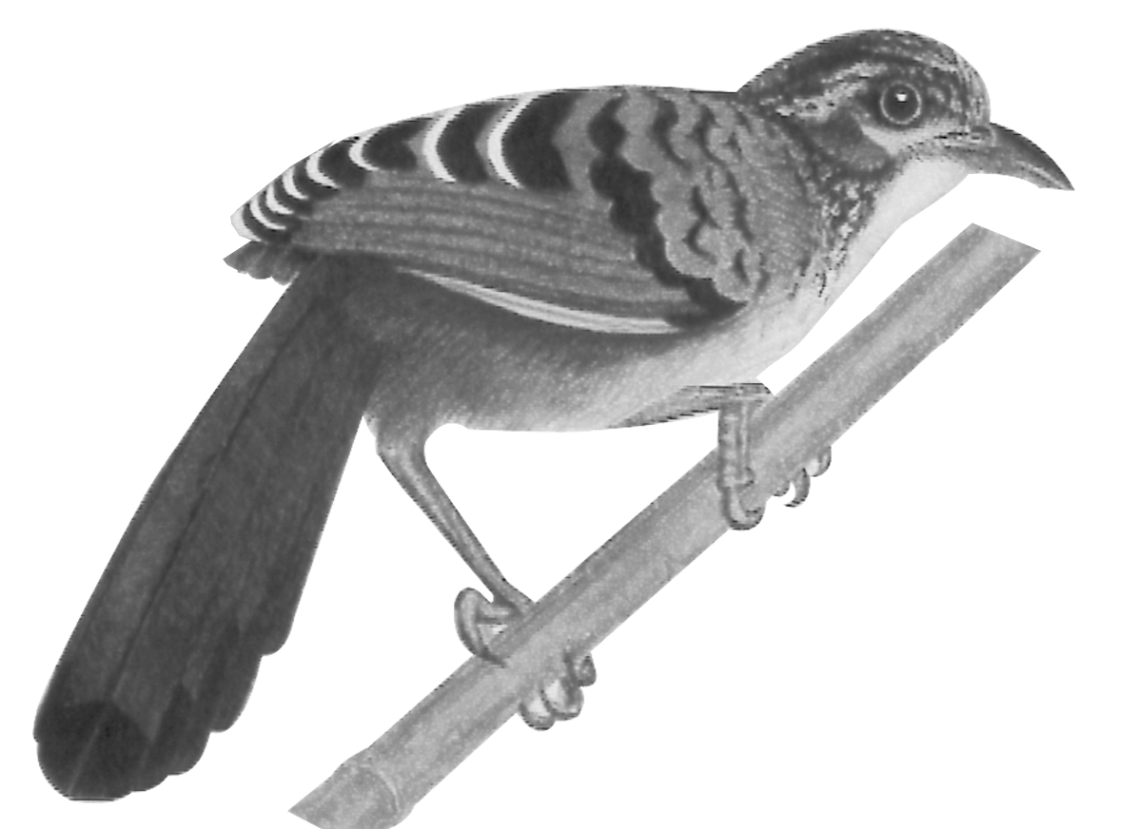

Chestnut-eared Laughingthrush Garrulax konkakinhensis

