Kien Luong Criteria: A1 & A4i

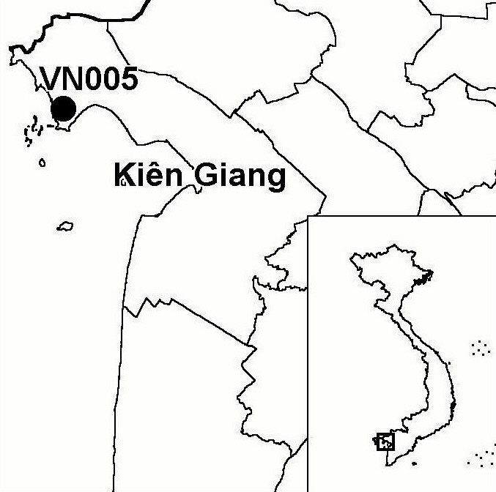
Province(s): Kien Giang
PA Status: None

Latitude: 10º13'N
Longitude: 104º38'E
Area: 7,624 ha
Altitude Range: 0-2 m asl

EBA / SA:

None
Priority Landscape:
LMF2 - North-western Mekong Delta Wetlands

General Description

Kien Luong IBA is situated in the south of the Ha Tien plain, one of the last remaining extensive areas of seasonally inundated grassland in the Mekong Delta. The natural vegetation at the site is seasonally inundated grassland with some brackish water characteristics, much of which is dominated by Eleocharis dulcis and E. ochrostachys. A small area of Melaleuca plantation is also present in the south-west part of the site¹. As at Ha Tien IBA, the soil at Kien Luong is predominantly acid-sulphate and susceptible to acidification if allowed to dry out and oxidise¹. In recent years, the site has been bisected by a series of canals, facilitating the conversion of large areas into agricultural land (principally wet rice) and aquacultural ponds.

Bird Fauna: Key Features

Kien Luong is one of the most important sites for the conservation of large waterbirds in the Mekong Delta². In particular, the IBA is an important non-breeding site for the eastern subspecies of Sarus Crane Grus antigone sharpii, and supported up to 45% of the total population of this subspecies in 2002³. Records of White-shouldered Ibis Pseudibis davisoni at the site during 1999 are also particularly noteworthy, as they indicate that a small breeding population may exist at the site¹. In Vietnam, White-shouldered Ibis has an extremely small and rapidly declining population, and it is currently only otherwise known from Nam Cat Tien IBA. Aside from the key species listed below, the site also supports Woolly-necked Stork Ciconia episcopus, which is of national conservation concern¹.

Species | IBA  Criteria | Global Threat Status | Other  IBAs | Notes
White-shouldered Ibis Pseudibis davisoni | A1 | CR | 1 | One bird was seen in April and a pair in August 1999; with possibly only two birds in total¹.
Sarus Crane  Grus antigone | A1, A4i | VU | 4 | Large flocks visit the site each dry season. Local people reported flocks of over 100 each dry season up to 1997⁴. A count of at least 135 individuals was made in April 1999¹, a maximum count of 336 was made in March 2001⁶, and a maximum count of 377 individuals was made in March 2002⁶.
Spot-billed Pelican  Pelecanus philippensis | A1 | VU | 6 | A single individual was seen in July 1999¹.
Painted Stork  Mycteria leucocephala | A1 | NT | 10 | A single individual was seen between April and August 1999¹.

Biome Restricted Species: The site does not qualify under criterion A3. See Appendix 4 for details.

Secondary Criteria

Species Status
Silver Langur Trachypithecus villosus⁵ DD

Threats to Biodiversity

As with Ha Tien IBA, the seasonally inundated grassland at the site is under severe and immediate threat of conversion to aquacultural ponds, agricultural land and Melaleuca plantations¹. Unfortunately, during 2001 and 2002, the integrity of Kien Luong was severely compromised by the construction of a series of canals causing significant habitat fragmentation and changes in flooding regimes. The construction of these canals was followed by conversion of large areas of seasonally inundated grassland into aquacultural ponds and, to a lesser extent, agricultural land, a problem further exacerbated by the establishment of Melaleuca plantations in remaining areas of natural grassland habitat. As a result of this rapid and extensive loss of natural habitat, it seems likely that the importance of the site for key bird species, particular Sarus Crane, will decrease significantly in coming years. Another threat to biodiversity at the IBA is quarrying of limestone karst for cement production, which threatens the habitat of Silver Langur Trachypithecus villosus.
Threat | Severity
Afforestation | ● ● ●
Agricultural intensification / expansion | ● ● ●
Aquaculture / fisheries | ● ● ●
Disturbance to birds | ● ●
Dredging and canalization | ● ● ●
Extraction industry (mining) | ● ●

Conservation Actions

- In 1999, the BirdLife International Vietnam Programme and IEBR proposed the establishment of a national protected area at the site¹.
- In 2001, Kien Luong was included on a list of proposed protected areas submitted to the national government, with a proposed area of 14,605 ha.
- In June 2001, Kien Giang Provincial Department of Agriculture and Rural Development and Vietnam National University, Ho Chi Minh City, hosted a workshop in Kien Giang province to discuss the conservation and utilisation of natural resources in the Ha Tien plain, at which the provincial authorities announced a plan to establish a protected area in the Ha Tien plain, which would not necessarily include the IBA.
- A coalition of interested parties - including BirdLife International - are currently developing a project to promote conservation of the biodiversity values within the IBA.

Recommendations

- Kien Luong meets the criteria for designation as a site of international importance for wetland conservation under the Ramsar Convention, and should, therefore, be designated as a Ramsar site.
- Conversion of natural habitats at the site and canal construction should cease immediately.
- All remaining viable areas of natural habitat should be placed under conservation management, with an appropriate land-use designation that prohibits further agricultural, aquacultural and forestry developments.
- Surveys should be conducted in other areas of the Ha Tien plain to identify alternative sites for the conservation of seasonally inundated grassland and the associated large waterbird species.

References

1. Buckton, S. T., Nguyen Cu, Nguyen Duc Tu and Ha Quy Quynh (1999) The conservation of key wetland sites in the Mekong Delta. Hanoi: Birdlife International Vietnam Programme.
2. BirdLife International and the Forest Inventory and Planning Institute (2001) Sourcebook of existing and proposed protected areas in Vietnam. Hanoi: BirdLife International Vietnam Programme and the Forest Inventory and Planning Institute.
3. Anon. (2002) Sarus Crane census in Indochina. Cambodia Bird News 9: 60.
4. Robson, C. R. (1997) From the field. OBC Bulletin 26: 60-66.
- Tran Triet ed. (2001) Proceedings of the workshop: Conservation and utilization of biodiversity resources of the Ha Tien-Kien Luong wetlands, Kien Giang province. Rach Gia 17-19 June 2001. Ho Chi Minh City: College of Natural Sciences, Vietnam National University.
- Eames, J. C. and Tordoff, A. W. (in prep) Recent records and a conservation status review of some threatened and near-threatened bird species in Vietnam.

