Khe Net Criteria: A1, A2 & A3

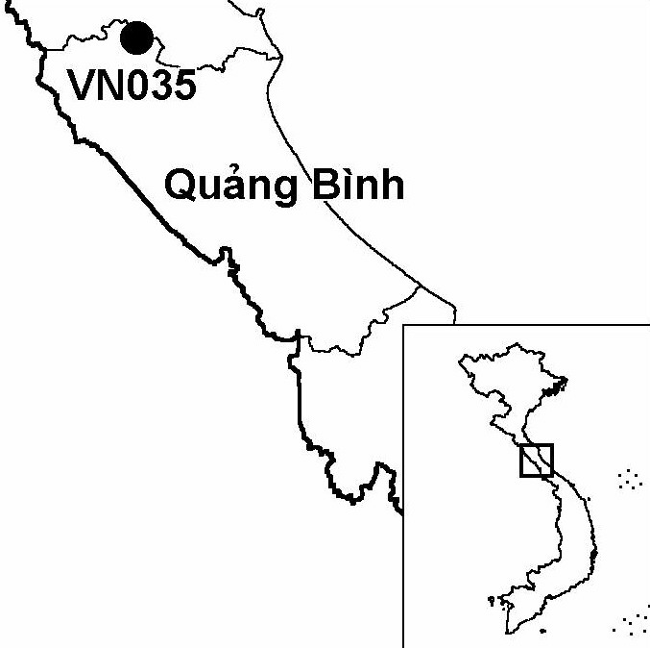
Province(s): Quang Binh
PA Status: None

Latitude: 18º02'N
Longitude: 105º58'E
Area: 23,524 ha
Altitude Range: 80-494 m asl

EBA / SA:

Annamese Lowlands EBA
Priority Landscape:
NA5 - Ke Go and Khe Net Lowlands

General Description

The IBA comprises Khe Net proposed nature reserve, which is situated in the Annamese lowlands. The topography of the IBA is characterised by low hills, which support a large area of lowland evergreen forest. The forest in the IBA is currently under the management of Tuyen Hoa Forest Enterprise, although commercial logging activities ceased in 1997¹. Most of the forest in the IBA has been heavily degraded by commercial logging activities, although there remain significant areas of relatively undisturbed forest in remote and inaccessible areas and on steep slopes. In addition to the lowland evergreen forest, there are some small patches of limestone forest in the south-west and south-east of the IBA². To the north, Khe Net IBA is contiguous with Ke Go IBA.

Bird Fauna: Key Features

Together with the contiguous Ke Go IBA, Khe Net IBA supports one of the largest remaining areas of lowland evergreen forest in the Annamese lowlands. Most significantly, the two sites support the only known population of the globally endangered Vietnamese Pheasant Lophura hatinhensis in the world. In addition, Khe Net IBA supports populations of five other restricted-range species of the Annamese Lowlands Endemic Bird Area: Annam Partridge Arborophila merlini, Imperial Pheasant L. imperialis, Crested Argus Rheinardia ocellata, Short-tailed Scimitar Babbler Jabouilleia danjoui and Grey-faced Tit Babbler Macronous kelleyi. Recent taxonomic research, however, indicates that Imperial Pheasant may not be a true species but, rather, a hybrid between Vietnamese Pheasant or Edwards's Pheasant or L. edwardsi and Silver Pheasant L. nycthemera³.

Species | IBA  Criteria | Global Threat Status | Other  IBAs | Notes
Vietnamese Pheasant  Lophura hatinhensis | A1, A2 | EN | 1 | At least eight birds were observed during one week's fieldwork in June and July 1994⁴. A further three birds were observed in lowland evergreen forest at 200 m asl in July 2000².
Crested Argus  Rheinardia ocellata | A1, A2 | VU | 15 | The species was heard calling from ridge tops in June and July 1994⁴.
Chestnut-necklaced Partridge  Arborophila charltonii | A1 | NT | 7 | The species was recorded between June and July 1994⁴. The species was heard calling on numerous occasions between June and July 2000, and a single female was caught².
Siamese Fireback  Lophura diardi | A1, A3 | NT | 13 | The species was recorded between June and July 1994⁴.
Red-collared Woodpecker  Picus rabieri | A1, A3 | NT | 11 | The species was recorded between June and July 1994, and between June and July 2000^{2,4}.
[Great Hornbill  Buceros bicornis] | A1 | NT | 14 | The species was provisionally recorded in 2000².
Brown Hornbill  Anorrhinus tickelli | A1, A3 | NT | 16 | The species was recorded between June and July 1994⁴. During July 2000, the species was observed on four days, in flocks ranging in size from 6 to 18 birds².
Blyth's Kingfisher  Alcedo hercules | A1, A3 | NT | 8 | The species was recorded between June and July 1994⁴, and between June and July 2000², along the Khe Che, Khe Mon and Khe Da Ma streams.
Short-tailed Scimitar Babbler  Jabouilleia danjoui | A1, A2 | NT | 17 | The species was recorded between June and July 1994, and between June and July 2000^{2,4}.
Imperial Pheasant  Lophura imperialis | A1, A2 | DD | 2 | In February 1990, an immature male was trapped by rattan collectors, 12 km to the west of Cat Bin⁵. While the precise locality is not certain, it appears to lie on the border between Ke Go Nature Reserve and Khe Net proposed nature reserve.
Annam Partridge  Arborophila merlini | A2 |  | 4 | Three birds were observed in June 2000².
Grey-faced Tit Babbler  Macronous kelleyi | A2 |  | 12 | The species was recorded between June and July 1994, and between June and July 2000^{2,4}.
Notes: [ ] = unconfirmed record.

Biome Restricted Species: The site qualifies under criterion A3 because it supports 18 species restricted to the Indochinese Tropical Moist Forests (Biome 09). See Appendix 4 for details.

Secondary Criteria

Species Status Species Status
[Northern Slow Loris Nyticebus bengalensis]² DD [Red-shanked Douc Pygathrix nemaeus nemaeus]² EN
Northern Pigtail Macaque Macaca leonina² VU [White-cheeked Gibbon Nomascus leucogenys]² DD
[Assamese Macaque Macaca assamensis]² VU Podocarpus neriifolius² DD
[Rhesus Macaque Macaca mulatta]² NT [Gaur Bos gaurus]² VU
Stump-tailed Macaque Macaca arctoides² VU Southern Serow Naemorhedus sumatraensis² VU
Hatinh Langur
Trachypithecus francoisi hatinhensis² EN

Notes: [ ] = unconfirmed record.

Threats to Biodiversity

Past commercial logging activities by Tuyen Hoa Forest Enterprise have led to the degradation of large areas of natural habitat within the IBA, including the key habitat for Vietnamese Pheasant: lowland evergreen forest. While commercial logging largely ceased in 1997, many households in the buffer zone of the proposed nature reserve are dependent on natural resources, and continue to extract timber and other forest products on a small scale. In addition to habitat degradation, hunting is a major threat to biodiversity at Khe Net. Snaring is widespread within the IBA, and threatens the populations of a number of key bird species, especially galliformes, such as Vietnamese Pheasant and Crested Argus.
Threat | Severity
Agricultural intensification / expansion | ●
Hunting | ● ●
Selective logging / cutting | ●

Conservation Actions

In 2001, a feasibility study for the establishment of a protected area at Khe Net was prepared, and proposed establishing a 23,524 ha nature reserve².

Recommendations

- Khe Net should be decreed as a nature reserve by the government of Vietnam, and a management board should be established.
- Protected area management regulations, particularly controls on hunting, timber extraction and NTFP collection, should be strictly enforced, particularly controls on snaring.
- A programme of environmental awareness activities should be initiated in the surrounding area to raise awareness among local communities and decision makers about the values of the IBA and to promote sustainable natural resource use.
- Further studies should be conducted to assess the status and distribution of Vietnamese Pheasant and other restricted-range species at the IBA.

References

1. BirdLife International and the Forest Inventory and Planning Institute (2001) Sourcebook of existing and proposed protected areas in Vietnam. Hanoi: BirdLife International Vietnam Programme and the Forest Inventory and Planning Institute.
2. Le Trong Trai, Tran Hieu Minh, Do Tuoc and Nguyen Van Sang (2001) [Feasibility study for the establishment of Khe Net Nature Reserve, Quang Binh province, Vietnam]. Hanoi: BirdLife International Vietnam Programme and the Forest Inventory and Planning Institute. (In Vietnamese.)
3. Garson, P. (2001) Pheasant taxonomy: a cunning way to remove species from the Red List! OBC Bulletin 33: 52.
4. Eames, J. C., Lambert, F. R. and Nguyen Cu (1994) A survey of the Annamese lowlands, Vietnam and its implications for the conservation of Vietnamese and Imperial Pheasants Lophura hatinhensis and L. imperalis. Birdlife Conservation International 4(4): 343-382.
5. Robson, C. R., Eames, J. C., Newman, M., Nguyen Cu and Truong Van La (1990) Forest bird surveys in Vietnam 1989/90: final report. Unpublished report to the International Council for Bird Preservation.

Imperial Pheasant Lophura imperialis

