Kon Plong Criteria: A1, A2 & A3

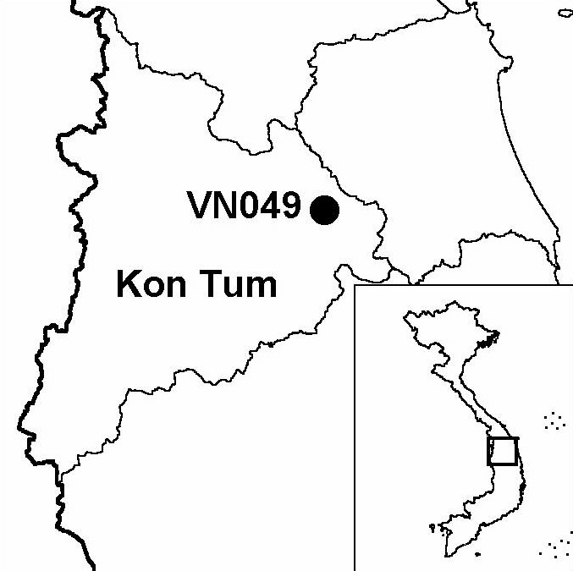
Province(s): Kon Tum
PA Status: None

Latitude: 14º46'N
Longitude: 108º20'E
Area: 65,077 ha
Altitude Range: 1,100-1,757 m asl

EBA / SA:

Kon Tum Plateau EBA
Priority Landscape:
CA1 - Central Annamites

General Description

Situated on the Kon Tum plateau, the IBA comprises the Kon Plong Forest Complex, which includes Manh Canh II and Tan Lap State Forest Enterprises and Ngoc Tem Watershed Protection Forest. The topography of the IBA consists of a montane plateau dissected by a complex of valleys. The highest point in the IBA is Mount Ngoc Boc at 1,757 m asl. The natural vegetation of Kon Plong IBA is lower montane evergreen forest, including a number of forest formations dominated by conifers. However, more than 75% of the total area of the IBA has been degraded by human activities, principally commercial logging, and now supports a range of secondary habitats, including regenerating forest, bamboo forest, grassland and scrub¹.

Bird Fauna: Key Features

Kon Plong IBA is situated in the Kon Tum Plateau Endemic Bird Area (EBA). The IBA supports seven restricted-range bird species: more than are known to occur at any other site in the EBA. Most significantly, the IBA supports two species whose global ranges are confined to the EBA: Golden-winged Laughingthrush Garrulax ngoclinhensis and Chestnut-eared Laughingthrush G. konkakinhensis. Although the forest at Kon Plong IBA is more degraded and fragmented than that at other IBAs in the Kon Tum Plateau EBA, two globally near-threatened hornbill species have been recorded: Brown Hornbill Anorrhinus tickelli and Great Hornbill Buceros bicornis. It is unlikely, however, that the IBA regularly supports a significant population of the latter species¹.

Species | IBA  Criteria | Global Threat Status | Other  IBAs | Notes
Crested Argus  Rheinardia ocellata | A1, A2 | VU | 15 | The species was heard on several occasions in primary forest on Mount Ngoc Boc between December 2000 and January 2001¹.
Golden-winged Laughingthrush  Garrulax ngoclinhensis | A1, A2 | VU | 1 | A flock of at least three birds was observed at 1,480 m asl on Mount Ngoc Boc in early January 2001¹.
†Great Hornbill  Buceros bicornis | A1 | NT | 13 | A feather belonging to this species was found on Mount Ngoc Boc in January 2001¹. The site probably does not regularly support a significant population of this species.
Brown Hornbill  Anorrhinus tickelli | A1, A3 | NT | 16 | The species was recorded on five occasions between December 2000 and January 2001, including flocks of 15 birds on two occasions¹.
Yellow-billed Nuthatch  Sitta solangiae | A1, A2 | NT | 11 | The species was recorded on four occasions between December 2000 and January 2001¹.
Black-hooded Laughingthrush  Garrulax milleti | A1, A2 | NT | 8 | The species was recorded on numerous occasions between December 2000 and January 2001¹.
Short-tailed Scimitar Babbler  Jabouilleia danjoui | A1, A2 | NT | 17 | Single birds were recorded on three occasions between December 2000 and January 2001¹.
White-cheeked Laughingthrush  Garrulax vassali | A2 |  | 8 | A flock of 10 birds and a flock of 40 were recorded in December 2000¹.
Chestnut-eared Laughingthrush  Garrulax konkakinhensis | A2 |  | 1 | The species was recorded on a number of occasions between December 2000 and January 2001¹.

Notes: † = not confirmed to regularly occur in significant numbers.

Biome Restricted Species: The site qualifies under criterion A3 because it supports 29 species restricted to the Sino-Himalayan Subtropical Forests (Biome 08). See Appendix 4 for details.

Secondary Criteria

Species Status Species Status
[Northern Slow Loris Nycticebus bengalensis]¹ DD [Elongated Tortoise Indotestudo elongata]¹ EN
[Pygmy Loris Nycticebus pygmaeus]¹ VU [Impressed Tortoise Manouria impressa]¹ VU
Northern Pigtail Macaque Macaca leonina¹ VU Pinus merkusii¹ VU
Stump-tailed Macaque Macaca arctoides¹ VU Podocarpus neriifolius¹ DD
Grey-shanked Douc Pygathrix nemaeus cinerea¹ VU Cephalotaxus mannii¹ VU
Buff-cheeked Gibbon Nomascus gabriellae¹ VU Southern Serow Naemorhedus sumatraensis¹ VU
Big-headed Turtle Platysternon megacephalum¹ EN

Notes: [ ] = unconfirmed record.

Threats to Biodiversity

The major threat to biodiversity at Kon Plong IBA is commercial timber extraction. A large proportion of the IBA is under state forest enterprise management, and timber extraction is currently taking place at unsustainable levels. Other significant threats include hunting and over-exploitation of NTFPs, both of which take place for domestic consumption and in response to commercial demand. Clearance of forest for agriculture is currently not a major threat to biodiversity at the IBA but may become so in the future if the local human population increases as a result of natural population growth or settlement of migrants. In this context, another potential threat is construction of roads through the IBA, which could act as foci for human settlement¹.
Threat | Severity
Agricultural intensification / expansion | ●
Commercial timber extraction | ● ● ●
Hunting | ● ●
Infrastructure development | ● ●
Selective logging / cutting | ●
Unsustainable exploitation of NTFPs | ● ●

As well as affecting the IBA directly, commercial forestry operations, road construction and subsequent human settlement and clearance of forest for agriculture may result in loss of contiguous areas of natural forest that currently link Kon Plong IBA with Ngoc Linh IBA to the north and Kon Ka Kinh and Kon Cha Rang IBAs to the south.

Conservation Actions

- During 2000, the World Bank-WWF Forest Alliance and the Tropical Forest Trust began developing a project to promote sustainable forest management within the IBA, entitled Sustainable forest management and biodiversity conservation in the Kon Plong Forest Complex. This project has yet to begin implementation.

Recommendations

- Sustainable forest management practices should be introduced at Manh Canh II and Tan Lap State Forest Enterprises¹.
- Sustainable exploitation of natural resources, particularly wild animals and NTFPs, should be promoted among local communities.
- Biodiversity considerations should be integrated into plans for infrastructure development and human settlement within the IBA, in order to mitigate potential negative impacts.

References

1. Eames, J. C., Kuznetsov, A. N., Monastyrskii, A. L., Nguyen Tien Hiep, Nguyen Quang Truong and Ha Quy Quynh (2001) A preliminary biological assessment of the Kon Plong forest complex, Kon Tum province, Vietnam. Hanoi: WWF Indochina Programme.
2. BirdLife International and the Forest Inventory and Planning Institute (2001) Sourcebook of existing and proposed protected areas in Vietnam. Hanoi: BirdLife International Vietnam Programme and the Forest Inventory and Planning Institute.

