Lang Bian Criteria: A1 & A2

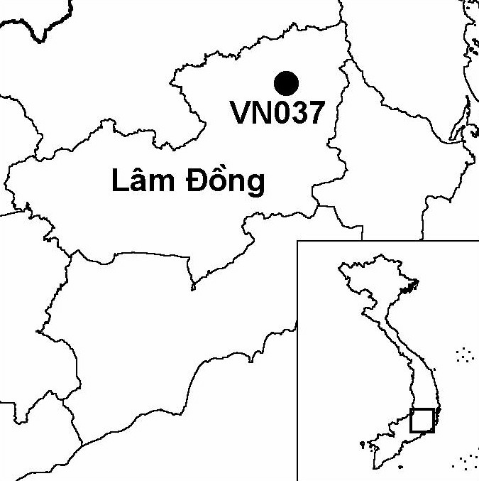
Province(s): Lam Dong
PA Status: Nature Reserve

Latitude: 12º03'N
Longitude: 108º26'E
Area: 10,000 ha
Altitude Range: 1,400-2,167 m asl

EBA / SA:

Da Lat Plateau EBA
Priority Landscape:
SA 3 - Southern Annamites Main Montane Block

General Description

The IBA is centred on Mount Lang Bian (also known as Mount Nui Ba), which lies on the Da Lat plateau. The major vegetation types at the IBA are coniferous forest, montane evergreen forest and secondary scrub. The coniferous forest is dominated by Pinus kesiya¹. Most of the IBA is contained within Bi Dup-Nui Ba Nature Reserve, although a significant area on the south face of Mount Lang Bian lies outside of the nature reserve, under the management of the provincial tourism company. To the north, Lang Bian IBA is contiguous with Chu Yang Sin IBA in Dak Lak province.

Bird Fauna: Key Features

Lang Bian IBA lies within the Da Lat Plateau Endemic Bird Area (EBA), and supports three of the eight restricted-range species that occur in this EBA: Collared Laughingthrush Garrulax yersini, Yellow-billed Nuthatch Sitta solangiae and Vietnam Greenfinch Carduelis monguilloti². In addition, eight individuals of a previously undescribed taxon of bullfinch were observed on Mount Lang Bian in February 1998. Although no specimens have been collected to date, it may be that these birds, which resemble Brown Bullfinch Pyrrhula nipalensis, represent an as yet undescribed species³. Mount Lang Bian is given as a historical collecting locality for the globally endangered Grey-crowned Crocias Crocias langbianis, a species endemic to the Da Lat plateau⁴. There are, however, no recent records of this species⁵, and it may now be extinct at the site as a result of loss of lower montane evergreen forest, the habitat type to which it is restricted.

Species | IBA  Criteria | Global Threat Status | Other  IBAs | Notes
Collared Laughingthrush  Garrulax yersini | A1, A2 | EN | 5 | There are regular records of the species in upper montane evergreen forest near the summit of Mount Lang Bian. For example, several birds were heard in May 1991^{2,6}, the species was recorded in December 1994⁷, six birds were observed and four were heard in April 1998⁸ and two birds were seen in February 2002⁹.
Yellow-billed Nuthatch  Sitta solangiae | A1, A2 | NT | 11 | Four birds were recorded in May 1991^{2,6}.
Vietnam Greenfinch  Carduelis monguilloti | A1, A2 | NT | 4 | There are regular records of the species in coniferous forest. For example, the species was recorded in January 1994⁶, December 1994⁷, April 1998⁸, December 2000¹⁰ and March 2002¹⁰.

Biome Restricted Species: The site does not qualify under criterion A3. See Appendix 4 for details.

Secondary Criteria

Species Status Species Status
*[Stump-tailed Macaque Macaca arctoides]¹¹ VU *Fokienia hodginsii¹¹ NT
*Buff-cheeked Gibbon Nomascus gabriellae¹¹ VU *Podocarpus neriifolius¹¹ DD
*Pinus dalatensis¹¹ VU *[Asian Elephant Elephas maximus]¹¹ EN
Pinus krempfii^{11,12} VU *Gaur Bos gaurus¹¹ VU
Pinus merkusii¹² VU *[Southern Serow Naemorhedus sumatraensis]¹¹ VU
*Calocedrus macrolepis¹¹ VU

Notes: [ ] = unconfirmed record; * = recorded during a survey of Bi Dup-Nui Ba Nature Reserve but, due to a lack of locality data, it is uncertain whether the species occurs within the IBA or not.

Threats to Biodiversity

Human activities have led to changes in the distribution of different vegetation types at the IBA, with impacts on biodiversity. For instance, charcoal production and firewood collection have led to the destruction of most of the evergreen forest on Mount Lang Bian. Similarly, shifting cultivation has led to loss of forest cover, and associated fires have promoted a transition from montane evergreen forest to fire-climax coniferous forest dominated by Pinus kesiya¹. As the biodiversity value of coniferous forest is lower than that of evergreen forest, this transition has tended to reduce the conservation importance of the IBA, especially for Collared Laughingthrush, which is restricted to upper montane evergreen forest².
Threat | Severity
Agricultural intensification / expansion | ● ●
Fire | ● ● ●
Hunting | ● ●
Infrastructure development | ●
Recreation / tourism | ● ●
Selective logging / cutting | ● ●
Unsustainable exploitation of NTFPs | ● ● ●
A further threat to biodiversity at Lang Bian IBA is posed by tourism development. To date, a number of tourism resorts have been constructed on the south face Mount Lang Bian, which is situated close to Da Lat city, a major tourist destination. Wild animal meat is openly sold in these resorts, and the large numbers of visitors represent an increased risk of forest fire.

Conservation Actions

- The establishment of Bi Dup Nature Reserve, which was later incorporated within Bi Dup-Nui Ba Nature Reserve, was decreed by the government of Vietnam in 1986¹.
- A management board for Bi Dup-Nui Ba Nature Reserve was established in 1993¹.

Recommendations

- Important areas of habitat on the southern face of Mount Lang Bian should be incorporated within the boundaries of Bi-Dup-Nui Ba Nature Reserve and managed with the principal objective of biodiversity conservation.
- A tourism management board, including representatives of the nature reserve management board, the provincial tourism company and other local stakeholders, should be established as a basis for environmentally sustainable tourism development at the site.
- Forest management at the site should focus on maintaining remaining areas of good quality montane evergreen forest, and promoting natural regeneration within more disturbed areas.
- Enforcement of protected area management regulations should be strengthened. In particular, strict controls should be introduced on exploitation of forest products, hunting and trade in wildlife.
- A comprehensive fire management programme should be initiated, including environmental awareness activities aimed at raising awareness among local communities of the hazards posed by fire.

References

1. BirdLife International and the Forest Inventory and Planning Institute (2001) Sourcebook of existing and proposed protected areas in Vietnam. Hanoi: BirdLife International Vietnam Programme and the Forest Inventory and Planning Institute.
2. Eames, J. C. (1995) Endemic birds and protected area development on the Da Lat plateau, Vietnam. Bird Conservation International 5(4): 491-523.
3. Robson, C. R. (1998) From the field. OBC Bulletin 27: 61-66.
4. Eames, J. C. and Ericson, P. G. P. (1996) The Björkegren expedition to French Indochina: a collection of birds from Vietnam and Cambodia. Nat. Hist. Bull. Siam Soc. 44: 75-111.
5. BirdLife International (2001) Threatened birds of Asia: the BirdLife International red data book. Cambridge, U.K.: BirdLife International.
6. Robson, C. R., Eames, J. C., Nguyen Cu and Truong Van La (1993) Further recent records of birds from Vietnam. Forktail 8: 25-52.
7. Dymond, J. N. (1998) Birds in Vietnam in December 1993 and December 1994. Forktail 13: 7-12.
8. Hornbuckle, J. (1998) Vietnam Trip Report 24 March to 14 April 1998. Unpublished Report on WorldTwitch Internet Website.
9. A. W. Tordoff personal observation.
10. R. Craik in litt. 2002.
11. Eames, J. C. and Nguyen Cu (1994) A management feasibility study of Thuong Da Nhim and Chu Yang Sin Nature Reserves on the Da Lat Plateau, Vietnam. Hanoi: WWF Vietnam Programme and the Forest Inventory and Planning Institute.
12. Nguyen Tien Hiep and Vidal, J. E (1996) Flore du Cambodge du Laos et du Vietnam. Vol. 28: Gymnospermae. Paris: Museum National D'Histoire Naturelle. (In French.)

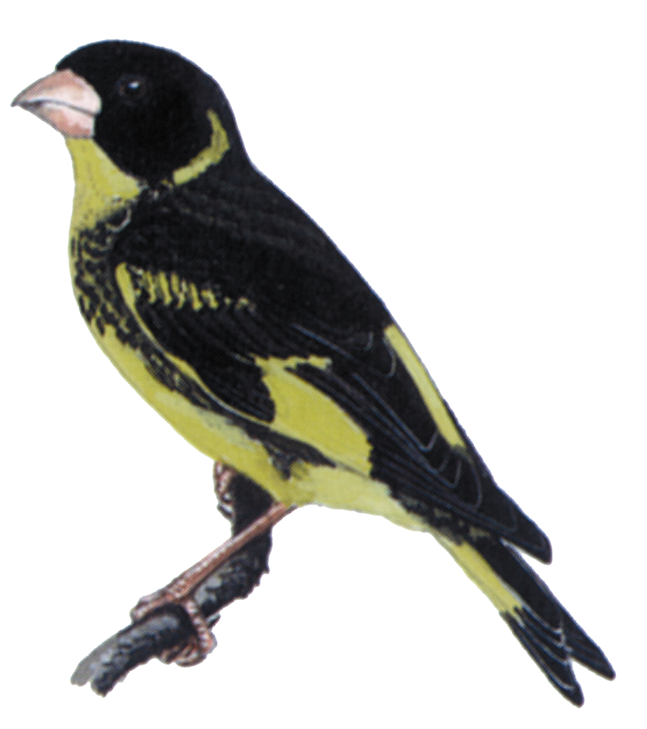

Vietnam Greenfinch Carduelis monguilloti

