Nghia Hung Criteria: A1, A4i & A4iii

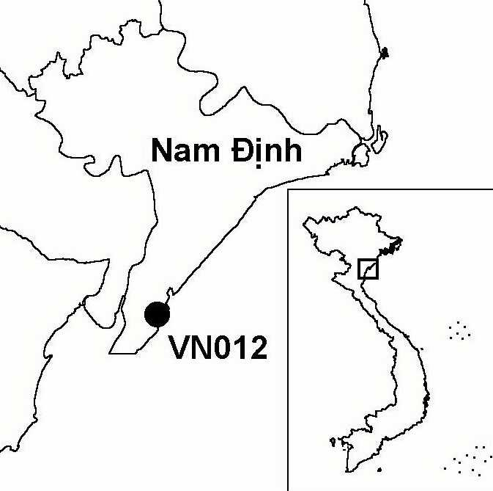
Province(s): Nam Dinh
PA Status: None

Latitude: 19º58'N
Longitude: 106º10'E
Area: 7,600 ha
Altitude Range: 0-2 m asl

EBA / SA:

None
Priority Landscape:
None

General Description

Nghia Hung IBA is located in the south of the Red River Delta, and comprises 12 km of coastline, between the estuaries of the Day and Ninh Co rivers. Adjacent to the Ninh Co estuary, the main habitats are saltmarsh, sandy beaches and dunes, some of which have been afforested with the exotic Casuarina equisetifolia. To the west of the Ninh Co estuary, the coastline is dominated by aquacultural ponds, some of which support beds of Phragmites reed. In the Day estuary, a large area of intertidal mudflats extends offshore. The landward side of these mudflats has been afforested with mangrove, much of which has been enclosed within aquacultural ponds. The IBA also includes two small, sandy islands, about 5 km offshore¹.

Bird Fauna: Key Features

Nghia Hung is an important staging and wintering site for migratory waterbirds. Each year, the site supports significant numbers of wintering gulls, shorebirds and waterfowl. During April 1994, it was estimated that over 30,000 shorebirds were in the district¹. A high tide roost of shorebirds is located on the southernmost offshore island where a maximum of 1,774 shorebirds were recorded during May 1996¹. Surveys to date have recorded the occurrence of nine globally threatened and near-threatened species at the site, including two endangered species, Spotted Greenshank Tringa guttifer and Black-faced Spoonbill Platalea minor. In addition, the site regularly supports more than 1% of the Asian biogeographic population of Spotted Redshank T. erythropus and Lesser Sand Plover Charadrius mongolus. Furthermore, Nghia Hung is not only important for migratory waterbirds; the offshore islands are both important stop-over sites for passerine migrants and other migratory birds.

Species | IBA  Criteria | Global Threat Status | Other  IBAs | Notes
Spotted Greenshank  Tringa guttifer | A1 | EN | 3 | A maximum of two birds were observed during April 1994². Five individuals were recorded at the site in May 1996¹.
Black-faced Spoonbill  Platalea minor | A1, A4i | EN | 8 | This species has been recorded on several occasions during recent years, with maximum counts of 28 birds in 1993, 41 in 1994, 10 in 1995, 16 in 1996 and 12 in 1997^{2,3}.
Spoon-billed Sandpiper  Eurynorhynchus pygmeus | A1 | VU | 3 | The species was observed on a number of occasions during April 1994, with a maximum count of seven birds².
Saunders's Gull  Larus saundersi | A1, A4i | VU | 5 | The species has been observed on a number of occasions during recent years, with maximum counts of 260 birds in 1994, 120 in 1995, 17 in 1997 and 18 in 2001. All records are from the period from January to March^{2,4}.
Chinese Egret  Egretta eulophotes | A1 | VU | 6 | Three individuals were observed in April 1993³. The species was observed on a number of occasions between March and May 1994, with a maximum count of two birds².
Spot-billed Pelican  Pelecanus philippensis | A1 | VU | 6 | Four birds were observed in June 1994².
Asian Dowitcher  Limnodromus semipalmatus | A1 | NT | 5 | The species was observed on a number of occasions between April and June 1994, with a maximum count of eight birds².
†Black-headed Ibis  Threskiornis melanocephalus | A1 | NT | 8 | A single immature bird was observed in February 1994². It is unlikely that the site regularly supports a significant population of this species.
†Japanese Paradise-flycatcher  Terpsiphone atrocaudata | A1 | NT | 1 | A single male was seen roosting on one of the small offshore islands during April 1994². The site is unlikely to regularly support a significant population.
Spotted Redshank  Tringa erythropus | A4i |  | 2 | Counts of 750 and 640 birds were made in April 1994 and May 1996 respectively^{1,2}.
Lesser Sand Plover  Charadrius mongolus | A4i |  | 0 | A count of 2,000 birds was made in April 1994⁴.

Notes: † = not confirmed to regularly occur in significant numbers.

Biome Restricted Species: The site does not qualify under criterion A3. See Appendix 4 for details.

Secondary Criteria

The site does not qualify under any secondary criterion.

Threats to Biodiversity

The main threats to biodiversity at Nghia Hung are hunting, disturbance and habitat loss. Hunting presents a particular threat to populations of waterbirds. During February 1996, 20 km of mist-nets were observed in the intertidal area of the site. Hunters also use airguns and shotguns. The main quarry species are ducks and geese, which are sold for export to China. Despite the introduction of a hunting ban, levels of hunting have remained high because local people depend heavily on exploitation of natural resources and do not understand why the ban was introduced, and because the local authorities have not implemented the ban strictly. In addition to hunting with guns, disturbance to birds, arising from shellfish collection, is also a threat. During a survey in 1996, around 1,000 people were observed engaged in this activity in the intertidal zone.

A further threat to biodiversity at the site is habitat loss. Habitat loss takes two forms. Firstly, intertidal mudflats are being afforested with mangrove, with the support of the Danish Red Cross. Secondly, intertidal habitats are being enclosed within aquacultural ponds. As of March 1998, there was a plan to construct a second dyke, which would enclose large areas of intertidal mudflat, including areas afforested with mangrove by the Danish Red Cross. These threats arise partly from a lack of appreciation among the district and provincial authorities of the value of mudflats and natural mangrove^{1,2}.
Threat | Severity
Afforestation | ● ● ●
Aquaculture/ fisheries | ● ● ●
Construction of dykes / dams | ● ● ●
Disturbance to birds | ● ●
Hunting | ● ● ●

Conservation Actions

- None to date.

Recommendations

- Nghia Hung meets the criteria for designation as a site of international importance for wetland conservation under the Ramsar Convention, and should, therefore, be designated as a Ramsar site¹.
- A management plan should be developed for the entire coastal zone of Nghia Hung district that seeks to promote sustainable exploitation of aquatic resources, taking into account the importance of feeding and roosting habitats for migratory shorebirds¹.
- Capacity building should be undertaken to improve the technical and management capacity of the district FPD.
- Strict controls on hunting should be introduced throughout the coastal zone of Nghia Hung district.
- Awareness-raising activities should be conducted among the stakeholders of the area to promote understanding and appreciation of the values of migratory birds, natural mangrove and intertidal mudflats.

References

1. Pedersen, A. and Nguyen Huy Thang (1996) The conservation of key coastal wetland sites in the Red River Delta. Hanoi: BirdLife International Vietnam Programme.
2. Pedersen, A., Nielsen, S., Le Dien Thuy and Le Trong Trai (1998) The status and conservation of threatened and near-threatened species of birds in the Red River Delta, Vietnam. Bird Conservation International 8: 31-51.
3. Birdlife International (2001) Threatened birds of Asia: the Birdlife International red data book. Cambridge, UK: Birdlife International.
4. Eames, J. C. and Tordoff, A. W. (in prep) Recent records and a conservation status review of some threatened and near-threatened bird species in Vietnam.
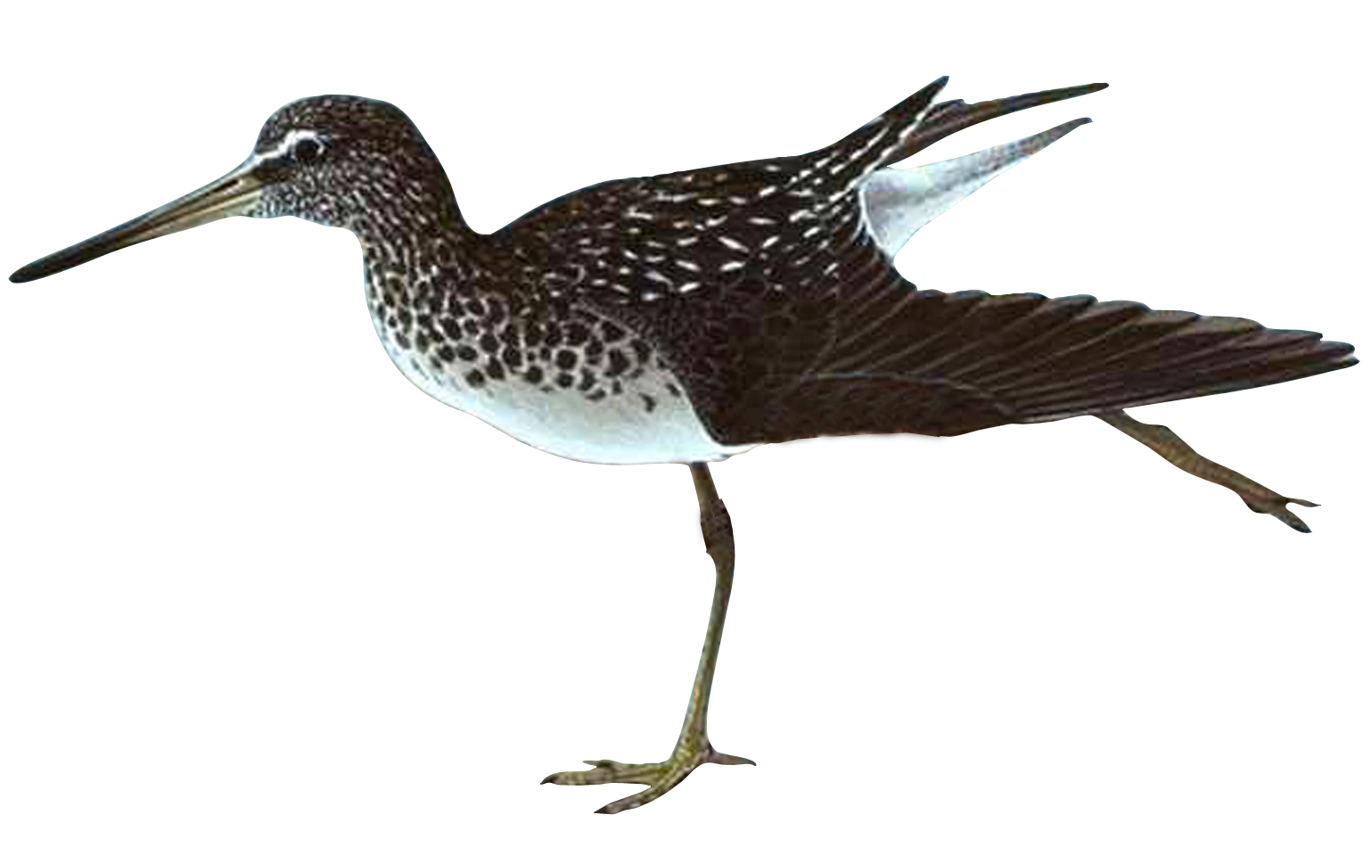

Spotted Greenshank Tringa guttifer

