Ngoc Linh Criteria: A1, A2 & A3

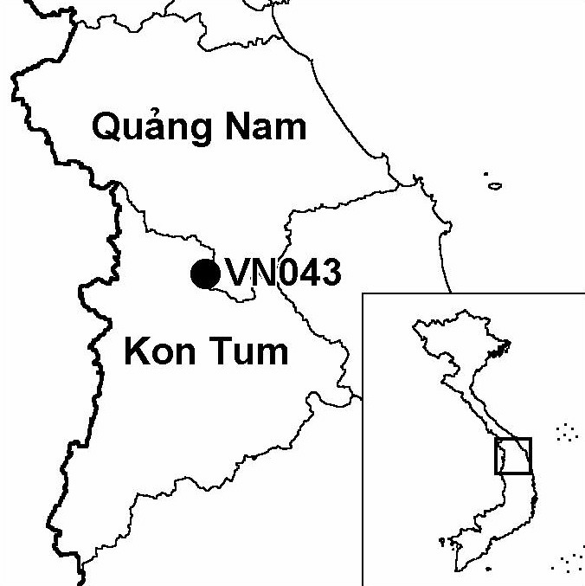
Province(s): Kon Tum and Quang Nam
PA Status: Nature Reserve

Latitude: 15º04'N
Longitude: 107º59'E
Area: 29,763 ha
Altitude Range: 500-2,598 m asl

EBA / SA:

Kon Tum Plateau EBA
Priority Landscape:
CA 1 - Central Annamites

General Description

The IBA is centred on Mount Ngoc Linh, which, at 2,598 m asl, is the highest point on the Kon Tum plateau. The eastern flank of Mount Ngoc Linh is located within Quang Nam province, while the western flank is located within Kon Tum province. Therefore, the IBA comprises Ngoc Linh (Quang Nam) proposed nature reserve, together with those parts of Ngoc Linh (Kon Tum) nature reserve that lie within Muong Hoong and Ngoc Linh communes. At elevations below 1,000 m asl, the natural vegetation of the IBA is lowland evergreen forest, although this has been extensively cleared on the Kon Tum province side. At elevations between 1,000 and 1,700 m asl, the IBA supports lower montane evergreen forest. At elevations above 1,700 m asl, upper montane evergreen forest is distributed, with elfin forest found at the highest elevations along mountain ridges. The upper montane evergreen forest is characterised by the presence of the endemic conifer Pinus dalatensis^{1,2}.

Bird Fauna: Key Features

Ngoc Linh IBA supports five of the nine restricted-range species that define the Kon Tum Plateau Endemic Bird Area (EBA). Most notably, the IBA supports two species whose global ranges are confined to this EBA: Golden-winged Laughingthrush Garrulax ngoclinhensis and Black-crowned Barwing Actinodura sodangorum. Both species were discovered on Mount Ngoc Linh in 1996, becoming the first new species to be discovered in mainland South-East Asia for over 30 years^{3,4}. While both species have since been found at other locations, Ngoc Linh IBA remains an important site for their conservation. The five restricted-range species found at Ngoc Linh IBA have different altitudinal ranges, and, therefore, it is necessary to maintain the full altitudinal gradient of natural habitats in order to conserve all species. The IBA supports the widest altitudinal gradient of natural habitat types in Vietnam, with a continuum of primary forest from 150 to 2,598 m asl². In addition to restricted-range species, Ngoc Linh IBA supports a number of subspecies confined to the Kon Tum Plateau EBA⁵.

Species | IBA  Criteria | Global Threat Status | Other  IBAs | Notes
Crested Argus  Rheinardia ocellata | A1, A2 | VU | 15 | The species was recorded in Quang Nam province on numerous occasions between March and April 1999².
Golden-winged Laughingthrush  Garrulax ngoclinhensis | A1, A2 | VU | 1 | One specimen was collected in May 1996 and two were collected in April 1998. All three specimens were collected in Kon Tum province, in undergrowth in primary upper montane evergreen forest between 2,000 and 2,200 m asl³. In addition, the species was recorded in Quang Nam province between March and May 1998².
Black-crowned Barwing  Actinodura sodangorum | A1, A2 | VU | 1 | One specimen was collected in May 1996, and a second specimen was collected in March 1998⁴. Both specimens were collected in Kon Tum province, at elevations between 2,000 and 2,100 m asl⁴. In addition, the species was heard on a number of occasions in Kon Tum province in March 1998⁶.
Brown Hornbill  Anorrhinus tickelli | A1, A3 | NT | 16 | The species was recorded between March and May 1998^{1,2}.
Yellow-billed Nuthatch  Sitta solangiae | A1, A2 | NT | 11 | The species was recorded in Quang Nam province between March and April 1999².
Black-hooded Laughingthrush  Garrulax milleti | A1, A2 | NT | 8 | The species was observed and heard on several occasions and a specimen was collected in Quang Nam province between March and April 1999².

Biome Restricted Species: The site qualifies under criterion A3 because it supports 38 species restricted to the Sino-Himalayan Subtropical Forests (Biome 08). See Appendix 4 for details.

Secondary Criteria

Species Status Species Status
Rhesus Macaque Macaca mulatta² NT [Keeled Box Turtle Pyxidea mouhotii]¹ EN
Stump-tailed Macaque Macaca arctoides² VU [Elongated Tortoise Indotestudo elongata]¹ EN
Red-shanked / Grey-shanked Douc [Wattle-necked Softshell Turtle Palea steindachneri]¹ EN
Pygathrix nemaeus nemaeus / cinerea² DD/EN Pinus dalatensis^{1,2,7} VU
[Big-headed Turtle Platysternon megacephalum]¹ EN Podocarpus neriifolius^{1,2} DD
[Indochinese Box Turtle Cuora galbinifrons]¹ CR Cephalotaxus manni¹ VU
[Chinese Three-striped Box Turtle Amentotaxus poilanei¹ VU
Cuora trifasciata]¹ CR [Southern Serow Naemorhedus sumatraensis]² VU
[Black-breasted Leaf Turtle Geoemyda spengleri]¹ EN

Notes: [ ] = unconfirmed record.

Threats to Biodiversity

The major threats to biodiversity at Ngoc Linh IBA are clearance of forest for agriculture, hunting, over-exploitation of NTFPs, timber extraction and infrastructure development. An analysis of remote sensing data indicates that the current rate of clearance of forest is very low. However, the rate may increase if the human population in surrounding areas increases, either through natural population growth or the settlement of migrants. Hunting is currently taking place at high levels, both for domestic consumption and to supply the wildlife trade. Use of snares is a particular threat for ground-dwelling birds, such as Crested Argus Rheinardia ocellata. Exploitation of timber and NTFPs is currently taking place at low levels, primarily to meet domestic demand. However, these activities may become unsustainable if commercial demand for these products increases².

Infrastructure development is, perhaps, the greatest threat to biodiversity at the IBA. There exist plans to build a road and develop a new economic centre near the IBA in Quang Nam province. In addition, there exist plans to build a road to Muong Hoong and Ngoc Linh communes on the Kon Tum side of the IBA. These developments may increase human pressure on the natural resources of the IBA, and open up the area to outside market forces².
Threat | Severity
Agricultural intensification / expansion | ●
Hunting | ● ●
Infrastructure development | ● ●
Selective logging / cutting | ●
Unsustainable exploitation of NTFPs | ●

Conservation Actions

In 1986, the establishment of Ngoc Linh (Kon Tum) Nature Reserve was decreed by the government of Vietnam⁸.
- In 1998, a nature reserve investment plan was prepared for Ngoc Linh (Kon Tum), and, subsequently, a management board was established⁸.
- In 2000, a feasibility study for the establishment of a nature reserve at Ngoc Linh (Quang Nam) was prepared, and approved by Quang Nam Provincial People's Committee^{1,2}.

Recommendations

- Ngoc Linh (Quang Nam) should be decreed as a nature reserve, and a management board should be established².
- Integrated management planning and practical collaboration in forest protection activities between the management boards of the two protected areas should be an essential long-term management objective for the IBA.
- National social forestry programmes should be expanded in the area surrounding the IBA, in order to involve local communities in forest protection, and to reduce their dependence on forest resources.
- An integrated programme of activities to control hunting should be implemented, including enforcement of nature reserve management regulations, raising conservation awareness, control of wildlife trade and promotion of alternative sources of income².
- An integrated programme of measures to reduce the risk of future clearance of forest for agriculture should be introduced, including recognition of local communities' land tenure rights, family planning and controls on in-migration².

References

1. Le Trong Trai, Richardson, W. J., Bui Dac Tuyen, Le Van Cham, Nguyen Huy Dung, Ha Van Hoach, Nguyen Van Sang, Monastyrskii, A. L. and Eames, J. C. (1999) An investment plan for Ngoc Linh Nature Reserve, Kon Tum province: a contribution to the management plan. Hanoi: BirdLife International Vietnam Programme and the Forest Inventory and Planning Institute.
2. Tordoff, A. W., Tran Hieu Minh and Tran Quang Ngoc (2000) A feasibility study for the establishment of Ngoc Linh Nature Reserve, Quang Nam province, Vietnam. Hanoi: BirdLife International Vietnam Programme and the Forest Inventory and Planning Institute.
3. Eames, J. C., Le Trong Trai and Nguyen Cu (1999a) A new species of laughingthrush (Passeriformes: Garrulacinae) from the western highlands of Vietnam. Bull. B.O.C. 119: 4-15.
4. Eames, J. C., Le Trong Trai, Nguyen Cu and Eve, R. (1999b) New species of barwing Actinodura (Passeriformes: Sylviinae: Timaliini) from the western highlands of Vietnam. Ibis 141: 1-10.
5. Eames, J. C. (2002) Eleven new sub-species of babbler (Passeriformes: Timaliini) from Kon Tum province, Vietnam. Bull. B.O.C. 122(2): 109-141.
6. J.C Eames in litt. 1998.
7. Nguyen Tien Hiep and Vidal, J.E (1996) [Flore du Cambodge du Laos et du Vietnam]. Vol. 28: Gymnospermae. Museum National D'Histoire Naturelle. (In French).
8. BirdLife International and the Forest Inventory and Planning Institute (2001) Sourcebook of existing and proposed protected areas in Vietnam. Hanoi: BirdLife International Vietnam Programme and the Forest Inventory and Planning Institute.

Golden-winged Laughingthrush Garrulax ngoclinhensis

