Phuoc Binh Criteria: A1 & A2

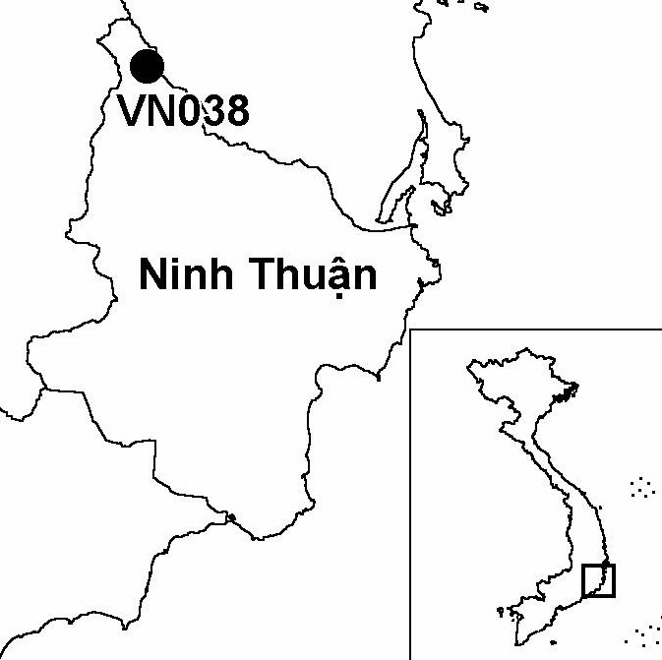
Province(s): Ninh Thuan
PA Status: None

Latitude: 12º04'N
Longitude: 108º47'E
Area: 23,597 ha
Altitude Range: 500-1,978 m asl

EBA / SA:

Da Lat Plateau EBA
Priority Landscape:
SA 3 - Southern Annamites Main Montane Block

General Description

The IBA comprises Phuoc Binh proposed nature reserve, which is located on the eastern edge of the Da Lat plateau, and is contiguous with Bi Dup IBA to the west. The topography of the west of the IBA is dominated by several high peaks, while to the east, the terrain drops away towards the coastal plain of south-central Vietnam. The natural vegetation of the IBA comprises a range of evergreen forest types, as well as small areas of coniferous forest. The IBA also contains significant areas of agricultural land¹.

Bird Fauna: Key Features

Phuoc Binh IBA is situated within the Da Lat Plateau Endemic Bird Area (EBA), and supports five of the eight restricted-range species that occur in this EBA, including two globally threatened species: Collared Laughingthrush Garrulax yersini and Crested Argus Rheinardia ocellata². In addition, Phuoc Binh is one of only six IBAs in Vietnam to support the globally vulnerable Pale-capped Pigeon Columba punicea. Furthermore, Phuoc Binh supports a subspecies of Spot-breasted Laughingthrush Garrulax merulinus annamensis that is only known from three other IBAs. This form is endemic to the Da Lat Plateau, and is treated by some authors as a distinct species³.

Species | IBA  Criteria | Global Threat Status | Other  IBAs | Notes
Collared Laughingthrush  Garrulax yersini | A1, A2 | EN | 5 | Single birds and small flocks were observed on a total of eight occasions in November 1993².
Crested Argus  Rheinardia ocellata | A1, A2 | VU | 15 | A single bird was heard calling in November 1993².
Pale-capped Pigeon  Columba punicea | A1, A3 | VU | 5 | A single bird was seen in November 1993².
Yellow-billed Nuthatch  Sitta solangiae | A1, A2 | NT | 11 | At least two birds were observed in a mixed flock in November 1993².
Short-tailed Scimitar Babbler  Jabouilleia danjoui | A1, A2 | NT | 16 | A single bird and two birds were observed on seperate occasions in November 1993².
Vietnam Greenfinch  Carduelis monguilloti | A1, A2 | NT | 4 | A pair and a group of five birds were recorded on separate occasions in November 1993².

Biome Restricted Species: The site does not qualify under criterion A3. See Appendix 4 for details.

Secondary Criteria

Species Status Species Status
Buff-cheeked Gibbon Nomascus gabriellae⁴ VU Fokienia hodginsii⁴ NT
Pinus dalatensis⁴ VU Podocarpus neriifolius⁴ DD
Pinus krempfii⁴ VU Gaur Bos gaurus⁴ VU

Threats to Biodiversity

The main threats to biodiversity at Phuoc Binh IBA are clearance of forest for agriculture and associated forest fires. Extensive areas of forest at low and medium elevations in the south-east of the IBA have already been converted to agriculture by local people, who practice a mixture of wet rice and shifting cultivation¹. An additional threat to biodiversity at the IBA is selective timber extraction, which is a particular threat to the valuable timber species Fokienia hodginsii.
Threat | Severity
Agricultural intensification / expansion | ● ●
Fire | ● ●
Hunting | ●
Selective logging / cutting | ●
Unsustainable exploitation of NTFPs | ●

Conservation Actions

- Phuoc Binh IBA is currently designated as a watershed protection forest¹.

Recommendations

- The establishment of a nature reserve at Phuoc Binh should be decreed by the government of Vietnam, and a management board should be established.
- Extensive areas of agricultural land within the boundary proposed in the investment plan should be excluded from the nature reserve, while any contiguous areas of natural habitat in Ninh Thuan province should be included.
- Protected area management regulations, particularly over-exploitation of forest products and clearance of forest for cultivation, should be enforced.
- A comprehensive fire management programme should be initiated at Phuoc Binh, including environmental awareness activities aimed at raising awareness among local communities of the hazards posed by fire. .

References

1. BirdLife International and the Forest Inventory and Planning Institute (2001) Sourcebook of existing and proposed protected areas in Vietnam. Hanoi: BirdLife International Vietnam Programme and the Forest Inventory and Planning Institute.
2. Eames, J. C. (1995) Endemic birds and protected area development on the Da Lat plateau, Vietnam. Bird Conservation International 5(4): 491-523.
3. Davidson, P., Poole, C., Omaliss, K., Robson, C., Timmins, R. J. and Duckworth, J. W. (unpublished) Priorities for bird conservation in the region of analysis. Unpublished report to the WWF Indochina Programme.
4. Eames, J. C. and Nguyen Cu (1994) A management feasibility study of Thuong Da Nhim and Chu Yang Sin Nature Reserves on the Da Lat Plateau, Vietnam. Hanoi: WWF Vietnam Programme and the Forest Inventory and Planning Institute.

Yellow-billed Nuthatch Sitta solangiae

