Phong Dien Criteria: A1, A2 & A3

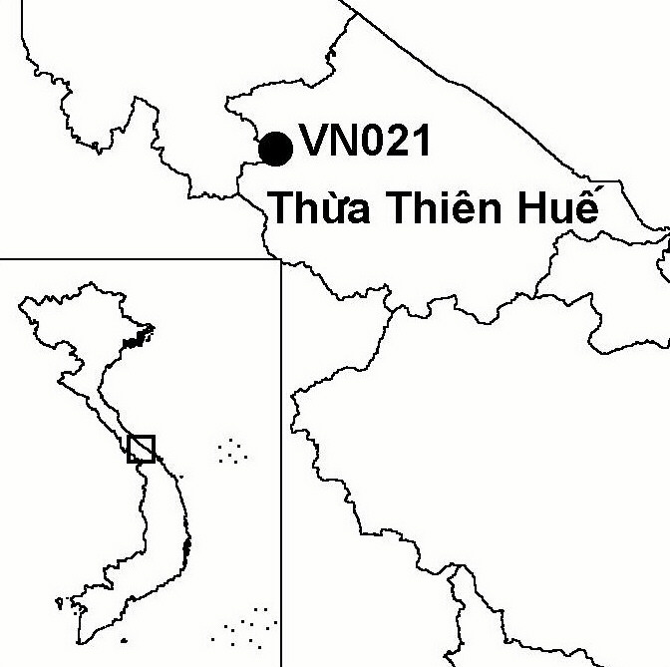
Province(s): Thua Thien Hue
PA Status: None

Latitude: 16º27'N
Longitude: 107º12'E
Area: 41,548 ha
Altitude Range: 50-1,615 m asl

EBA / SA:

Annamese Lowlands EBA
Priority Landscape:
CA 1 - Central Annamites

General Description

The IBA comprises Phong Dien proposed nature reserve, which is situated in the Annamese lowlands. The topography of the IBA is dominated by a ridge of low mountains, extending south-east from the Annamite mountains. Prior to the Second Indochina War, the vegetation of the IBA was dominated by lowland evergreen forest and lower montane evergreen forest. Now, throughout most of the IBA, the forest has been extensively degraded, fragmented and reduced in extent through a combination of logging, shifting cultivation, wartime spraying of defoliants, napalm and forest fires^{1,2,3}. However, the forest within the IBA forms part of one of the largest remaining areas of lowland evergreen forest in the Annamese lowlands. To the west, Phong Dien IBA is contiguous with Dakrong IBA in Quang Tri province.

Bird Fauna: Key Features

The avifauna of Phong Dien IBA is characteristic of the Annamese Lowlands Endemic Bird Area (EBA), and the IBA supports six of the nine species that define this EBA. The species of greatest conservation importance at Phong Dien is Edwards's Pheasant Lophura edwardsi. Until its rediscovery in 1996, this species was believed to be extinct in the wild. Edwards's Pheasant has a very restricted range in central Vietnam but reports from hunters suggest that this species is still relatively common at the IBA. Detailed information is lacking on the status of other restricted-range species found at the IBA, such as Annam Partridge Arborophila merlini and Short-tailed Scimitar Babbler Jabouilleia danjoui, although a field survey in 1998 confirmed that Crested Argus Rheinardia ocellata is still common^{1,2}.

Species | IBA  Criteria | Global Threat Status | Other  IBAs | Notes
Edwards's Pheasant  Lophura edwardsi | A1, A2 | EN | 2 | One male and one female were trapped in Phong My commune, at 300 to 400 m asl, in August 1996². In addition, two females, one male and four eggs were taken by rattan collectors within the watershed of the My Chanh river between 100 and 300 m asl in March 2000⁴.
Crested Argus  Rheinardia ocellata | A1, A2 | VU | 15 | The species was recorded between June and July 1998².
Siamese Fireback  Lophura diardi | A1, A3 | NT | 13 | The species was recorded between June and July 1998².
Red-collared Woodpecker  Picus rabieri | A1, A3 | NT | 11 | The species was recorded between June and July 1998².
[Great Hornbill  Buceros bicornis] | A1 | NT | 14 | The species was provisionally recorded between June and July 1998².
Brown Hornbill  Anorrhinus tickelli | A1, A3 | NT | 16 | The species was recorded between June and July 1998².
Blyth's Kingfisher  Alcedo hercules | A1, A3 | NT | 8 | The species was recorded between June and July 1998².
Short-tailed Scimitar Babbler  Jabouilleia danjoui | A1, A2 | NT | 17 | The species was recorded between June and July 1998².
Annam Partridge  Arborophila merlini | A2 |  | 4 | The species was recorded between June and July 1998².
White-cheeked laughingthrush  Garrulax vassali | A2 |  | 8 | The species was recorded between June and July 1998².
Grey-faced Tit Babbler  Macronous kelleyi | A2 |  | 12 | The species was recorded between June and July 1998².

Notes: [ ] = unconfirmed record.

Biome Restricted Species: The site qualifies under criterion A3 because it supports 18 species restricted to the Indochinese Tropical Moist Forests (Biome 09). See Appendix 4 for details.

Secondary Criteria

Species Status Species Status
*Northern Slow Loris Nycticebus bengalensis² DD [Indochinese Box Turtle Cuora galbinifrons]² CR
*Northern Pigtail Macaque Macaca leonina² VU [Chinese Three-striped Box Turtle Cuora trifasciata]² CR
*Rhesus Macaque Macaca mulatta² NT [Elongated Tortoise Indotestudo elongata]² EN
*Stump-tailed Macaque Macaca arctoides² VU [Wattle-necked Softshell Turtle Palea steindachneri]² EN
*Red-shanked Douc Pygathrix nemaeus nemaeus² EN [Chinese Softshell Turtle Pelodiscus sinensis]² VU
*White-cheeked Gibbon Nomascus leucogenys² DD Podocarpus neriifolius² DD
[Big-headed Turtle Platysternon megacephalum]² EN [Southern Serow Naemorhedus sumatraensis] ² VU

Notes: * = although recorded during a survey of Phong Dien and Dakrong proposed nature reserves, it is uncertain whether the species occurs within the IBA as locality data is lacking; [ ] = unconfirmed record.

Threats to Biodiversity

The major threat to biodiversity at Phong Dien IBA is hunting, particularly the use of snares, which is indiscriminate and threatens ground bird species such as Edwards's Pheasant and Crested Argus. A recent study on hunting at Phong Dien discovered a strong association between hunting and rattan collection because rattan collectors set snares while in the forest⁵. Other threats to biodiversity at the IBA include over-exploitation of firewood and other NTFPs, timber extraction, and forest fires, which result from the use of fire to clear land for agriculture¹.
Threat | Severity
Fire | ● ●
Hunting | ● ●
Selective logging / cutting | ●
Unsustainable exploitation of NTFPs | ● ●

Conservation Actions

- In 1998, following the rediscovery of Edwards's Pheasant Lophura edwardsi at the site, a feasibility study for the establishment of a protected area at Phong Dien was conducted².
- In 2001, an investment plan was prepared for Phong Dien, which proposed the establishment of a 41,548 ha nature reserve³. This investment plan has since been approved by Thua Thien Hue Provincial People's Committee and the Ministry of Agriculture and Rural Development.
- Although, to date, a nature reserve management board has not been established⁵, two forest guard stations, in Phong Dien and A Luoi district, have been assigned the responsibility of biodiversity conservation at the site.
- During 2000 and 2001, with the support of the WWF Indochina Programme, Thua Thien Hue Provincial Forest Protection Department implemented several activities aimed at raising environmental awareness and controlling hunting at the site⁵.
- In 2002, a conservation strategy for Edwards's Pheasant at Phong Dien was prepared with the support of the Rufford Small Grants Scheme of the Whitley Awards Foundation⁵.

Recommendations

- Phong Dien should be decreed as a nature reserve, and a management board should be established³.
- Local communities should be involved in forest protection and management⁵.
- Environmental awareness activities should be implemented among local communities, particularly focussing on the control of hunting⁵.
- Anti-hunting and logging patrols should focus on the upper watersheds of the My Chanh and O Lau rivers, which are the key areas for Edwards's Pheasant⁵.
- Collection of rattan and other NTFPs within the IBA should be regulated, to ensure that these activities take place at sustainable levels⁵.
- A programme of community-based fire prevention, including awareness raising activities and establishment of village fire-watch groups, should be initiated.
- A monitoring programme should be established to monitor levels of hunting and illegal logging⁵.
- Further studies should be conducted to assess the habitat requirements of Edwards's Pheasant⁵.

References

1. BirdLife International and the Forest Inventory and Planning Institute (2001) Sourcebook of existing and proposed protected areas in Vietnam. Hanoi: BirdLife International Vietnam Programme and the Forest Inventory and Planning Institute.
2. Le Trong Trai, Richardson, W. J., Le Van Cham, Tran Hieu Minh, Tran Quang Ngoc, Nguyen Van Sang, Monastyrskii, A. L. and Eames, J. C. (1999) A feasibility study for the establishment of Phong Dien (Thua Thien Hue province) and Dakrong (Quang Tri province) Nature Reserves, Vietnam. Hanoi: BirdLife International Vietnam Programme and the Forest Inventory and Planning Institute.
3. Le Trong Trai, Tran Hieu Minh, Tran Quoc Dung and Hughes, R. (2001) An investment plan for the establishment of Phong Dien Nature Reserve, Thua Thien Hue province, Vietnam. Hanoi: BirdLife International Vietnam Programme and the Forest Inventory and Planning Institute.
4. Eames, J. C. and Tordoff, A. W. (in prep) Recent records and a conservation status review of some threatened and near-threatened bird species in Vietnam.
5. Tran Quang Ngoc, Nguyen Van Vinh, Le Trong Trai, Phan Thanh Ha, Le Ngoc Tuan and Dang Thang Long (2002) Understanding the impacts of hunting on Edwards's Pheasant Lophura edwardsi at Phong Dien Nature Reserve, Vietnam: towards a strategy for managing hunting activities. Unpublished report to the Whitley Awards Foundation.
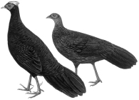

Edwards's Pheasant Lophura edwardsi

