Phong Nha Criteria: A1, A2 & A3

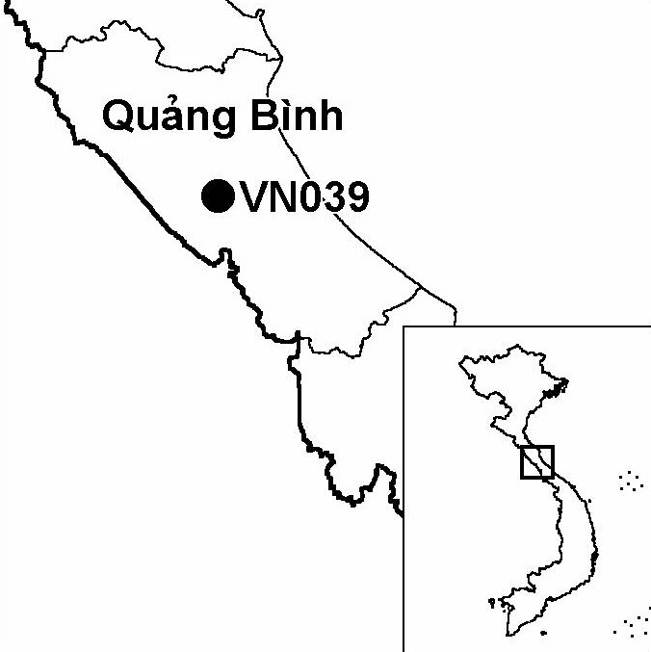
Province(s): Quang Binh
PA Status: National Park

Latitude: 17º29'N
Longitude: 106º16'E
Area: 41,132 ha
Altitude Range: 150-400 m asl

EBA / SA:

Annamese Lowlands EBA
Priority Landscape:
NA 6 - Central Indochina Limestone

General Description

The IBA comprises the Phong Nha sector of Phong Nha-Ke Bang National Park, which, prior to 2001, was designated as Phong Nha Nature Reserve. The IBA is situated within the largest area of contiguous limestone forest in Indochina, which also includes Hin Namno National Biodiversity Conservation Area in Laos, and the Ke Bang limestone area in Vietnam. The IBA has a limestone karst topography, as a result of which human encroachment into the site has been limited. Consequently, the limestone karst is almost entirely forested, apart from steep cliff faces. At the foot of the limestone karst, the natural vegetation is lowland evergreen forest, although some areas have been cleared for cultivation. There are a number of major cave systems at Phong Nha, and the site attracts large numbers of domestic tourists every year. Phong Nha is one of the most important sites in Vietnam for the conservation of globally threatened primate species, including at least one taxon endemic to limestone karst areas in central Indochina: Hatinh Langur Trachypithecus francoisi hatinhensis¹. In addition, the IBA supports an all-black langur, the precise taxonomic affinities of which are currently undetermined¹. To the north-west, Phong Nha IBA is contiguous with Ke Bang IBA.

Bird Fauna: Key Features

Phong Nha IBA is situated within the Annamese Lowlands Endemic Bird Area (EBA), and supports at least two of the nine restricted-range species that define this EBA. Notably, the IBA is one of only two sites in Vietnam known to support Sooty Babbler Stachyris herbeti, a species that went unrecorded for over 70 years between its discovery in Laos around 1920 and its rediscovery at Phong Nha in 1994². In addition to Sooty Babbler, Phong Nha IBA supports a population of a form of leaf warbler that is endemic to limestone karst areas in central Indochina. This form, which resembles Sulphur-breasted Warbler Phylloscopus ricketti in external appearance but differs in terms of vocalisations, may represent an undescribed species³.

Species | IBA  Criteria | Global Threat Status | Other  IBAs | Notes
Crested Argus  Rheinardia ocellata | A1, A2 | VU | 15 | One bird was heard in November 1994 and one or two birds were heard in June 1996⁴.
Chestnut-necklaced Partridge  Arborophila charltonii | A1 | NT | 7 | A pair was heard duetting in November 1994⁴.
Siamese Fireback  Lophura diardi | A1, A3 | NT | 13 | The species was recorded between June and July 1994².
Red-collared Woodpecker  Picus rabieri | A1, A3 | NT | 11 | The species was recorded between June and July 1994². A family group of four was seen in June 1996 and two birds were observed in December 1996⁴.
Great Hornbill  Buceros bicornis | A1 | NT | 13 | The species was recorded between June and July 1994².
Brown Hornbill  Anorrhinus tickelli | A1, A3 | NT | 16 | The species was recorded between June and July 1994². Three birds were observed and up to eight were heard in June 1996⁴.
[Short-tailed Scimitar Babbler  Jabouilleia danjoui] | A1, A2 | NT | 18 | Although the species has not yet been recorded at the IBA, it was recorded in the neighbouring Rao Bong watershed between June and July 1994². While it is likely to occur at the IBA, this is currently unconfirmed.
Sooty Babbler  Stachyris herbeti | A1, A2 | NT | 1 | After a gap of over 70 years since the species's discovery, it was rediscovered at Phong Nha between June and July 1994². During two subsequent visits, four small flocks were seen in November 1995 and several flocks, one of which numbered more than 20 birds, were observed in June 1996⁴.

Notes: [ ] = unconfirmed record.

Biome Restricted Species: The site qualifies under criterion A3 because it supports 14 species restricted to the Indochinese Tropical Moist Forests (Biome 09). See Appendix 4 for details.

Secondary Criteria

Species Status Species Status
Northern Slow Loris Nyticebus bengalensis⁵ DD Hatinh Langur
Pygmy Loris Nyticebus pygmaeus⁵ VU Trachypithecus francoisi hatinhensis^{5,6} EN
Northern Pigtail Macaque Macaca leonina⁵ VU Red-shanked Douc Pygathrix nemaeus nemaeus⁵ EN
Assamese Macaque Macaca assamensis⁵ VU Buff-cheeked Gibbon Nomascus gabriellae⁵ VU
Rhesus Macaque Macaca mulatta⁵ NT *[Gaur Bos gaurus]⁵ VU
Stump-tailed Macaque Macaca arctoides⁵ VU Southern Serow Naemorhedus sumatraensis⁵ VU

Notes: [ ] = unconfirmed record; * = possibly extinct at the site.

Threats to Biodiversity

Currently, the biggest threat to biodiversity at Phong Nha IBA is hunting, which is widespread at the site and represents a particular threat to populations of primates and large mammals. Levels of hunting are high in response to high demand from the wildlife trade. In addition to hunting, illegal timber extraction is also a major threat to biodiversity, and, again, occurs largely in response to commercial demand¹.

Due to the unsuitability of the limestone karst terrain, the rate of habitat loss to date at Phong Nha has been relatively low⁵. However, a road, which is currently being constructed through the IBA, may result in increased rates of habitat loss and disturbance to key species, especially globally threatened primates¹. The on-going construction of National Highway 2 close to the IBA is also a cause for concern, as this may facilitate human settlement in the surrounding area, thereby increasing human pressure on natural resources.
Threat | Severity
Agricultural intensification / expansion | ●
Hunting | ● ●
Infrastructure development | ● ●
Recreation / tourism | ●
Selective logging / cutting | ● ●

Another potential threat to biodiversity at the site is tourism development. To date, however, tourism development at the site has been concentrated on the cave systems, and impacts on forest habitats have been limited.

Conservation Actions

- In 1986, the government of Vietnam decreed the establishment of a cultural and historical site at Phong Nha¹.
- In 1993, Phong Nha Cultural and Historical Site was upgraded to nature reserve status and a management board was established¹.
- In 1998, with funding from the UK Department for International Development, WWF initiated a transboundary conservation project at Phong Nha, entitled Linking Hin Namno and Phong Nha through Parallel Conservation¹.
- In 1998, Fauna and Flora International initiated a conservation project at Phong Nha-Ke Bang, comprising capacity building and field survey components¹.
- In December 2001, the government of Vietnam decreed the establishment of Phong Nha-Ke Bang National Park, comprising Phong Nha Nature Reserve and part of the Ke Bang limestone area.
- Koln Zoo is currently developing plans to undertake capacity building activities and further biological surveys at the site¹.

Recommendations

- National park management regulations, particularly controls on hunting and timber extraction should be effectively enforced.
- Strict controls on human settlement along the route of National Highway 2 should be introduced, in order to minimised increased pressures on the natural resources of the IBA following construction of this road.
- All proposed infrastructure developments at the national park, particularly those involving road construction, should be subjected to careful Environmental Impact Assessment, and appropriate mitigation measures should be implemented.
- A tourism management board, including representatives of the national park management board, the provincial tourism company and other local stakeholders, should be established as a basis for environmentally sustainable tourism development at the site.

References

1. BirdLife International and the Forest Inventory and Planning Institute (2001) Sourcebook of existing and proposed protected areas in Vietnam. Hanoi: BirdLife International Vietnam Programme and the Forest Inventory and Planning Institute.
2. Eames, J. C., Lambert, F. R. and Nguyen Cu (1994) A survey of the Annamese Lowlands, Vietnam, and its implications for the conservation of Vietnamese and Imperial Pheasants Lophura hatinhensis and L. imperialis. Bird Conservation International 4(4): 343-382.
3. Duckworth, J. W., Salter, R. E. and Khounboline, K. eds. (1999) Wildlife in Lao P.D.R.: 1999 status report. Vientiane: IUCN, Wildlife Conservation Society and the Centre for Protected Areas and Watershed Management.
4. Eames, J. C. and Tordoff, A. W. (in prep.) Recent records and a conservation status review of some threatened and near-threatened bird species in Vietnam.
5. Nguyen Xuan Dang, Pham Nhat, Pham Trong Anh, Hendrichsen, D. (1998) Results of surveys on mammal fauna in Phong Nha – Ke Bang area, Quang Binh, Vietnam: July 1-August 21, 1998. Unpublished report to the Fauna & Flora International Indochina Programme, Hanoi.
6. Timmins, R. J., Do Tuoc, Trinh Viet Cuong and Hendrichsen, D. K. (1999) A preliminary assessment of the conservation importance and conservation priorities of the Phong Nha-Ke Bang proposed national park, Quang Binh province, Vietnam. Hanoi: Fauna & Flora International Indochina Programme.

Sooty Babbler Stachyris herberti

