Sinh Long Criteria: A3

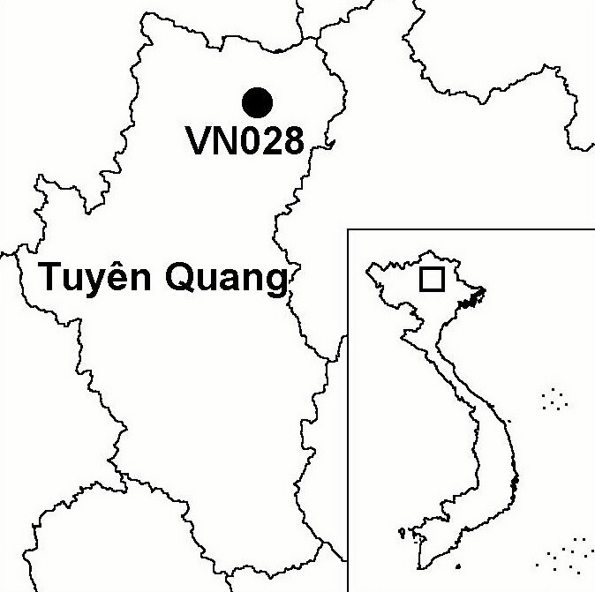
Province(s): Tuyen Quang
PA Status: None

Latitude: 22º30'N
Longitude: 105º24'E
Area: 10,000 ha
Altitude Range: 450-1,475 m asl

EBA / SA:

None
Priority Landscape:
None

General Description

Sinh Long IBA is situated within the Na Hang/Ba Be Forest Complex in northern Vietnam. The topography of the site is dominated by a mountain ridge. This ridge supports fragmented limestone forest along the ridge top, secondary lower montane evergreen forest on the slopes, and shifting cultivation on the lower slopes and in valley bottoms¹. Sinh Long IBA is contiguous with the Tat Ke sector of Na Hang proposed nature reserve.

Bird Fauna: Key Features

The avifauna of Sinh Long is typical of lower montane evergreen forest in northern Vietnam. While Sinh Long is not known to support any globally threatened or near-threatened species, the site qualifies as an IBA because it supports a large number of biome-restricted species. Most significantly, Sinh Long supports a number of species found at few other sites in Vietnam, including Collared Treepie Dendrocitta frontalis, Black-breasted Thrush Turdus dissimilis, Limestone Wren Babbler Napothera crispifrons, Lesser Rufous-headed Parrotbill Paradoxornis atrosuperciliaris and Greater Rufous-headed Parrotbill P. ruficeps.

Biome Restricted Species: The site qualifies under criterion A3 because it supports 39 species restricted to the Sino-Himalayan Subtropical Forests (Biome 10) and 10 species restricted to the Indochinese Tropical Moist Forests (Biome 09). See Appendix 4 for details.

Secondary Criteria

Species Status Species Status
[Rhesus Macaque Macaca mulatta]¹ NT [Big-headed Turtle Platysternon megacephalum]¹ EN
[Stump-tailed Macaque Macaca arctoides]¹ VU [Black-breasted Leaf Turtle Geoemyda spengleri]¹ EN
[Francois's Langur [Keeled Box Turtle Pyxidea mouhotii]¹ EN
Trachypithecus francoisi francoisi]¹ VU [Southern Serow Naemorhedus sumatraensis]¹ VU

Notes: [ ] = unconfirmed record.

Threats to Biodiversity

Currently, the major threats to biodiversity at Sinh Long IBA are clearance of forest, hunting, over-exploitation of NTFPs, timber extraction and isolation from nearby forest areas. Clearance of forest for agriculture, has already led to the loss of forest at low elevations at the site, and is a potentially severe threat in the future if the human population in surrounding areas increases as a result of natural population growth or settlement of migrants. Wildlife populations in the IBA are under intense pressure from hunting, which is conducted both for domestic consumption and to supply the wildlife trade. Timber and many NTFPs are currently being over-exploited by local communities, both for domestic use and to meet commercial demand from traders. Finally, isolation from nearby forest areas as a result of clearance of intervening forest areas is a potential threat¹.
Threat | Severity
Agricultural intensification / expansion | ● ●
Hunting | ● ● ●
Selective logging / cutting | ● ●
Unsustainable exploitation of NTFPs | ● ●

Conservation Actions

- None to date.

Recommendations

- Sinh Long IBA should be incorporated within the Tat Ke sector of Na Hang proposed nature reserve.
- Forest protection activities should be initiated at the IBA to reduce current levels of forest clearance, wildlife hunting and over-exploitation of forest products at the site.

References

1. Le Trong Trai, Eames, J. C., Kuznetsov, A. N., Nguyen Van Sang, Bui Xuan Puong and Monastyrskii, A. L. (2001) A biodiversity survey of the Dong Phuc, Ban Thi-Xuan Lac and Sinh Long areas, Tuyen Quang and Bac Kan provinces, Vietnam. Unpublished report to the Vietnam PARC Project, Na Hang/Ba Be Component.

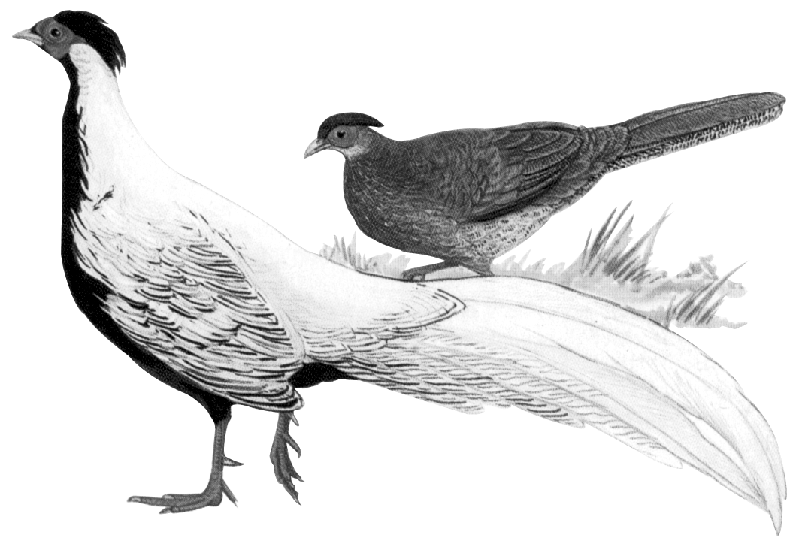

Silver Pheasant Lophura nycthemera

