Tram Chim Criteria: A1, A3 & A4i

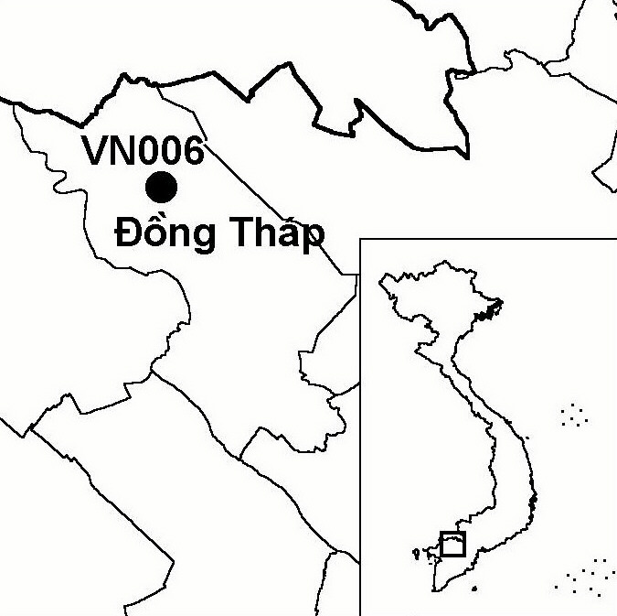
Province(s): Dong Thap
PA Status: National Park

Latitude: 10º44'N
Longitude: 105º31'E
Area: 7,588 ha
Altitude Range: 0-2 m asl

EBA / SA:

None
Priority Landscape:
LMF2 - North-western Mekong Delta Wetlands

General Description

The IBA comprises Tram Chim National Park and adjacent areas of natural habitat, located in the Mekong Delta, 25 km to the north of Cao Lanh, the capital of Dong Thap province. The site supports one of the last remnants of the Plain of Reeds wetland ecosystem, which previously covered some 700,000 ha of the Mekong Delta in Vietnam¹. The topography of the site is a shallow basin, which slopes to the south-east, parallel to the Mekong River, to the north-east, perpendicular to the Mekong River, and to the south-west, perpendicular to the Vai Co river². The vegetation of the site includes large areas of seasonally inundated grassland, regenerating Melaleuca forest and open swamp. Melaleuca forest is distributed throughout the site, both as plantations and as scattered, natural patches in areas of grassland or open swamp. Large populations of waterbirds are found at the site, particularly in the dry season, when thousands of waterfowl visit¹.

Bird Fauna: Key Features

Tram Chim is famous for the population of Sarus Crane Grus antigone which inhabits the national park during the dry season¹, although numbers of birds observed annually have declined over the last few years³. The number of cranes at Tram Chim has fluctuated in relation to water management at the national park. When drawdowns that mimic the natural hydrology of the wetland are conducted, crane numbers increase. When water levels are maintained artificially high, crane numbers decline, as the vegetation that serves as their food base collapses⁴. The avifauna of the site has been the subject of many surveys, including a monitoring scheme for key waterbird species, which has been operated by the park staff since 1988⁵. To date, survey work has confirmed the presence of 10 globally threatened and near-threatened bird species, although many of these species do not occur regularly or in significant numbers. In addition, large concentrations of two waterfowl species have been recorded at the site: Garganey Anas querquedula and Common Teal A. crecca. A survey of wetland sites in the Mekong Delta found that Tram Chim supported the second highest bird species richness of the sites visited¹. The occurrence of the secretive and seldom-recorded grassland specialist Bengal Florican Houbaropsis bengalensis at the site is especially significant in the national context, as the species is currently known from only one other site in Vietnam: Ha Tien IBA. Other wetland species of note at the site include Comb Duck Sarkidiornis melanotus, Cotton Pygmy Goose Nettapus coromandelianus, Greater Painted-snipe Rostratula benghalensis and Pheasant-tailed Jacana Hydrophasianus chirurgus¹.

Species | IBA  Criteria | Global Threat Status | Other  IBAs | Notes
Bengal Florican  Houbaropsis bengalensis | A1, A3 | EN | 1 | The species was recorded in small numbers throughout the 1990s, with a maximum count of four birds in February-March 1990^{6,7}. During a survey in 1999, local people reported breeding at the site, and, claimed to have found eggs and chicks. Some people were also familiar with the characteristic display of the species¹. A member of national park staff also claims to have seen the eggs of this species⁴.
†Black-faced Spoonbill  Platalea minor | A1 | EN | 8 | A single individual was observed and photographed in January 1994, just outside the IBA³. The site does not regularly support a significant population.
†Greater Adjutant  Leptoptilos dubius | A1 | EN | 0 | The species was recorded in March 1988³, and one individual was recorded feeding along a stream in December 1992⁸. There have been no confirmed records since this time, and the site does not regularly support a significant population.
Sarus Crane  Grus antigone | A1, A4i | VU | 4 | Regular counts have been made since 1988, with maximum counts of 1,052 in 1988, 665 in 1989, 741 in 1990, 814 in 1991, 365 in 1992, 187 in 1993, 271 in 1994, 302 in 1995, 631 in 1996, 511 in 1997, 503 in 1998 and 469 in 1999⁷. In recent years, however, numbers seem to be declining. The maximum count in 2001 was around 48 birds, while the total count in May 2002 was around 150⁴.
†Greater Spotted Eagle  Aquila clanga | A1 | VU | 2 | Single individuals were observed most years from 1988 to 1994, and in February 1997^{3,4}. The site may not regularly support a significant population.
[Spot-billed Pelican  Pelecanus philippensis] | A1 | VU | 7 | Pelican records from January 1989 probably refer to this species⁷. If the species does occur, it is as a vagrant or rare non-breeding visitor.
Lesser Adjutant  Leptoptilos javanicus | A1 | VU | 7 | The species is a non-breeding visitor to the site. The species has been recorded most years since 1988, with a maximum of 51 birds in 1999⁴.
Oriental Darter  Anhinga melanogaster | A1 | NT | 9 | The species breeds at the site⁴. In 1999, the maximum count was 141 birds⁴.
Black-headed Ibis  Threskiornis melanocephalus | A1 | NT | 8 | The species is an uncommon visitor to the site¹.
Painted Stork  Mycteria leucocephala | A1 | NT | 10 | The species is a non-breeding visitor to the site. In January 1994, at least 92 individuals, and perhaps as many as 150 (including many juveniles), were observed just outside the IBA³. A maximum count of 207 was made in 1999, while a maximum count of over 140 was made in 2000⁴.
Asian Golden Weaver  Ploceus hypoxanthus | A1 | NT | 3 | A single flock of c.20 individuals was observed in 1999¹; which was the first year in which the species was recorded at the site⁴. Following 1999, the species established a breeding colony, which has been increasing in size every year⁴.
Garganey  Anas querquedula | A4i |  | 0 | In winter 1992/93, 20,000 individuals were recorded⁹.
Common Teal  Anas crecca | A4i |  | 0 | In winter 1989/90, 10,000 birds were recorded⁹.

Notes: [ ] = unconfirmed record; † = not confirmed to regularly occur in significant numbers.

Biome Restricted Species: The site qualifies under criterion A3 because it supports one species restricted to the Indo-Gangetic Plains (Biome 12). See Appendix 4 for details.

Secondary Criteria

The site does not qualify under any secondary criterion.

Threats to Biodiversity

Tram Chim is surrounded by agricultural land, and human pressure on the IBA is high. Despite its status as a national park, hunting, poisoning and disturbance to birds have been identified as major conservation issues at Tram Chim^{1,10}. In 2000, the management board of the park began building six canals inside the national park, the construction of which could have fragmented the natural habitat and altered the water regime. Fortunately, construction was halted after only two canals were completed.
Threat | Severity
Agricultural intensification / expansion | ● ●
Construction of dykes / dams | ● ●
Disturbance to birds | ● ●
Dredging and canalization | ● ●
Hunting | ● ●
Infrastructure development | ● ●
Introduction of exotic plant species | ● ●
Other | ● ● ●

The most important factor in maintaining suitable habitat for Sarus Crane at the IBA is appropriate hydrological management. During the 1990s, water levels at the site were allowed to remain high for unnaturally long periods each year, leading to changes in the vegetation, especially die-back of Eleocharis ochrostachys, the main food plant of Sarus Crane. However, following implementation of a new water management regime in 2000 and 2001, evidence of natural vegetation recovery was observed. It is hoped that such appropriate water-level management will result in an increase of the Sarus Crane population at Tram Chim.

Finally, the invasion of the exotic plant species Mimosa pigra is a major threat to biodiversity at Tram Chim. The area of M. pigra at the IBA has doubled each year for the last three years, and now covers more than 2,000 ha of what was once seasonally inundated grassland¹¹.

Conservation Actions

- Tram Chim was declared a national park on 29 December 1998 by the government of Vietnam¹⁰.
- The International Crane Foundation have been active at Tram Chim since 1988, during which time they have built sluice gates and developed a management plan for the site in collaboration with the national park management board¹⁰.
- Tram Chim National Park is one of the demonstration sites for a full-scale GEF project entitled the Mekong River Basin Wetland Biodiversity Conservation and Sustainable Use Project, which is currently being implemented by IUCN¹⁰.

Recommendations

- Tram Chim meets the criteria for designation as a site of international importance for wetland conservation under the Ramsar Convention, and should, therefore, be designated as a Ramsar site¹.
- Water levels at the site should be managed in a way consistent with increasing the availability of food plants for Sarus Crane, and restoration of a representative example of the Plain of Reeds ecosystem.
- Hunting and fuelwood collection within the national park should be effectively controlled.
- Further spread of Mimosa pigra at the site should be prevented, and areas already invaded should be cleared of the species.

References

1. Buckton, S. T., Nguyen Cu, Nguyen Duc Tu and Ha Quy Quynh (1999) The conservation of key wetland sites in the Mekong Delta. Hanoi: Birdlife International Vietnam Programme.
2. Beilfuss, R. and Barzen, J. (1994) Hydrological wetland restoration in the Mekong Delta, Vietnam. Pp: 453-468 in W. J. Mitsch ed. Global wetlands: old world and new. Amsterdam: Elsevier Science.
3. Eames, J. C. and Tordoff, A. W. (in prep) Recent records and a conservation status review of some threatened and near-threatened bird species in Vietnam.
4. J. Barzen in litt. 2002.
5. Baltzer, M. C., Nguyen Thi Dao, and Shore, R. G. eds (2001) Towards a vision for biodiversity conservation in the forests of the lower Mekong Ecoregion complex – Technical Annex. WWF Indochina/ WWF US, Hanoi and Washington D.C.
6. Eames, J. C. (1995) The Bengal Florican Eupodotis bengalensis in Indochina. Forktail 11:36-46.
7. Birdlife International (2001) Threatened birds of Asia: the Birdlife International Red Data Book. Cambridge, UK: Birdlife International.
8. Robson, C. R. (1993) From the field. OBC Bulletin 17: 49-53.
9. Miyabayashi, Y. and Mundkur, T. (1999) Atlas of key sites for Anatidae in the East Asian Flyway. Tokyo and Kuala Lumpur: Wetlands International.
10. Birdlife International and the Forest Inventory and Planning Institute (2001) Sourcebook of existing and proposed protected areas in Vietnam. Hanoi: BirdLife International Vietnam Programme and the Forest Inventory and Planning Institute.
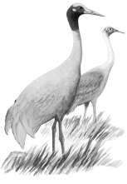
11. Tran Triet in litt. 2002.

Sarus Crane Grus antigone

