Tra Cu Criteria: A1 & A4i

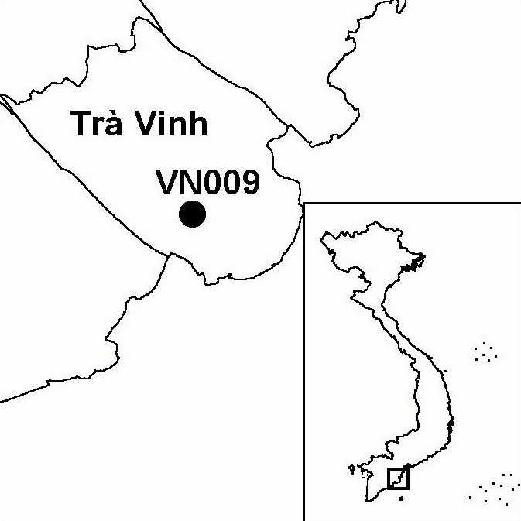
Province(s): Tra Vinh
PA Status: None

Latitude: 9º41'N
Longitude: 106º21'E
Area: 2 ha
Altitude Range: 0-1 m asl

EBA / SA:

None
Priority Landscape:
None

General Description

Tra Cu is a small bird sanctuary situated in the grounds of a pagoda. The site is protected and managed by the monks at the pagoda. The breeding birds nest in coconut palms, large broadleaf trees and clumps of bamboo. The surrounding area is dominated by wet rice cultivation¹.

Bird Fauna: Key Features

Despite its small size, in terms of numbers, Tra Cu is one of the largest breeding colonies of waterbirds in the Mekong Delta¹. Currently, knowledge regarding the site is restricted to findings of two short visits to the site in 1999. These visits confirmed the presence of the globally near-threatened Black-headed Ibis Threskiornis melanocephalus and over 1% of the Asian biogeographic population of Black-crowned Night Heron Nycticorax nycticorax¹. In addition, Tra Cu is known to support significant numbers of Little Cormorant Phalacrocorax niger, Little Egret Egretta garzetta, Cattle Egret Bubulcus ibis and Glossy Ibis Plegadis falcinellus¹.

Species | IBA  Criteria | Global Threat Status | Other  IBAs | Notes
Black-headed Ibis  Threskiornis melanocephalus | A1 | NT | 8 | At least 50 individuals, including a number of juveniles, were observed in February and July 1999¹.
Black-crowned Night Heron  Nycticorax nycticorax | A4i |  | 1 | 300 individuals were recorded in February and 1,600 individuals in July 1999¹.

Biome Restricted Species: The site does not qualify under criterion A3. See Appendix 4 for details.

Secondary Criteria

The site does not qualify under any secondary criterion.

Threats to Biodiversity

Due to the level of protection afforded by the monks, no hunting takes place within the temple grounds. However, birds feeding or flying to and from roost are exposed to hunting pressure. The potential negative impact of hunting and other forms of disturbance are quite high, because the breeding birds are concentrated in an extremely small area.
Threat | Severity
Disturbance to birds | ●
Hunting | ● ●

Conservation Actions

- Tra Cu IBA is not under any formal protected area designation.

Recommendations

- Activities to raise awareness of the importance and fragility of the bird fauna of Tra Cu IBA should be implemented among the local community.

References

1. Buckton, S. T., Nguyen Cu, Nguyen Duc Tu and Ha Quy Quynh (1999) The conservation of key wetland sites in the Mekong Delta. Hanoi: Birdlife International Vietnam Programme.

