Tra Co Criteria: A1

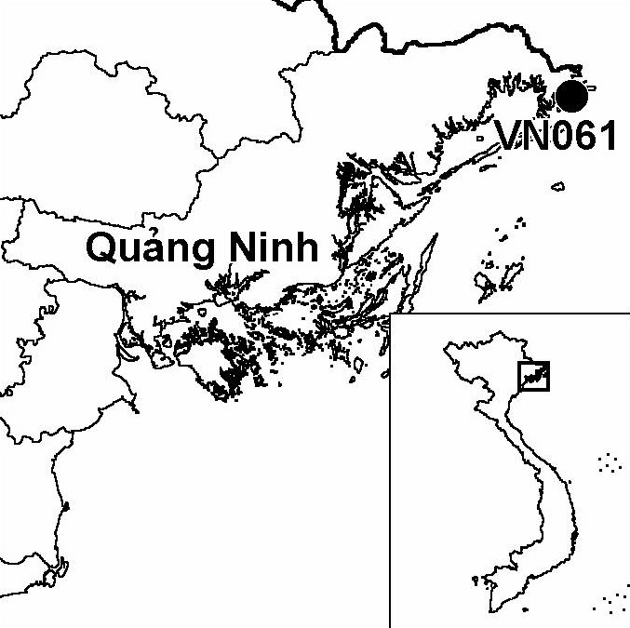
Province(s): Quang Ninh
PA Status: None

Latitude: 21º28'N
Longitude: 108º01'E
Area: 3,000 ha
Altitude Range: 0-2 m asl

EBA / SA:

None
Priority Landscape:
None

General Description

The IBA is centred on Tra Co island, which is situated off the coast of northern Vietnam, close to the international border with China. The island comprises a long, sandy beach, backed by a Casuarina equisetifolia plantation, and is linked to the mainland by a causeway. The north-eastern tip of Tra Co island, known as Mui Got Giay, consists of a sandy spit, behind which is a small area of mangrove. The south-western tip of Tra Co island, known as Mui Ngoc, is situated at the mouth of a small bay, which contains a significant area of intertidal mudflats. On the far side of the bay, in Van Ninh commune, the coastline is dominated by aquacultural ponds. In addition to the island, the bay and the coastline of Van Ninh commune, the IBA also comprises Bai Tuc Lam, an area of mangrove along the international border. Tra Co IBA is currently not under any protected area designation, and the island is being developed as a tourism site¹.

Bird Fauna: Key Features

Although there has only been a single, brief ornithological survey to date, the findings indicate that Tra Co is an important site for migratory bird species. The sandy spit on the northern tip of the island supports a high-tide wader roost, while the intertidal mudflats in the bay to the south of the island support wintering Saunders's Gulls Larus saundersi. In fact, Tra Co IBA is the first wintering site for this globally threatened species in Vietnam to have been identified outside of the coastal zone of the Red River Delta¹. In addition, the nationally threatened Great Cormorant Phalacrocorax carbo has been recorded in the Bai Tuc Lam mangrove area, although security restrictions have prevented a detailed survey of this area to date¹. Furthermore, Tra Co is one of only two IBAs in Vietnam known to support Red-billed Starling Sturnus sericeus, a biome-restricted species.

Species | IBA  Criteria | Global Threat Status | Other  IBAs | Notes
Saunders's Gull  Larus saundersi | A1 | VU | 5 | An adult and five juveniles observed in an area of aquacultural ponds in Van Ninh commune, and two adults were observed on an intertidal mudflat between Tra Co island and Van Ninh commune in December 2001¹.

Biome Restricted Species: The site does not qualify under criterion A3. See Appendix 4 for details.

Secondary Criteria

The site does not qualify under any secondary criterion.

Threats to Biodiversity

The biodiversity of Tra Co IBA is currently under severe threat from a number of sources. Mist netting, which has been observed on Tra Co island, represents a particular threat to migratory shorebirds. The development of tourism on the island is an additional threat, as it may result in loss of habitat and disturbance to birds. Also, unsustainable aquacultural practices have already resulted in the loss of mangrove from most aquaculture ponds within the IBA¹.

Perhaps the biggest potential threat to biodiversity at the IBA, however, is posed by plans to build a port and dredge the bay south-west of Mui Ngoc, in order to allow ferries to enter Mong Cai town. This planned development threatens to destroy the intertidal mudflats in the bay, which are the key feeding habitat for Saunders's Gull¹.
Threat | Severity
Aquaculture / fisheries | ●
Disturbance to birds | ● ●
Dredging and canalization | ● ● ●
Hunting | ● ●
Infrastructure development | ● ● ●
Recreation / tourism | ● ●

Conservation Actions

None to date.

Recommendations

- The northern tip of Tra Co island, around Mui Got Giay, should be designated as a local protected area and all forms of infrastructure development within the area should be strictly prohibited¹.
- Decisive measures are required to control mist netting at the IBA, particularly at Mui Got Giay, and should place special emphasis upon ensuring adequate protection for the avifauna of the site during bird migrations¹.
- Further expansion and development of intensive aquaculture should be strictly controlled at the site¹.
- Environmental considerations should be incorporated into any future plans for tourism and infrastructure development at the site¹.
- Further surveys are required to determine the importance of the Bai Tuc Lam area for migratory waterbirds, and, until such time as these are carried out, this area should be considered of potential importance for bird conservation and taken into account in any future development plans¹.
- Activities should be implemented to raise awareness among all stakeholders of the biodiversity and socio-economic values of the site, particularly among decision makers at the district and provincial levels¹.

References

1. Le Manh Hung, Nguyen Duc Tu, Tordoff, A. W. and Vu Hong Phuong (2002) A rapid bird survey of the coastal zone of Quang Ninh province, Vietnam. Unpublished report to the BirdLife International Vietnam Programme and the Institute of Ecology and Biological Resources.

