Tay Con Linh Criteria: A1, A2 & A3
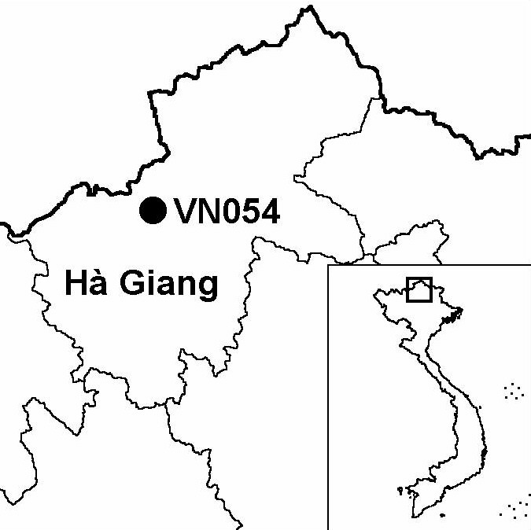

Province(s): Ha Giang
PA Status: None

Latitude: 22º46'N
Longitude: 104º49'E
Area: 40,344 ha
Altitude Range: 100-2,616 m asl

EBA / SA:

None
Priority Landscape:
None

General Description

The IBA is centred on Mount Tay Con Linh, which, at 2,616 m asl, is the highest mountain in north-eastern Vietnam. The northern flank of the mountain is included within Tay Con Linh I proposed nature reserve, while the southern flank is included within Tay Con Linh II proposed nature reserve. The topography of the IBA is steep and mountainous. The natural habitat types at the IBA are lowland evergreen forest, lower montane evergreen forest and upper montane evergreen forest, although areas at low elevations have largely been cleared for agriculture, and all remaining forest below 1,200 m asl is heavily disturbed^{1,2}.

Bird Fauna: Key Features

Tay Con Linh IBA supports a rich montane avifauna, including a large number of species restricted to the Sino-Himalayan Subtropical Forests Biome. Tay Con Linh is one of only four IBAs in Vietnam known to support a population of the globally vulnerable Beautiful Nuthatch Sitta formosa. In addition, during a survey in May 2000, an undescribed taxon of Short-tailed Scimitar Babbler Jabouilleia danjoui was collected at the IBA². This is the most northerly record of this restricted-range species.

Species | IBA  Criteria | Global Threat Status | Other  IBAs | Notes
Beautiful Nuthatch  Sitta formosa | A1, A3 | VU | 3 | Pairs, possibly the same birds, were observed at 1,500 m asl on two occasions in May 2000².
Short-tailed Scimitar Babbler  Jabouilleia danjoui | A1, A2 | NT | 17 | A single specimen was collected in dense vegetation at 1,400 m asl in May 2000².

Notes: [ ] = unconfirmed record.

Biome Restricted Species: The site qualifies under criterion A3 because it supports 35 species restricted to the Sino-Himalayan Subtropical Forests (Biome 08). See Appendix 4 for details.

Secondary Criteria

Species Status Species Status
[Cupressus torulosa]^{3,4} NT Fokienia hodginsii⁵ NT

Threats to Biodiversity

Around 11,600 people, belonging to the Dao, Tay, Hmong, Hoa and Co Lao ethnic minorities, live inside Tay Con Linh IBA. A significant area of forest has already been cleared for agriculture, both wet rice and shifting cultivation. Other major threats to biodiversity at the IBA include hunting and over-exploitation of forest products.
Threat | Severity
Agricultural intensification / expansion | ● ●
Fire | ●
Hunting | ● ● ●
Selective logging / cutting | ● ●
Unsustainable exploitation of NTFPs | ● ●

Interviews with local people indicate that there have been severe declines in mammal populations and diversity in the last 30 years. Consequently, birds appear to be under strong hunting pressure. Some species particularly sensitive to hunting pressure, such as hornbills, parakeets and pheasants, may already have been eradicated from the IBA².

Conservation Actions

Investment plans for Tay Con Linh I and Tay Con Linh II were prepared in July 1994, and proposed establishing two separate nature reserves¹. After the approval of these investment plans by the Ministry of Agriculture and Rural Development and Ha Giang Provincial People's Committee, two separate management boards were established in November 1994¹.

Recommendations

- The two nature reserve management boards established at the provincial level should be combined, and Tay Con Linh should be decreed as a nature reserve by the government of Vietnam.
- Enforcement of forest management regulations should be strengthened, particularly controls on forest clearance and illegal logging.
- National social forestry programmes should be extended, in order to increase the involvement of local communities in forest protection and provide an alternative source of forest products.
- An integrated programme of anti-hunting activities should be initiated, including conservation awareness raising, controls on wildlife trade, and community-based anti-hunting patrols.

References

1. BirdLife International and the Forest Inventory and Planning Institute (2001) Sourcebook of existing and proposed protected areas in Vietnam. Hanoi: BirdLife International Vietnam Programme and the Forest Inventory and Planning Institute.
2. Vogel, C. J., Sweet, P. R., Le Manh Hung and Hurley, M. M. (submitted, Forktail) Ornithological records from Ha Giang province, Vietnam.
3. Anon. (1994a) [Investment plan for Tay Con Linh I Nature Reserve]. Hanoi: Forest Inventory and Planning Institute. (In Vietnamese.)
4. Anon. (1994b) [Investment plan for Tay Con Linh II Nature Reserve]. Hanoi: Forest Inventory and Planning Institute. (In Vietnamese.)
5. Nguyen Tien Hiep and Vidal, J. E (1996) Flore du Cambodge du Laos et du Vietnam, vol. 28: Gymnospermae. Paris: Museum National D'Histoire Naturelle. (In French.)

Beautiful Nuthatch Sitta formosa

