Tam Dao Criteria: A1 & A3

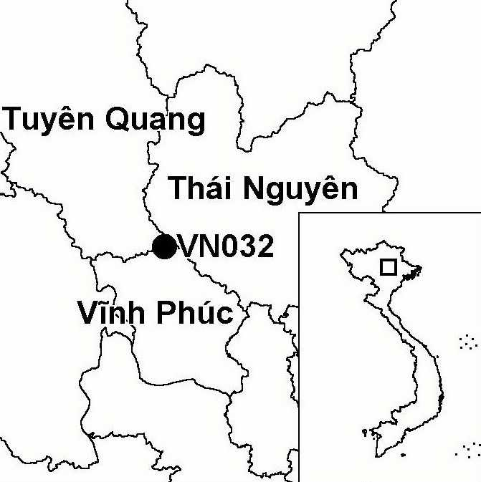
Province(s): Vinh Phuc, Thai Nguyen and
Tuyen Quang
PA Status: National Park

Latitude: 21º32'N
Longitude: 105º34'E
Area: 36,883 ha
Altitude Range: 100-1,592 m asl

EBA / SA:
None
Priority Landscape:
None

General Description

The IBA comprises Tam Dao National Park in northern Vietnam. The topography of Tam Dao IBA is dominated by a long mountain ridge, which rises abruptly from the plain of the Red River Delta. Originally, Tam Dao supported a large area of lower montane evergreen forest, with lowland evergreen forest at lower elevations, and elfin forest on the highest peaks¹. However, due to a long history of over-exploitation of forest resources, clearance of forest for agriculture and forest fire, the lowland evergreen forest has been largely cleared and replaced by a range of secondary vegetation types, including large areas of pine plantation.

Bird Fauna: Key Features

Tam Dao IBA is one of the few sites in Vietnam from where there have been recent records of Imperial Eagle Aquila heliaca and Fairy Pitta Pitta nympha, two globally threatened species. However, both species are presumably rare passage migrants through the IBA, and it is unlikely that the site regularly supports a significant population of either. From an ornithological perspective, the greatest significance of Tam Dao IBA is that it supports a large number of biome-restricted species. In particular, the site supports a number of biome-restricted species that are known from few other sites in Vietnam, such as Blue-naped Pitta Pitta nipalensis, Purple Cochoa Cochoa purpurea, Chestnut-headed Tesia Tesia castaneocoronata, Pale-footed Bush Warbler Cettia pallidipes and Greater Rufous-headed Parrotbill Paradoxornis ruficeps.

Species | IBA  Criteria | Global Threat Status | Other  IBAs | Notes
†Imperial Eagle  Aquila heliaca | A1 | VU | 2 | A juvenile was observed in flight in December 1993². It is unlikely that the site regularly supports a significant population.
†Fairy Pitta  Pitta nympha | A1, A3 | VU | 2 | One live individual, which was reportedly captured within the IBA, was found on a market stall in Tam Dao town in May 1997². It is unlikely that the site regularly supports a significant population.

Notes: † = not confirmed to regularly occur in significant numbers.

Biome Restricted Species: The site qualifies under criterion A3 because it supports 39 species restricted to the Sino-Himalayan Subtropical Forests (Biome 08) and nine species restricted to the Indochinese Tropical Moist Forests (Biome 09). See Appendix 4 for details.

Secondary Criteria

Species Status Species Status
[Fokienia hodginsii]³ NT Amentotaxus argotaenia var. argotaenia⁴ VU

Notes: [ ] = unconfirmed record.

Threats to Biodiversity

There exist a number of severe threats to biodiversity at Tam Dao IBA. Most significantly, due to weak enforcement of national park management regulations, exploitation of forest resources is widespread and unsustainable. Unsustainable exploitation of forest products takes the form of hunting, collection of medicinal plants, insects and orchids, firewood collection and selective timber extraction. This problem is compounded by the development of Tam Dao as a tourism destination, thereby creating a large market for forest products, including stone, timber and other construction materials for tourist infrastructure. Wildlife is openly sold at markets and restaurants within the national park. Another major threat to biodiversity is habitat loss as a result of forest fire. Some forest fires occur accidentally, a problem exacerbated by the pronounced dry season at Tam Dao, which makes the forest susceptible to fire. Other fires are set deliberately by local people, for instance to clear forest for tea plantations¹.
Threat | Severity
Afforestation | ●
Agricultural intensification / expansion | ● ●
Fire | ● ●
Hunting | ● ● ●
Recreation / tourism | ● ●
Selective logging / cutting | ● ●
Unsustainable exploitation of NTFPs | ● ● ●

Conservation Actions

- In 1977, Tam Dao was decreed as a nature reserve by the government of Vietnam¹.
- In 1996, Tam Dao was upgraded to national park status, and a management board was established¹.
- An integrated conservation and development project, which will focus on buffer zone management at the national park, is currently being developed by GTZ¹.

Recommendations

- Protected area management regulations should be effectively enforced, particularly controls on exploitation of and trade in forest products.
- Tourism should be developed in a sustainable manner, so that negative environmental impacts are minimised and potential benefits for the management of the biodiversity of the national park are maximised.
- Measures to reduce the risk of fires during the dry season should be introduced, including extension activities among local communities.

References

1. BirdLife International and the Forest Inventory and Planning Institute (2001) Sourcebook of existing and proposed protected areas in Vietnam. Hanoi: BirdLife International Vietnam Programme and the Forest Inventory and Planning Institute.
2. Eames, J. C. and Tordoff, A. W. (in prep.) Recent records and a conservation status review of some threatened and near-threatened bird species in Vietnam.
3. Anon. (1993) [Investment plan for Tam Dao National Park]. Hanoi: Forest Inventory and Planning Institute. (In Vietnamese.)
4. Nguyen Tien Hiep and Vidal, J. E. (1996) Flore du Cambodge du Laos et du Vietnam. Vol. 28: Gymnospermae. Paris: Museum National D'Histoire Naturelle. (In French.)

Imperial Eagle Aquila heliaca

