Tien Hai Criteria: A1 & A4i

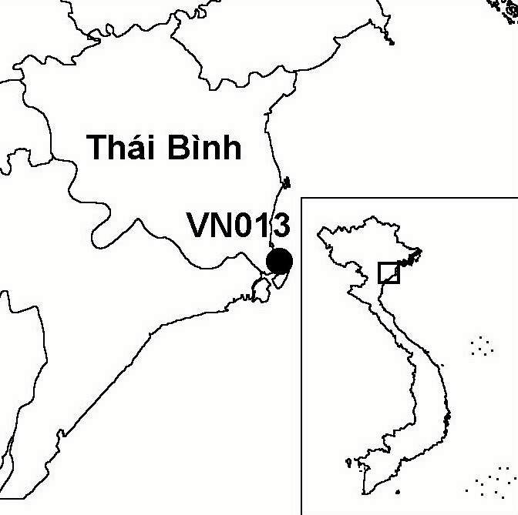
Province(s): Thai Binh
PA Status: Nature Reserve

Latitude: 20º18'N
Longitude: 106º36'E
Area: 12,500 ha
Altitude Range: 0-2 m asl

EBA / SA:

None
Priority Landscape:
None

General Description

The IBA comprises Tien Hai Nature Reserve, which is situated in the coastal zone of the Red River Delta, to the north of the mouth of the main channel of the Red River, known as the Ba Lat River. The IBA consists of a stretch of coastline dominated by aquacultural ponds, a large area of intertidal mudflats and two large, sandy islands. Both islands have been extensively afforested with the exotic Casuarina equisetifolia. Along the landward shore of the larger island, Con Vanh, is a large area of mangrove, most of which has been enclosed within aquacultural ponds^{1,2}.

Bird Fauna: Key Features

Tien Hai is an important staging and wintering site for migratory waterbirds. However, despite its location at the mouth of the main channel of the Red River, the importance of the site for migratory waterbirds is much lower than that of nearby Xuan Thuy IBA. The reasons for this are not clear, although they may include differences in patterns of sediment deposition as a result of prevailing currents, and levels of human impact between the two sites. Tien Hai is a known wintering site of one globally threatened species: Black-faced Spoonbill Platalea minor^{1,2}. The lack of records of other globally threatened bird species from the site may partly reflect low survey coverage.

Species | IBA  Criteria | Global Threat Status | Other  IBAs | Notes
Black-faced Spoonbill  Platalea minor | A1, A4i | EN | 8 | A group of six birds was observed feeding along the bank of the Ba Lat River in 1996¹.

Biome Restricted Species: The site does not qualify under criterion A3. See Appendix 4 for details.

Secondary Criteria

The site does not qualify under any secondary criterion.

Threats to Biodiversity

The biggest potential threat to biodiversity at the site is habitat loss, as a result of afforestation of sandy islands with Casuarina equisetifolia and intertidal mudflats with mangrove, which threatens the key habitats for migratory waterbird species. Other major threats are disturbance to birds and hunting. While the precise level of these threats is not known, during a 1996 survey, over 900 people were observed collecting shellfish in the intertidal zone, and hunters were observed carrying guns.
Threat | Severity
Afforestation | ● ● ●
Aquaculture / fisheries | ● ●
Disturbance to birds | ● ●
Hunting | ● ●

Conservation Actions

- The establishment of a nature reserve at Tien Hai was decreed by the government of Vietnam in September 1994².
- In January 1995, a decision was issued by the Ministry of Environment, Science and Technology to expand the Ramsar site at Xuan Thuy to include Con Vanh and Con Thu islands within Tien Hai IBA. Currently however, these are still managed separately, as part of Tien Hai Nature Reserve.

Recommendations

- Tien Hai meets the criteria for designation as a site of international importance for wetland conservation under the Ramsar Convention, and should, therefore, be designated as a Ramsar site.
- An appropriate land-use plan should be prepared for the site, which reduces human pressure on the most critical areas for biodiversity, and clearly defines the boundary of the nature reserve¹.
- Nature reserve management regulations prohibiting hunting should be strictly enforced.
- There should be no further afforestation of sandy islands with Casuarina equisetifolia or intertidal mudflats with mangrove¹.
- The capacity of the nature reserve should be increased, in terms of staff, infrastructure and training¹.

References

1. Pedersen, A. and Nguyen Huy Thang (1996) The conservation of key coastal wetland sites in the Red River Delta. Hanoi: BirdLife International Vietnam Programme.
2. Birdlife International and the Forest Inventory and Planning Institute (2001) Sourcebook of existing and proposed protected areas in Vietnam. Hanoi: BirdLife International Vietnam Programme and the Forest Inventory and Planning Institute.

