Tien Lang Criteria: A1 & A4i

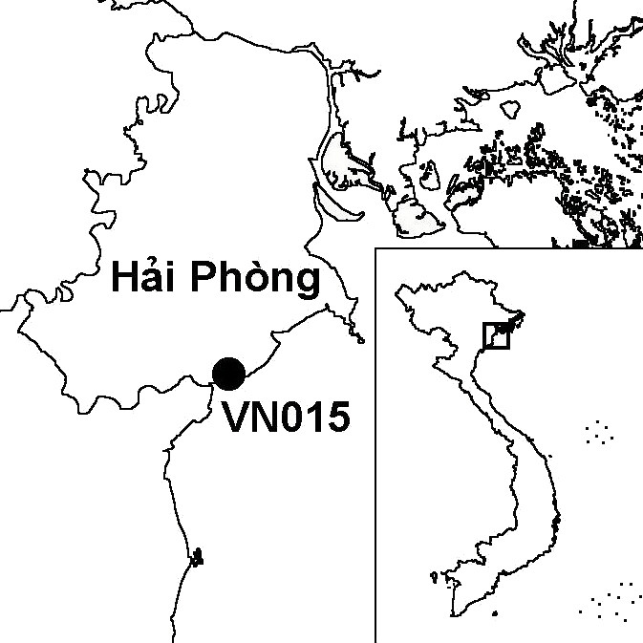
Province(s): Hai Phong
PA Status: None

Latitude: 20º39'N
Longitude: 106º39'E
Area: 5,000 ha
Altitude Range: 0-2 m asl

EBA / SA:

None
Priority Landscape:
None

General Description

The IBA is situated in the coastal zone of the Red River Delta, and comprises a 13 km stretch of coastline bordered by the Van Uc estuary to the north and the Thai Binh estuary to the south. Each estuary supports approximately 100 ha of old-growth mangrove forest, almost all of which is enclosed within aquacultural ponds. Each estuary also contains extensive intertidal mudflats, some areas of which have been afforested with mangrove¹. To the south, the site borders Thai Thuy IBA.

Bird Fauna: Key Features

Tien Lang IBA is an important wintering and staging area for migratory shorebirds. The site regularly supports small but significant populations of two globally threatened species: Black-faced Spoonbill Platalea minor and Saunders's Gull Larus saundersi. In addition, the site supports significant concentrations of egrets, herons and shorebirds. Most notably, the site supports over 1% of the biogeographic population of Spotted Redshank Tringa erythropus. During a survey of the site in April 1996, large numbers of passage migrants were observed, including over 50,000 Barn Swallows Hirundo rustica and Sand Martins Riparia riparia, and over 1,600 Black Bazas Aviceda leuphotes¹.

Species | IBA  Criteria | Global Threat Status | Other  IBAs | Notes
Black-faced Spoonbill  Platalea minor | A1, A4i | EN | 8 | The species is a regular winter visitor in small numbers, with the biggest single count being 16 birds in March 1996².
Saunders's Gull  Larus saundersi | A1, A4i | VU | 5 | A single bird was observed in February 1995². A maximum count of 30 birds was made between February and April 1996¹.
Black-headed Ibis  Threskiornis melanocephalus | A1 | NT | 8 | Eight adults were observed feeding on a mudflat in the Van Uc estuary in March 1994³.
Spotted Redshank  Tringa erythropus | A4i |  | 2 | A count of 394 birds was made in April 1996¹.

Biome Restricted Species: The site does not qualify under criterion A3. See Appendix 4 for details.

Secondary Criteria

The site does not qualify under any secondary criterion.

Threats to Biodiversity

The biggest threat to the old-growth mangrove at the site is enclosure within aquacultural ponds and selective cutting for fuel. In additional, the intertidal mudflats, which are the most important habitat for migratory waterbirds, are threatened by afforestation with mangrove. An additional threat to biodiversity at the site is hunting with guns and mist-nets. More than 500 m of mist-nets were observed during a survey in 1996¹.
Threat | Severity
Afforestation | ● ● ●
Aquaculture / fisheries | ● ● ●
Disturbance to birds | ● ●
Hunting | ● ●
Selective logging / cutting | ● ●

Conservation Actions

- In 1996, BirdLife International and the Forest Inventory and Planning Institute proposed that Tien Lang IBA should be conferred protected area status¹. To date, however, this has not taken place.

Recommendations

- Tien Lang meets the criteria for designation as a site of international importance for wetland conservation under the Ramsar Convention, and should, therefore, be designated as a Ramsar site.
- There should be no further aquacultural development, afforestation or logging of old-growth mangrove at the site¹.
- Measures should be implemented to control hunting at the site¹.
- A feasibility study for the establishment of a protected area at the site should be carried out.

References

1. Pedersen, A. and Nguyen Huy Thang (1996) The conservation of key coastal wetland sites in the Red River Delta. Hanoi: BirdLife International Vietnam Programme.
2. Eames, J. C. and Tordoff, A. W. (in prep) Recent records and a conservation status review of some threatened and near-threatened bird species in Vietnam.
3. Pedersen, A., Nielsen, S., Le Dien Thuy and Le Trong Trai (1998) The status and conservation of threatened and near-threatened species of birds in the Red River Delta, Vietnam. Bird Conservation International 8: 31-51.

