Tuyen Lam Criteria: A1, A2 & A3

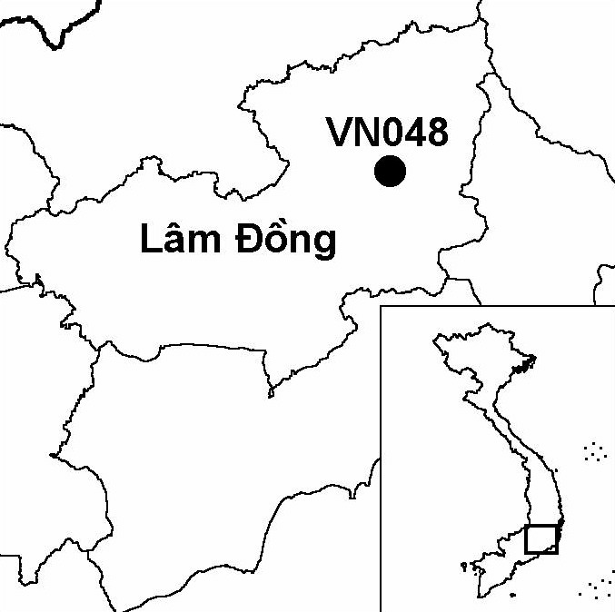
Province(s): Lam Dong
PA Status: None

Latitude: 11º52'N
Longitude: 108º25'E
Area: 13,000 ha
Altitude Range: 1,400-1,812 m asl

EBA / SA:

Da Lat Plateau EBA
Priority Landscape:
SA 3 - Southern Annamites Main Montane Block

General Description

The IBA comprises a large forest fragment on the Da Lat plateau, which extends to the south and west of Tuyen Lam lake, a reservoir located 6 km south-west of Da Lat city. Tuyen Lam lake is surrounded by coniferous forest dominated by Pinus kesiya. At the southern end of the reservoir, the coniferous forest is backed by lower montane evergreen forest, which extends south-east to a site known as Cam Ly. The forest fragment is surrounded by a mosaic of market gardens, secondary scrub and plantation forest.

Bird Fauna: Key Features

While the total area of natural forest at Tuyen Lam IBA is lower than that at several other IBAs in the Da Lat Plateau Endemic Bird Area (EBA), the site supports six of the eight restricted-range species that define this EBA: Grey-crowned Crocias Crocias langbianis, Yellow-billed Nuthatch Sitta solangiae, Collared Laughingthrush Garrulax yersini, White-cheeked Laughingthrush G. vassali, Black-hooded Laughingthrush G. milleti and Vietnam Greenfinch Carduelis monguilloti. Of these species, the most significant is the globally endangered Grey-crowned Crocias, of which there are recent records from only one other site in the world: Chu Yang Sin IBA. Tuyen Lam IBA is an important site for the conservation of this species due to the presence of extensive areas of lower montane evergreen forest, a habitat type that has been extensively lost elsewhere on the Da Lat plateau. Tuyen Lam IBA also supports a number of distinctive subspecies, confined to the Da Lat Plateau EBA, some of which may be worthy of elevation to species level. These include subspecies of Spot-breasted Laughingthrush Garrulax merulinus annamensis, Blue-winged Minla Minla cyanouroptera and Grey-headed Parrotbill Paradoxornis gularis margaritae. Other key species recorded at Tuyen Lam IBA include Germain's Peacock Pheasant Polyplectron germaini, a restricted-range species characteristic of the South Vietnamese Lowlands EBA, and Pale-capped Pigeon Columba punicea, a globally vulnerable species. Regarding the latter species, the largest recent counts of this species in Vietnam have been made at Tuyen Lam IBA¹.

Species | IBA  Criteria | Global Threat Status | Other  IBAs | Notes
Collared Laughingthrush  Garrulax yesini | A1, A2 | EN | 5 | Three birds were observed in December 1994¹.
Grey-crowned Crocias  Crocias langbianis | A1, A2 | EN | 1 | Since 1994, the species has been recorded on a number of occasions^{2,3,4}. The most recent record is of three birds seen in September 2002⁵.
Germain's Peacock Pheasant  Polyplectron germaini | A1, A2 | VU | 4 | The species was heard calling in February 1992¹.
Pale-capped Pigeon  Columba punicea | A1, A3 | VU | 5 | There are regular records of this species, including 41 birds seen in January 1992 and 92 birds seen in December 1995¹.
Yellow-billed Nuthatch  Sitta solangiae | A1, A2 | NT | 11 | Up to 10 birds were observed in May 1991⁵. The species was recorded in December 1994². Flocks of three and four birds were observed in April 1998³. The most recent record is of a single bird seen in February 2000⁴.
Black-hooded Laughingthrush  Garrulax milleti | A1, A2 | NT | 8 | There are regular records of this species, including two flocks of at least five and three birds in May 1991⁶, a flock of six to eight birds in April 1997⁴, and between three and five birds in April 1998³. The most recent record is of a single bird heard in February 2000⁴.
Vietnam Greenfinch  Carduelis monguilloti | A1, A2 | NT | 4 | The species was recorded in December 1994² and February 2000⁴. The most recent record is of a flock of 12 birds seen in September 2002⁵.
White-cheeked Laughingthrush  Garrulax vassali | A2 |  | 8 | At least 30 birds were observed in May 1991⁵. The species was recorded in December 1994². Four birds were recorded in April 1998³. The most recent record is of a flock of 12 birds seen in September 2002⁵.

Biome Restricted Species: The site qualifies under criterion A3 because it supports 27 species restricted to the Sino-Himalayan Subtropical Forests (Biome 08). See Appendix 4 for details.

Secondary Criteria

Species Status
Buff-cheeked Gibbon Nomascus gabriellae⁷ VU

Threats to Biodiversity

The major threat to biodiversity at Tuyen Lam IBA is habitat loss as a result of conversion of forest to agriculture. The IBA is surrounded by a number of market gardens, some of which are encroaching the natural forest⁶. Small-scale illegal logging has been observed taking place at several places within the site⁵. Firewood collection and charcoal production have also been identified as major causes of habitat loss at the site¹. Tourism development is already taking place around Tuyen Lam lake, and represents a potential additional threat to biodiversity at the IBA.
Threat | Severity
Agricultural intensification / expansion | ● ●
Fire | ● ●
Infrastructure development | ●
Recreation / tourism | ●
Selective logging / cutting | ● ●
Unsustainable exploitation of NTFPs | ● ●

Conservation Actions

None to date.

Recommendations

- Tuyen Lam IBA should be designated as a special-use forest or other appropriate land-use designation compatible with biodiversity conservation, a forest management board should be established, and forest management regulations should be enforced, particularly controls on charcoal production and firewood collection.
- All further conversion of forest to agriculture at the IBA should be strictly prohibited.
- Further surveys should be conducted to assess the status and distribution of key species at the site, as a basis for design of an appropriate site boundary.
- Environmental Impact Assessments should be conducted prior to any further infrastructure development at the site, particularly development of tourism infrastructure, and appropriate mitigation measures should be implemented.
- A tourism management board, including representatives of the forest management board, the provincial tourism company and other local stakeholders, should be established, as a basis for the sustainable development of ecotourism at the site.

References

1. BirdLife International (2001) Threatened birds of Asia: the BirdLife International red data book. Cambridge, U.K.: BirdLife International.
2. Dymond, J. N. (1998) Birds in Vietnam in December 1993 and December 1994. Forktail 13: 7-12.
3. Hornbuckle, J. (1998) Vietnam trip report 24 March to 14 April 1998. Unpublished report posted on the WorldTwitch Website.
4. Eames, J. C. and Tordoff, A. W. (in prep.) Recent records and a conservation status review of some threatened and near-threatened bird species in Vietnam.
5. R. Craik in litt. 2002.
6. Robson, C. R., Eames, J. C., Nguyen Cu and Truong Van La (1993) Birds recorded during the third BirdLife/Forest Birds Working Group expedition in Vietnam. Forktail 9: 89-119.
7. J. C. Eames personal observations.

Grey-crowned Crocias Crocias langbianis

