Truong Son Criteria: A1, A2 & A3

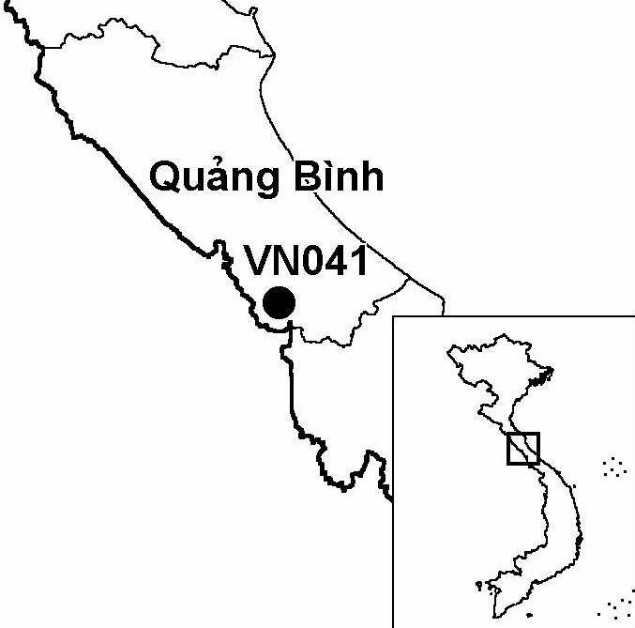
Province(s): Quang Binh
PA Status: None

Latitude: 17º07'N
Longitude: 106º30'E
Area: 50,000 ha
Altitude Range: 100-1,350 m asl

EBA / SA:

Annamese Lowlands EBA
Priority Landscape:
None

General Description

Truong Son IBA is situated in the Annamese lowlands, close to the international border with Laos. Although the precise boundaries of the IBA have yet to be defined, due to limited information on the status and distribution of key bird species in the area, available information indicates that the IBA will encompass areas of forest in western Le Thuy and Quang Ninh districts. The topography of the area is dominated by the foothills of the Annamite mountains but rises in the west to elevations of over 1,000 m asl. A large proportion of Le Thuy district is covered by natural forest, and significant areas of relatively undisturbed lowland evergreen forest remain in the south of the district. In contrast, forest in the north and east of the district are more heavily disturbed, with large areas of secondary vegetation present. Quang Ninh district, which adjoins Le Thuy district to the north, supports a large area of limestone forest, as well as larger areas of lowland evergreen forest. The IBA is currently under the management of Khe Giua, Ba Ren and Truong Son State Forest Enterprises¹. To the west, Truong Son IBA is contiguous with Upper Xe Banfai IBA in Laos.

Bird Fauna: Key Features

Truong Son IBA supports an avifauna typical of the Annamese Lowlands Endemic Bird Area (EBA). To date, three of the nine restricted-range species characteristic of the EBA, have been recorded at the site: Annam Partridge Arborophila merlini, Crested Argus Rheinardia ocellata and Short-tailed Scimitar Babbler Jabouilleia danjoui. In addition, a fourth restricted-range species, the globally endangered Edwards's Pheasant Lophura edwardsi, has been provisionally recorded, based on a single specimen record from an unknown locality in western Quang Ninh district². A rapid survey of the IBA during June 2002 was unable to obtain equivocal evidence regarding the status of this species at the site¹. In addition, the IBA supports suitable habitat for three other restricted-range species, Imperial Pheasant L. imperialis, Sooty Babbler Stachyris herbeti and White-cheeked Laughingthrush Garrulax vassali, although none have been confirmed to occur at the site to date¹.

Species | IBA  Criteria | Global Threat Status | Other  IBAs | Notes
[Edwards's Pheasant  Lophura edwardsi] | A1, A2 | EN | 3 | In 1998 or 1999, a specimen of a juvenile Edwards's Pheasant was collected at an unknown locality in western Quang Ninh district².
Crested Argus  Rheinardia ocellata | A1, A2 | VU | 15 | At least three, four and five Crested Argus were heard calling on separate days in June 2002 in lowland evergreen forest in the Khe Nuoc Trong area of Le Thuy district¹. Tail feathers, reportedly from birds captured within the IBA, were observed in two villages in Le Thuy district and one village in Quang Ninh district during June 2002¹.
[Siamese Fireback  Lophura diardi] | A1, A3 | NT | 14 | According to the local forest protection department, a single captive bird was confiscated in Le Thuy district in July 1999¹. Local hunters affirmed the presence of this species in western Le Thuy district¹.
Red-collared Woodpecker  Picus rabieri | A1, A3 | NT | 11 | A single bird was seen at 200 m asl in lowland evergreen forest in the Nuoc Trong area of Le Thuy district in June 2002¹.
[Great Hornbill  Buceros bicornis] | A1 | NT | 14 | One skull of a bird reportedly hunted in 1976 was observed at a village in Le Thuy district in June 2002¹. Local hunters report the continued occurrence of the species¹.
Brown Hornbill  Anorrhinus tickelli | A1, A3 | NT | 16 | A single bird and a group of least six were observed on separate days in June 2002 at 200 m asl in lowland evergreen forest in the Khe Nuoc Trong area of Le Thuy district¹. Five captive juveniles were observed at three villages in Quang Ninh district in June 2002¹.
Lesser Fish Eagle  Ichthyophaga humilis | A1 | NT | 6 | In June 2002, a single adult was observed flying along a narrow, forested river in the Khe Nuoc Trong area of Le Thuy district¹.
Short-tailed Scimitar Babbler  Jabouilleia danjoui | A1, A2 | NT | 16 | Two pairs, probably the same birds, were observed on separate occasions at 200 m asl in a forested gully in the Khe Nuoc Trong area of Le Thuy district in June 2002¹.
Annam Partridge  Arborophila merlini | A1, A2 |  | 4 | A single male specimen was captured in a snare line placed at 200 m asl in lowland evergreen forest in the Khe Nuoc Trong area of Le Thuy district in June 2002¹. Arborophila partridge calls, thought probably to be this species, were frequently heard in the same area during June 2002¹.
Notes: [ ] = unconfirmed record.

Biome Restricted Species: The site qualifies under criterion A3 because it supports nine species restricted to the Indochinese Tropical Moist Forests (Biome 09). See Appendix 4 for details.

Secondary Criteria

Species Status Species Status
[Red-shanked Douc Pygathrix nemaeus nemaeus]¹ EN Southern Serow Naemorhedus sumatraensis¹ VU
White-cheeked / Buff-cheeked Gibbon Saola Pseudoryx nghetinhensis¹ EN
Nomascus leucogenys / gabriellae¹ DD/VU

Notes: [ ] = unconfirmed record.

Threats to Biodiversity

The natural forest in Truong Son IBA has been reduced in extent and fragmented as a result of several factors, including the effects of the Second Indochina War and commercial logging operations. Habitat degradation and loss continue at the site, as a result of on-going commercial logging operations. However, as a result of a reduction in logging operations and the zoning of significant areas of good quality forest as watershed protection forest (where timber extraction is prohibited), rates of habitat degradation and loss have declined in recent years. In addition, the rate of conversion of forest to agricultural land is relatively low, due to the low human population density¹.

In addition to habitat loss, another major threat to biodiversity at Truong Son IBA is hunting. This threat is particularly severe to large mammal populations, most notably that of the globally endangered Saola Pseudoryx nghetinhensis, but also affects hornbills and galliformes. Without effective conservation action, hunting pressure and rates of habitat loss are likely to intensify following the completion of the western branch of National Highway 2, which is currently being constructed through the IBA. The completion of this highway may facilitate human settlement within the IBA and open up the area to outside economic forces, including the wildlife trade¹.
Threat | Severity
Agricultural intensification / expansion | ●
Commercial timber extraction | ● ●
Hunting | ● ● ●
Infrastructure development | ● ● ●

Conservation Actions

- None to date.

Recommendations

- The feasibility of establishing a protected area including all or part of the IBA should be assessed, and, if appropriate, such a protected area should be established under the management of Quang Binh Provincial FPD¹.
- Further studies should be conducted to assess the distribution and status of all species of conservation concern in the area, as a basis for targeted conservation interventions and integration of biodiversity considerations into state forest enterprise management plans and other land-use plans¹.
- Appropriate anti-hunting regulations should be developed and enforced within forest compartments that support species of conservation concern¹.
- Community-based conservation initiatives should be developed in communities adjacent to forest compartments supporting species of conservation concern¹.
- Human settlement along the route of the western branch of National Highway 2 should be strictly controlled and no settlement should be permitted adjacent to forest compartments supporting species of conservation concern¹.
- State forest enterprise management plans should be modified so that forest compartments supporting Saola, gibbon, Brown Hornbill Anorrhinus tickelli or Great Hornbill Buceros bicornis are zoned as watershed protection forest, where timber extraction is prohibited¹.

References

1. Le Manh Hung, Pham Duc Tien, Tordoff, A. W. and Nguyen Dinh Dung (2002) A rapid field survey of Le Thuy and Quang Ninh districts, Quang Binh province, Vietnam. Unpublished report to the Birdlife International Vietnam Programme and the Institute of Ecology and Biological Resources.
2. Eames, J. C. and Tordoff, A. W. (in prep.) Recent records and a conservation status review of some threatened and near-threatened bird species in Vietnam.

Short-tailed Scimitar Babbler Jabouilleia danjoui

