Thai Thuy Criteria: A1 & A4i

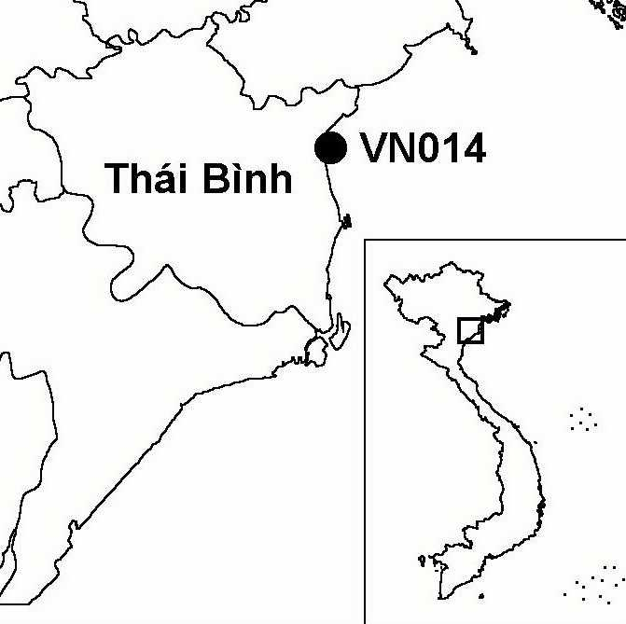
Province(s): Thai Binh
PA Status: None

Latitude: 20º33'N
Longitude: 106º38'E
Area: 13,696 ha
Altitude Range: 0-2 m asl

EBA / SA:

None
Priority Landscape:
None

General Description

The IBA comprises Thai Thuy proposed nature reserve in the coastal zone of the Red River Delta. Thai Thuy IBA includes a 16 km stretch of coastline, bordered by the Thai Binh river to the north and the Tra Ly river to the south. Near the mouths of the Thai Binh and Tra Ly rivers are the largest remaining areas of old-growth mangrove in the Red River Delta. To the south of the Thai Binh river mouth are extensive intertidal mudflats, formed by sediment deposition. Large areas of these mudflats have been afforested with mangrove. To the west of the Thai Binh river mouth is an area of saltpans. Finally, the area around the Tra Ly river mouth is dominated by aquacultural ponds^{1,2}. To the north, the site borders Tien Lang IBA.

Bird Fauna: Key Features

Situated at the mouth of the Thai Binh river, where high rates of sediment deposition result in the development of extensive intertidal habitats, Thai Thuy is an important wintering and staging area for migratory waterbirds. Each year, the site supports significant numbers of wintering gulls, shorebirds and waterfowl, including over 1% of the global population of the globally threatened Saunders's Gull Larus saundersi. After Xuan Thuy IBA, the site is one of the most important wintering areas for Black-faced Spoonbill Platalea minor in the coastal zone of the Red River Delta. In addition, the site supports a small resident population of the globally near-threatened Black-headed Ibis Threskiornis melanocephalus.

Species | IBA  Criteria | Global Threat Status | Other  IBAs | Notes
Black-faced Spoonbill  Platalea minor | A1, A4i | EN | 8 | The species is a regular winter visitor in small numbers, with maximum counts of 23 birds in the winter of 1995/1996, 12 in 1996/1997 and four in 1999/2000³.
Spoon-billed Sandpiper  Eurynorhynchus pygmeus | A1 | VU | 3 | A single individual was observed feeding on an exposed mudflat in the Thai Binh estuary in January 2001³.
Saunders's Gull  Larus saundersi | A1, A4i | VU | 5 | The species is a regular winter visitor in significant numbers, with maximum counts of 147 birds in the winter of 1995/1996, 55 in 1996/1997, 75 in 1997/1998, 100 in 1998/1999, 80 in 1999/2000 and four in 2000/2001³.
†Imperial Eagle  Aquila heliaca | A1 | VU | 2 | A single individual was observed in February 1996³. It is unlikely that the site regularly supports a significant population.
Chinese Egret  Egretta eulophotes | A1 | VU | 6 | A single individual was observed in October 1996³.
†Far Eastern Curlew  Numenius madagascariensis | A1 | NT | 4 | The only record of this species from the site is of a single bird observed in October 1998³. The site probably does not regularly support a significant population of this species.
†Black-headed Ibis  Threskiornis melanocephalus | A1 | NT | 8 | The site supports a small resident population, which may be declining. The maximum count of this species is 14 birds in April 1996. During visits in 2000 and 2001, only six and four birds were recorded respectively³.

Notes: † = not confirmed to regularly occur in significant numbers.

Biome Restricted Species: The site does not qualify under criterion A3. See Appendix 4 for details.

Secondary Criteria

The site does not qualify under any secondary criterion.

Threats to Biodiversity

One of the biggest threats to biodiversity at Thai Thuy is loss of feeding habitat for migratory waterbirds, as a result of afforestation of intertidal mudflats with mangrove. By 1997, over 2,500 ha had been planted with the mangrove Kandelia candel. Hunting is another major threat to biodiversity at the site. During a survey in 1996, the use of mist-nets, airguns and shotguns were all observed. The old-growth mangrove forest is also exploited by local people as a source of wood, and is used for grazing livestock. A further threat is pollution in the form of agricultural run-off and outflow from two industrial processing enterprises, which is allowed to flow into the rivers unchecked^{1,2}.
Threat | Severity
Afforestation | ● ● ●
Aquaculture / fisheries | ● ●
Disturbance to birds | ● ●
Hunting | ● ●
Selective logging / cutting | ●
Other | ●

Conservation Actions

- The coastal zone of Thai Thuy district was the focus of a project implemented by the Danish Red Cross and the Vietnamese Red Cross, the objectives of which were mangrove afforestation and protection of existing areas of mangrove². However, this project may have resulted in a net loss of natural habitat at the IBA.

Recommendations

- Thai Thuy meets the criteria for designation as a site of international importance for wetland conservation under the Ramsar Convention, and should, therefore, be designated as a Ramsar site.
- Further afforestation of intertidal mudflats and expansion of aquaculture should be prohibited at the site.
- Effective measures to control hunting and exploitation of old-growth mangrove at the site should be introduced.
- Thai Thuy should be decreed as a nature reserve by the government of Vietnam, and a management board should be established under the management of Thai Binh province.

References

1. Pedersen, A. and Nguyen Huy Thang (1996) The conservation of key coastal wetland sites in the Red River Delta. Hanoi: BirdLife International Vietnam Programme.
2. BirdLife International and the Forest Inventory and Planning Institute (2001) Sourcebook of existing and proposed protected areas in Vietnam. Hanoi, Vietnam: BirdLife International Vietnam Programme and the Forest Inventory and Planning Institute.
3. Eames, J. C. and Tordoff, A. W. (in prep.) Recent records and a conservation status review of some threatened and near-threatened bird species in Vietnam.

