U Minh Thuong Criteria: A1, A3 & A4i

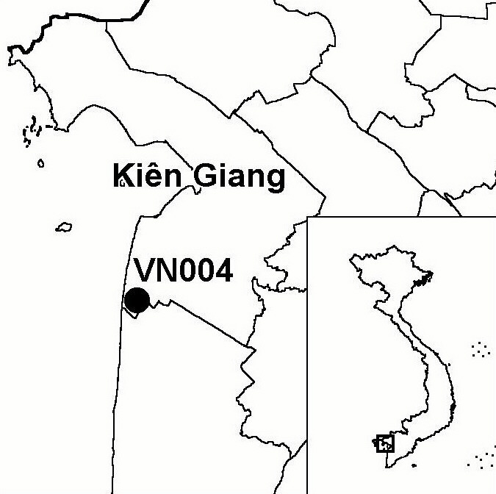
Province(s): Kien Giang
PA Status: National Park

Latitude: 9º35'N
Longitude: 105º05'E
Area: 22,918 ha
Altitude Range: 0-2 m asl

EBA / SA:

None
Priority Landscape:
LMF1 - U Minh Peat Swamp Forests

General Description

This IBA is centred on U Minh Thuong (UMT) National Park, which supports a range of wetland habitats, including semi-natural Melaleuca forest, seasonally inundated grassland and open swamp. The IBA also includes the buffer zone of the national park, most of which consists of paddyfields with small patches of Melaleuca plantation. Finally, the IBA includes the so-called "prison forest", a large Melaleuca plantation to the north-west of the national park, currently under the management of a prison, which supports an important breeding colony of waterbirds¹. In addition to its importance for waterbirds, UMT has a number of other biodiversity values, including being one of only three sites in the world known to support a population of Hairy-nosed Otter Lutra sumatrana.

Bird Fauna: Key Features

UMT supports one of the last two significant areas of peat swamp forest remaining in Vietnam (the other one being U Minh Ha), and is recognised as one of the three highest priority sites for wetland conservation in the Mekong Delta¹. The avifauna of UMT has been relatively well studied with initial surveys carried out in 1997², and, since April 1999, monthly bird surveys have been conducted at the site³. Surveys to date have confirmed the presence of 185 bird species², including nine species of global conservation concern, many of which occur as non-breeding visitors. In 1999, a survey of 10 key wetland sites in the Mekong Delta found that UMT supported the highest bird species richness and, possibly, the largest waterbird breeding colony of all sites visited¹. UMT fulfils several criteria under the Ramsar Convention and, as such, has been recommended for notification as a Ramsar site¹. In addition to the key species listed below, several other species of national conservation importance in Vietnam have also been recorded at UMT, including Asian Openbill Anastomus oscitans and Woolly-necked Stork Ciconia episcopus^{1,2}.

Species | IBA  Criteria | Global Threat Status | Other  IBAs | Notes
[Sarus Crane  Grus antigone] | A1 | VU | 5 | There are unconfirmed reports from local people that the species is a non-breeding visitor in small numbers². However, there have been no field records or anecdotal reports since regular ornithological studies began at the site in April 1999⁴.
†Greater Spotted Eagle  Aquila clanga | A1 | VU | 2 | Single birds were observed in February 1997, and in April and August 2000^{3,5}. The site may not regularly support a significant population.
Spot-billed Pelican  Pelecanus philippensis | A1 | VU | 6 | The species is thought to be a rare non-breeding visitor according to local reports². A single bird was seen in August 2000 and a group of six was seen in October 2000³. A juvenile bird, believed to have been captured in the "prison forest", was found in the possession of local people in July 2001³.
Lesser Adjutant  Leptoptilos javanicus | A1 | VU | 7 | The species breeds in Melaleuca forest in the core zone of the national park³. The maximum count of this species was eight in April 2000, although this is thought to be an under-estimate of the total population³.
Grey-headed Fish Eagle  Ichthyophaga icthyaetus | A1 | NT | 8 | The species has been recorded on several occasions but most records come from the same perching site and are though to be of the same adult bird. A juvenile was observed in October 2000, indicating that the species may breed at the IBA³.
Oriental Darter  Anhinga melanogaster | A1 | NT | 9 | Two individuals were recorded nearby in 1997². Single birds were observed on three occasions during 1999-2000³. A pair was observed in the "prison forest" breeding colony on two occasions in the breeding season of 2001³.
Black-headed Ibis  Threskiornis melanocephalus | A1 | NT | 8 | The species is thought to be a breeding visitor³. The species is regularly observed in April-May 1999, with a highest single count of 44 birds in April. However, the highest counts in 2000 and 2001 were of only four and five birds respectively³.
Painted Stork  Mycteria leucocephala | A1,A4i | NT | 10 | The species is thought to be a non-breeding visitor. Most records come from the between October and January, with a maximum count of 380 birds in October 2000³.
Asian Golden Weaver  Ploceus hypoxanthus | A1 | NT | 3 | A single bird was recorded in 1997². Four individuals were observed in June 2000³.
Purple Swamphen  Porphyrio porphyrio | A4i |  | 0 | A maximum daily count of 2,000 birds was made in 1997². An estimate of the density of this species based on the point counts over a period of two years, extrapolated across the total area of Phragmites reedbed, gives a total estimate of 16,000 birds at the IBA⁴.
Bronze-winged Jacana  Metopidius indicus | A4i |  | 0 | A maximum daily count of 1,000 birds was made in 1997². An estimate of the density of this species based on the point counts over a period of two years, extrapolated across the total area of Phragmites reedbed, gives a total estimate of 18,000 birds at the IBA⁴.
Oriental Pratincole  Glareola maldivarum | A4i |  | 0 | The species is a passage migrant that uses UMT as a stop over on both its northward and southward migration. The maximum count to date was 1,790 individuals in September 2001³.
Little Cormorant  Phalacrocorax niger | A4i |  | 1 | The species breeds in the "prison forest", with maximum counts of 1,348 individuals in May 1999, 1,696 individuals in May 2000 and 1,541 individuals in June 2001³.
Purple Heron  Ardea purpurea | A4i |  | 0 | The species is a resident, which breeds between April and August, with maximum counts of 413 individuals in August 1999, 277 in May 2000 and 1,006 in May 2001³.
Great Egret  Casmerodius albus | A4i |  | 1 | Maximum counts of 2,030, 1,406 and 1,310 were made in September, October and November 2001 respectively⁴.
Glossy Ibis  Plegadis falcinellus | A4i |  | 0 | There is a breeding colony in the "prison forest", where a maximum of 1,368 birds were recorded in May 1999¹. However, the highest count in 2000 was of only 527 birds in April³.

Notes: [ ] = unconfirmed record; † = not confirmed to regularly occur in significant numbers.

Biome Restricted Species: The site qualifies under criterion A3 because it supports 10 species restricted to the Indo-Malayan Tropical Dry Zone (Biome 11). See Appendix 4 for details.

Secondary Criteria

Species Status Species Status
*Long-tailed Macaque Macaca fascicularis^{2,3} NT Malayan Snail-eating Turtle
Asian Box Turtle Cuora amboinensis³ VU Malayemys subtrijuga^{2,3} VU
Yellow-headed Temple Turtle
Hieremys annandalii^{2,3} EN

Notes: * = introduced species.

Threats to Biodiversity

The Melaleuca forest is an essential habitat for a significant component of the key bird species known to occur at the IBA. However, this key bird habitat is being lost at an increasing rate, as a result of forest fires⁶. While fire is a natural part of the ecology of Melaleuca forest, an inappropriate hydrological management regime at the national park has led to low water levels during the dry season and drying out of the peat layer, thereby increasing the frequency and severity of fires, several of which occurred in 2002.

Additional threats to the biodiversity of the site include illegal hunting, by both local people and organised groups of outsiders, and disturbance and easy access caused by the development of tourism infrastructure in the core zone of the national park, including the construction of a surfaced road into the centre of the core zone and the erection of a monument there⁶.
Threat | Severity
Fire | ● ● ●
Hunting | ● ●
Infrastructure development | ● ● ●
Recreation, tourism | ● ● ●
Other | ● ● ●

Conservation Actions

- Since 1998, Care International and Kien Giang Provincial Department of Agriculture and Rural Development have been working in partnership to implement a Danida-funded integrated conservation and development project, the main aim of which is to conserve the existing biodiversity of UMT by strengthening local management capacity and improving the livelihood security of local communities, thereby reducing their dependency upon natural resources⁶.
- The government of Vietnam upgraded UMT to national park status in January 2002.

Recommendations

- The "prison forest", which supports one of the largest waterbird colonies in the Mekong Delta, should be incorporated into the national park, to ensure its long-term conservation¹.
- UMT meets the criteria for designation as a site of international importance for wetland conservation under the Ramsar Convention, and should, therefore, be designated as a Ramsar site.
- All planned infrastructure developments at the site should be carefully assessed for their potential impact upon the flora and fauna. Large-scale activities potentially affecting key species or breeding waterbird colonies should be considered very difficult to either mitigate or justify and should, therefore, be wholly avoided.
- No new canals should be constructed in the national park, as these will cause will further drying out of the peat swamp, increasing the risk of fire at the site, and facilitate better access by poachers.
- A hydrological management regime that avoids drying out of the peat layer and maintains the hydrological value of the site as a source of freshwater for local agriculture should be introduced.
- Existing controls on illegal hunting and trapping of animals should be strengthened.
- Confiscated wildlife should not be released into the national park, unless it can be established that the animals originated from UMT.

References

1. Buckton, S. T., Nguyen Cu, Nguyen Duc Tu and Ha Quy Quynh (1999) The conservation of key wetland sites in the Mekong Delta. Hanoi: Birdlife International Vietnam Programme.
2. Safford, R. J., Tran Triet, Maltby, E. and Duong Van Ni (1998) Status, biodiversity and management of the U Minh wetlands, Vietnam. Tropical Biodiversity 5(3): 217-244.
3. CARE Vietnam and Kien Giang DARD (in press) Biodiversity survey report of U Minh Thuong Nature Reserve. Unpublished report of the U Minh Thuong Nature Reserve Conservation and Community Development Project.
4. Nguyen Phuc Bao Hoa in litt. 2002.
5. Robson, C. R. (1997) From the field. OBC Bulletin 26: 60-66.
6. Birdlife International and the Forest Inventory and Planning Institute (2001) Sourcebook of existing and proposed protected areas in Vietnam. Hanoi: BirdLife International Vietnam Programme and the Forest Inventory and Planning Institute.

