Van Ban Criteria: A1, A2 & A3

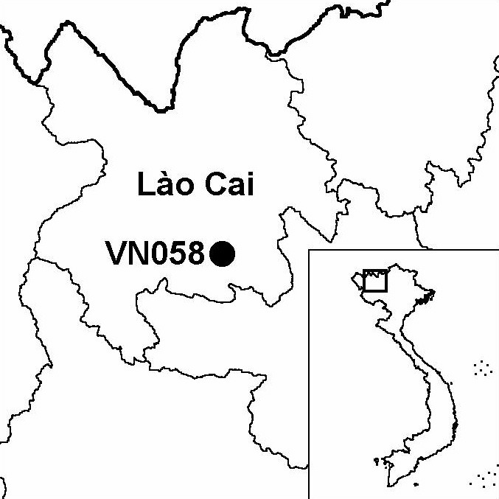
Province(s): Lao Cai
PA Status: None

Latitude: 22º03'N
Longitude: 104º11'E
Area: 60,000 ha
Altitude Range: 200-2,913 m asl

EBA / SA:
Fan Si Pan and Northern Laos SA
Priority Landscape:
None

General Description

The IBA is situated in the Hoang Lien mountains, roughly mid-way between Fan Si Pan and Che Tao IBAs. While the precise boundaries of the IBA have yet to be defined, it comprises around 60,000 ha of western Van Ban district, including some of the largest areas of closed canopy forest remaining in the Hoang Lien mountains. The major habitats types at the IBA are lowland evergreen forest, lower montane evergreen forest, upper montane evergreen forest and anthropogenic habitats. Lowland evergreen forest is distributed at elevations between 300 and 900 m asl. While this habitat has been degraded by selective timber extraction, the forest canopy is still closed in some areas. Lower montane evergreen forest is distributed at elevations between 900 and 1,800 m asl, and is characterised by the presence of two conifer species: Dacrycarpus imbricatus and Fokienia hodginsii. Upper montane evergreen forest is distributed at elevations above 1,800 m asl, and is characterised by the presence of Rhododendron spp. Anthropogenic habitats are found at all but the very highest elevations, and include both permanent and shifting cultivation, and, in areas that have been cleared for agriculture or subjected to burning, secondary grassland and scrub¹.

Bird Fauna: Key Features

The bird community of Van Ban IBA is characteristic of montane evergreen forest in northern Vietnam. The bird community of upper montane evergreen forest is characterised by the presence of Black-faced Warbler Abroscopus schisticeps, Streaked Barwing Actinodura souliei, Chestnut-tailed Minla Minla strigula, Red-tailed Minla M. ignotincta, Golden-breasted Fulvetta Alcippe chrysotis, Rufous-winged Fulvetta A. castaneceps and Stripe-throated Yuhina Yuhina gularis. The bird community of lower montane evergreen forest is quite distinct from that of upper montane evergreen forest in terms of composition, and is characterised by the presence of Grey Peacock Pheasant Polyplectron bicalcaratum, Red-headed Trogon Harpactes erythrocephalus, Rufous-faced Warbler Abroscopus albogularis, Grey Laughingthrush Garrulax maesi, Blue-winged Minla Minla cyanouroptera, Grey-cheeked Fulvetta Alcippe morrisonia and Grey-headed Parrotbill Paradoxornis gularis.

Apart from Fan Si Pan IBA, Van Ban IBA supports the largest number of biome-restricted species of any IBA in Vietnam, including two species for which there are recent confirmed records from no other IBA in the country: White-bellied Redstart Hodgsonius phaenicuroides and Rufous-chinned Laughingthrush Garrulax rufogularis. In addition, Van Ban IBA supports the globally vulnerable Beautiful Nuthatch Sitta formosa, and two of the four restricted-range species that define the Fan Si Pan and Northern Laos Secondary Area: Yellow-billed Nuthatch S. solangiae and Broad-billed Warbler Tickellia hodgsoni.

Species | IBA  Criteria | Global Threat Status | Other  IBAs | Notes
Beautiful Nuthatch  Sitta formosa | A1, A3 | VU | 3 | During surveys in 2001 and 2002, single individuals were seen in mixed feeding flocks in montane evergreen forest between 1,050 and 2,350 m asl^{1,2}.
Yellow-billed Nuthatch  Sitta solangiae | A1, A2 | NT | 11 | During surveys between 2001 and 2002, the species was occasionally recorded in lower montane evergreen forest between 1,000 and 1,800 m asl^{1,2}.
Broad-billed Warbler  Tickellia hodgsoni | A2 |  | 2 | The species was recorded on two occasions at 2,000 m asl in November 2000³.
Biome Restricted Species: The site qualifies under criterion A3 because it supports 20 species restricted to the Sino-Himalayan Temperate Forests (Biome 07) and 58 species restricted to the Sino-Himalayan Subtropical Forests (Biome 08). See Appendix 4 for details.

Secondary Criteria

Species Status Species Status
Assamese Macaque Macaca assamensis³ VU [Impressed Tortoise Manouria impressa]⁴ VU
[Rhesus Macaque M. mulatta]³ DD Chinese Softshell Turtle Pelodiscus sinensis⁴ VU
Stump-tailed Macaque M. arctoides³ VU Fokienia hodginsii^{1,3,5,6} NT
Black Gibbon Nomascus concolor³ EN Amentotaxus argotaenia⁷ VU
[Big-headed Turtle Platysternon megacephalum]⁴ EN Taiwania cryptomerioides^{5,6,7} VU
Black-breasted Leaf Turtle Geoemyda spengleri⁴ EN Southern Serow Naemorhedus sumatraensis³ VU
[Keeled Box Turtle Pyxidea mouhotii]⁴ EN

Notes: [ ] = unconfirmed record.

Threats to Biodiversity

One of the major threats to biodiversity at Van Ban IBA is habitat degradation as a result of selective extraction of timber species, most notably Fokienia hodginsii. Recently, the government of Vietnam passed a decision permitting the extraction of over 20,000 m³ of F. hodginsii timber from the Hoang Lien mountains. Although this decision specifies that only dead F. hodginsii may be harvested, in reality, effective enforcement of this condition will undoubtedly prove to be impossible. As a large part of the IBA is currently under the management of state forest enterprises, this decision represents a potentially serious threat to areas of primary forest that have hitherto only been subjected to small-scale timber extraction by local people.
Threat | Severity
Agricultural intensification / expansion | ●
Commercial timber extraction | ● ●
Fire | ● ●
Forest grazing | ●
Hunting | ● ● ●
Selective logging / cutting | ● ●

Other major threats include habitat loss, through clearance of forest for agriculture and associated forest fires, and hunting. Hunting is a serious threat to all populations of large mammals at the IBA, particularly the remnant population of Black Gibbon Nomascus concolor.

Conservation Actions

Under the project Community-based Conservation of the Hoang Lien Mountains Ecosystem, Fauna & Flora International (FFI), in collaboration with Lao Cai Provincial Forest Protection Department, are currently carrying out an integrated programme of conservation interventions at Van Ban IBA, including biological and human ecological surveys, community-based initiatives, environmental awareness raising, and promotion of the establishment of a nature reserve. In 2003, FFI will expand its Hoang Lien project to incorporate poverty alleviation interventions focusing on community-based natural resources management, together with further protected area development and landscape-scale approaches, culminating in the gazettement of a Man and the Biosphere Reserve.

Recommendations

- The feasibility of establishing a nature reserve at Van Ban IBA should be assessed, and, if appropriate, a nature reserve management board should be established.
- Enforcement of forest management regulations, particularly controls on hunting and illegal timber extraction should be strengthened, and combined with activities to raise environmental awareness among local communities to help combat trade in wildlife.
- Forest management at the IBA should focus on maintaining existing forest cover, particularly at elevations below 900 m asl¹. To this end, all forms of commercial timber extraction (particularly extraction of Fokienia hodginsii) should be prohibited at the IBA, and strict controls should be placed on clearance of forest for agriculture.
- A programme of community-based fire prevention, including awareness raising activities and establishment of village fire-watch groups, should be initiated.
- Further survey work should be conducted to ascertain the distribution and status of key species at the site and determine the habitat requirements of threatened species such as Beautiful Nuthatch, Ward's Trogon Harpactes wardi and Red-winged Laughingthrush Garrulax formosus, to provide a basis for targeted conservation actions and forest protection activities¹.

References

1. Tordoff, A. W., Le Manh Hung, Nguyen Quang Truong and Swan, S.R. (2002) A rapid field survey of Van Ban district, Lao Cai province, Vietnam. Unpublished report to the BirdLife International Vietnam Programme and the Institute of Ecology and Biological Resources.
2. S. R. Swan in litt. 2002.
3. Long, B., Le Khac Quyet and Phung Van Khoa (2000) An assessment of the potential and priorities for conservation in Van Ban district, Lao Cai province. Unpublished report to the Fauna & Flora International Indochina Programme.
4. Nguyen Quang Truong (2002) Report on the herpetological survey in Van Ban district, Lao Cai province. Unpublished report to the Fauna & Flora International Vietnam Programme.
5. Nguyen Tien Hiep, Do Tien Doan and Phan Ke Loc (2002) The diversity of the flora of Vietnam 9. Taiwania Hayata and T. cryptomerioides Hayata (Taxodiaceae): new genus and species for the flora. Journal of Genetics and Applications 1(2002): 32-40.
6. Farjon, A. (2002) Rare and possibly threatened conifers in Vietnam. Unpublished report to the Fauna & Flora International Vietnam Programme.
7. Averyanov, L., Phan Ke Loc and Do Tien Doan (2002) Flora and vegetation survey of Van Ban district, Lao Cai province of northern Vietnam. Unpublished report to the Fauna & Flora International Vietnam Programme.

